TENDER SPECIFICATIONS

PSV-HPPS-SOF. Hydroelectric Power Plant Simulator
Energy generation from water flows is the most exploited renewable energy source in the world for obtaining electricity, due to its simplicity of operation and its adaptability to different environments. The orography of the terrain is essential for the construction of dams that allow the storage of water and increase the potential waterfall for its subsequent conversion into electrical energy. For this purpose, mobile gates open the flow of stored water, which will move the hydraulic turbine and this, in turn, the electric generator.
Application description
The PSV-HPPS-SOF software has been designed by EDIBON to show the user the basic principles of operation of hydraulic power plants, exposing in a didactic way the elements and parameters involved in the generation process, as well as the interrelations between these parameters thanks to the mathematical models integrated in the simulator.
The application offers various levels of training that will provide the user with the essential knowledge and skills on the fundamental principles of control, operation and functioning of hydroelectric power plants. In this way it will be possible to carry out a previous configuration of the plant’s operating conditions, to later control and manage it based on these parameters.
Operation and model
As regards the configurable conditions, the system has been designed so that the user can select the type of turbine he wishes to use (Kaplan, Francis or Pelton), associating it with a range of net waterfall, according to the values handled in real plants and the operating height allowed by the turbine itself. Consequently, he can define the hydrostatic pressure of the water reservoir himself.
The software is designed to supply energy based on demand, so that the student establishes the electrical power and, with it, the working regime of the plant. As a result, variations in the turbine water flow, defined from the fundamental mathematical model of this type of plant, will be observed:

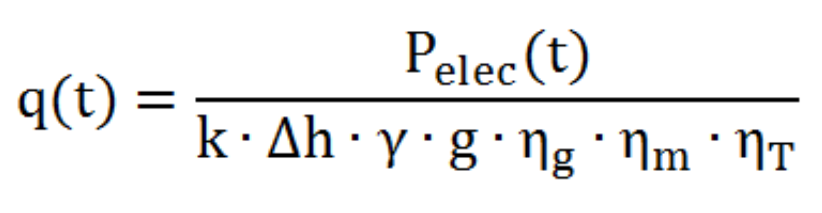
In this way, when faced with a specific demand for power, the hydraulic gate will be opened in proportion to this energy requirement which, in turn, facilitates an increase in water flow at the turbine inlet, in order to increase the kinetic power transmitted and equalise the resistive torque, taking into account certain dynamic inertias of the plant.
This aspect has been simulated to reproduce the real operation of the hydroelectric plant, so that once the value of the electrical power demand is entered, it can be seen how this setpoint is reached dynamically.
The injection of power into the network will be done in a real way if the user wishes, operating with the hardware. Likewise, the software provides the necessary tools to carry out the synchronization of the generator with the electrical grid, facilitating the guided understanding of this procedure, within the framework of the SCADA software.
In this way, the experience allows the student to assimilate the necessary conditions for successful synchronization between the generator and the grid, thanks to the monitoring of this power injection process through the different tools provided by the software. In addition, the student will be able to analyze the response of the plant to an increase or decrease in the volume of work required, observing the variations in flow.
Likewise, a series of practices are provided in island mode so that the user understands the automatic voltage and frequency control that the controller exerts on the generator; all of this implemented in the application’s SCADA software, involving the student so that he or she understands the effect that variations in demand produce on the electrical and mechanical parameters of the generator and how the controller compensates for their fluctuations automatically.
Once the user has started up, he can observe the evolution of the reservoir’s capacity at all times and analyse the emptying speed, thanks to the dynamics of the PSV-HPPS-SOF software, allowing the user to establish a maximum volume of water, in relation to his own inherent potential energy.
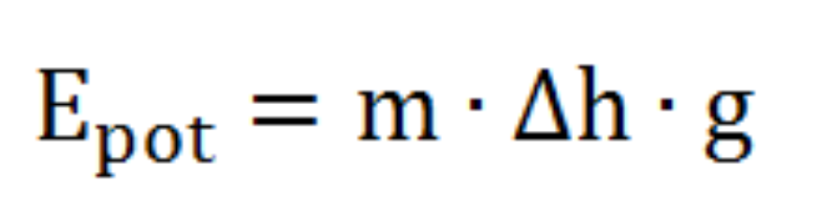

When establishing this total available capacity, the progressive emptying of the reservoir will be observed, in accordance with the discharge flow, depending on the requirements of the energy demanded, the useful water head and the efficiencies of the synchronous generator, turbine, in addition to the performance associated with the dynamic fluid losses which, once again, will be configurable.
All these parameters can be analyzed thanks to the indicators arranged in the different points of the process, in the main screen of the software, located in a clear way in their corresponding work units.
The water will be drained until the reservoir is empty. However, when the water level is below the upper level of the damper, a minimum level alarm will be triggered, which will stop the simulation. When working in synchronism with the network, the user can observe how this stop is gradual, to avoid the sudden acceleration of the turbine caused by a sudden disconnection.

PSV-GSPP-SOF. Gas Turbine Power Plants
As mentioned in the introduction, because of the unpredictable nature of renewable energy sources, the stability of the current electricity system is strictly linked to the optimal management of thermal power plants, such as gas plants, to alleviate the variability of demand throughout the day, maintaining continuity of supply at all times. Thus, a thermal power system contributes greatly to stabilizing the grid, ensuring the electricity supply even in the event that renewable sources cannot supply the entire load.
Application description
The PSV-GSPP-SOF software has been designed by EDIBON with the aim of showing the user the basic principles of operation of Brayton cycle gas turbine power plants, exposing in a didactic way the elements and parameters present in the generation process, as well as the interrelations between these parameters through the mathematical models integrated in the simulator.
The basic principle of gas turbine power plants is to transform the intrinsic energy of a fuel into electrical energy to be delivered to the grid. Likewise, the application offers different levels of training that will provide the user with the essential knowledge and skills on the fundamental principles of control, operation and functioning of thermal power plants, where this energy transformation takes place. In this way it will be possible to carry out a previous configuration of the operating conditions of the plant, to later carry out the control and management based on these parameters.

Operation and model
With regard to the configurable conditions, the system has been designed so that the user can select different types of fossil fuel (Natural Gas, Kerosene, Propane, Butane or Hydrogen), associated with a certain calorific value, according to the values handled in real plants. Consequently, he may himself define the heating capacity provided in the combustion chamber.
The software is designed to supply energy based on the real electrical demand, so that the student establishes the electrical power and, with it, the working regime of the plant. Consequently, variations will be observed in the flow of fuel introduced into the combustion chamber, defined from the mathematical model of a gas turbine based on the Brayton cycle, characteristic of these thermal power plants. In this model, the thermal energy transferred to the fluid through the fuel will be established according to the operating temperatures, shown at all times on the main screen, within the reach of the user.

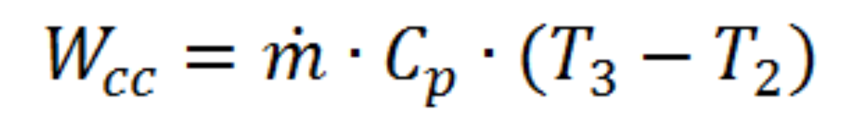

In this way, when the user establishes a specific setpoint of power demand, it will cause an opening of the intake valve proportional to this energy requirement which, in turn, will facilitate an increase in the flow of fuel at the entrance to the combustion chamber, in order to increase the heat power transmitted (Q_global) and equalize the resistive torque, exceeding the work required by the compressor.

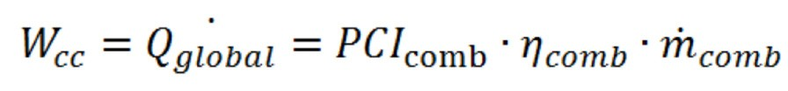

In addition, the real operation of a combustion in the chamber has been simulated, whereby combustion cannot take place with an excess of fuel, requiring an air intake to reach the nominal fuel/air ratio.
All these parameters can be analyzed thanks to the indicators arranged in the different points of the process, in the main screen of the software, located in a clear way in their corresponding work units. In addition, the user will be able to observe at all times the conditions of the fluid (air, fuel or mixture) at each point of the process, i.e. the Brayton cycle.
The injection of power into the grid will be done in a real way if desired, operating with the hardware. Thus, the software provides the necessary tools to carry out the synchronization of the generator with the power grid, allowing the understanding, step by step, of this procedure, within the framework of the SCADA software.
In this way, the experience allows the student to understand the conditions necessary for successful synchronization between the generator and the grid, thanks to the monitoring of this power injection process through the different tools provided by the software. In addition, the student will be able to analyze the response of the plant to variations in the volume of work, maintaining the synchronization to the network, observing the fluctuations in the flow of fuel and air intake.
Likewise, a series of practices are provided in island mode so that the user understands and internalizes the automatic voltage and frequency control that the controller exerts on the generator; all implemented in the application SCADA software, involving the student so that he or she understands the effect that variations in demand produce on the electrical and mechanical parameters of the generator and how the controller compensates for their fluctuations automatically.
Before starting up, the student will be able to determine the conditions of the aspirated air, as well as adjust the pressure ratio of the compressor, causing observable alterations in the thermodynamic process, so that he can analyse the effect that the different configurations trigger on the fuel injection and, in short, on the heat power transferred in the combustion chamber.
In addition, the user will be able to modify the efficiency of the different machines and units that make up the process, observing the variations in the flow of fuel and in the general thermal efficiency of the process.
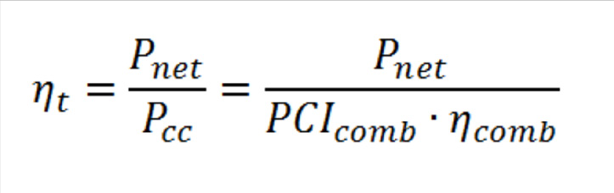

In this aspect, the software provides the appropriate tools for the student to analyze the impact on thermal performance by changing the compression ratio. For example, you may observe how as the ratio decreases, the need for heat production (combustion chamber) increases, leading to a decrease in the thermal efficiency of the plant, since as there is a fixed electrical energy set point determined by the user, the combustion power required to meet this demand will increase.
On the other hand, the software also allows the user to understand the dynamic operation of this type of plant, allowing him to observe the evolution of the flow of fuel and air until the system reaches the permanent regime. Thus, for example, when the turbine is stopped, it is shown how the thermal inertia of the system causes a progressive cooling of the different points of the process, until the temperatures return to the initial ones and the power given in the combustion chamber is zero.

PSV-WPPP-SOF. Wind Power Plants
Energy generation from air flows is one of the most exploited renewable energy sources in the world for obtaining electricity, due to its simplicity of operation and its adaptability to certain climates.
Wind power is the conversion of wind energy into a useful form of energy, whether using wind turbines to produce electricity, windmills for mechanical power, wind pumps to pump water or sewage, or sails to move boats. The most significant use of this energy source is in wind turbines. These devices make up a renewable system that is not very flexible and cannot be strictly adapted to daily demand conditions, as their operation is established according to the conditions of the environment where they are distributed (wind in the area). However, thanks to the flexibility of operation of the simulation software provided by EDIBON, you will be able to experience a multitude of generation situations with which to understand the basic principles of operation of the elements present in this type of power system.
Application description
The PSV-WPPP-SOF software has been designed by EDIBON to show the user the basic principles of operation of wind power plants, exposing in a didactic way the elements and parameters present in the generation process, as well as the interrelations between these parameters thanks to the mathematical models integrated in the simulator.
The application offers various levels of training that will provide the user with the essential knowledge and skills on the fundamental principles of control, operation and functioning of this type of power plant. Consequently, it will be possible to carry out a previous configuration of the plant’s operating conditions, for subsequent control and management based on these factors.
Operation and model
The wind power plant simulation software allows to simulate the behavior of a conventional wind turbine under different conditions previously preset by the user.
From the software the user can load different wind profiles and relate them to the theoretical power curve of the turbine. These wind speed and power curves are drawn by the user. In addition, the user will be able to set as starting conditions the following elements: nominal power of the wind turbine, minimum wind speed for turbine start-up and maximum wind speed for operation. These parameters will be essential to start the simulation.
All turbine behavior is based on the fundamental stationary model represented by the following equation:
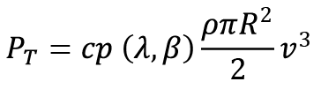

In this way, given a specific wind speed setpoint large enough for the turbine to start moving, the user will be able to analyze the generator operation, the synchronization process to the grid, the power variations as a function of wind speed and the power characteristic of the turbine.
This process has been simulated to reproduce the real operation of a wind power plant in such a way that, once the operating conditions of the turbine and the wind profile are introduced, it will be possible to observe how the generator reaches the different power points according to the wind conditions. For this purpose, the software will display in real time different electrical parameters that represent the operation of the real electrical generator (P, Q, S, f, cos(fi)).
The injection of power into the network will be done in a real way if the user wishes, operating with the hardware. Thus, the software provides the necessary tools for the synchronization of the generator with the power grid, allowing you to understand, step by step, this procedure, within the framework of the SCADA software.
In this way, the experience allows the student to assimilate the necessary conditions for successful synchronization between the generator and the network, thanks to the monitoring of this injection process through the different tools provided by the software. In addition, the student will be able to analyze the response of the plant to an increase or decrease in the volume of work required, maintaining synchronization to the grid, through the adjustment of wind speed.
Likewise, a series of practices are provided in island mode so that the user understands and internalizes the automatic voltage and frequency control that the controller exerts on the generator; all of this implemented in the application SCADA software, involving the student in such a way that he or she understands the effect that variations in demand produce on the generator’s parameters.
Once the user has started up the machine, he can observe the evolution of the power coefficient (ratio between the power used and the power available) at all times, depending on the pitch angle and the speed at the tip of the rotor. Thus, the student will have at his disposal a powerful tool to understand the adjustment of this power coefficient, through the automatic regulation of the angle of attack of the blades, modelled by Weibull probability distributions.
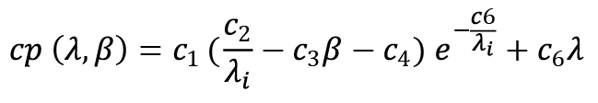

In this way, the student will observe how the pitch angle is automatically modified in order to maintain the preset operating frequency of the generator, just as in real plant wind turbines. In turn, it will internalize the limits of operation of a wind turbine, according to wind speeds that are too high, forcing the pitch angle to its limit value, making it impossible to regulate the generator.

PSV-BPP-SOF. Biomass Power Plants
The operation and structure of biomass plants are based on the Rankine steam cycle, with the characteristic that the fuel burned in the boiler is organic matter called biomass, serving as a type of energy that can be considered renewable. In this way, through adequate control of combustion, supply will be adapted to the daily demand profile, providing flexibility between generation and consumption. You can experience this flexibility of operation thanks to the simulation software PSV-BPP-SOF, with which you will test a multitude of practices and generation situations.
Application description
The PSV-BPP-SOF software has been designed by EDIBON with the aim of showing the user the basic principles of operation of Rankine cycle biomass power plants, presenting in a didactic way the elements and parameters present in the generation process, as well as the interrelations between these parameters by means of the mathematical models integrated in the simulator.
The basic principle of biomass power plants is to transform the intrinsic energy of a fuel that can be considered renewable into electrical energy that will be delivered to the grid. Thus, the application offers different levels of training that will provide the user with the essential knowledge and skills on the fundamental principles of operation and functioning of thermal power plants, where this energy transformation takes place. In this way it will be possible to carry out a previous configuration of the operating conditions of the plant, to later carry out the control and management based on these factors.
By means of this software the student will be able to understand that every thermal cycle of power generation or thermal machine can be represented as a function of the net generated power and the incoming or outgoing thermal powers, according to the fundamental equations of thermodynamics for each element and thermal process of the cycle.
Operation and model
With regard to the configurable conditions, the system has been designed so that the user can choose between different types of biomass, i.e. raw material, associated with a certain calorific value, according to the values handled in real plants. In addition, the possibility of configuring the composition of the raw material by modifying the concentrations of carbon, hydrogen and oxygen at will is provided, in order to evaluate the behaviour of a specific compound.
In this way, it is designed to supply energy on the basis of the biomass mass flow introduced, so that the student establishes this parameter manually and, with it, the working regime of the turbine. The system has been designed to be as didactic as possible, so that, in order to guide the user towards the value with which the preset operating conditions are reached, an assistance parameter is included which will indicate the optimum mass flow value to be entered in order to reach the network operating conditions (50/60 Hz and 400 V).
Likewise, when faced with a specific biomass flow target, large enough to start the turbine, the user can analyse the operation of the thermal generator and the acquisition, or not, of certain operating conditions, especially the frequency of operation.
This aspect has been simulated to reproduce the real operation of the thermal plant, so that once the flow value is entered, it can be seen how the generation power is reached dynamically, in the output parameters that the user has within reach.
The injection of power into the network will be done in a real way if the user wishes, operating with the hardware. Thus, the software provides the necessary tools to carry out the synchronization of the generator with the power grid, facilitating the guided understanding of this procedure, within the framework of the SCADA software.
Therefore, the experience allows the student to assimilate the necessary conditions for successful synchronization between generator and network, thanks to the monitoring of this injection process through the different tools provided by the software. In addition, the student will be able to analyze the response of the plant to an increase or decrease in the volume of work required, maintaining the synchronization to the network, through the increase of the biomass mass flow.
Likewise, a series of practices are provided in island mode so that the user understands and internalizes the automatic voltage and frequency control that the controller exerts on the generator; all of this implemented in the application SCADA software, involving the student in such a way that he or she understands the effect that variations in demand produce on the generator’s parameters.
Once the start up is done, the student will be able to determine the pressure and temperature conditions of the produced steam, causing observable alterations in the thermodynamic process. Thus, it will be able to analyze the effect that the different configurations trigger on the biomass injection needs and, ultimately, on the calorific power transferred in the boiler and on the steam flow produced. In addition, the user will be able to modify the efficiency of this boiler, observing the associated reduction or increase in frequency, causing the need to establish again variations in the fuel flow.
In this aspect, the student will have at his disposal a powerful tool to understand the repercussions on the operating conditions of different plant configurations. In turn, it will internalize the operating limits of a biomass power plant, according to the degree of steam at the boiler outlet.

PSV-GPP-SOF. Geothermal Power Plants
In certain areas of the earth there are geothermal fields where the area of land has a higher than normal thermal gradient, i.e. a much greater increase in temperature at depth. These areas are home to the high-temperature geothermal steam extraction wells that connect to the power plant via a network of pipes. These plants form a flexible energy system that can be adapted to daily demand conditions, since, despite the fact that their operation is strictly linked to the qualities of the environment where they are distributed (aquifers), through appropriate control and management of the resources, security of supply can be guaranteed at all times.
The operation and structure of geothermal power plants are based on the Rankine steam cycle, with the characteristic that there is no fuel burned in a boiler, since the steam is extracted directly, serving as a type of energy that can be considered renewable, since the geothermal steam is once again condensed and reinjected into the well after the turbine is turned. With adequate control of the extraction of steam from the subsoil, it is possible to contribute to the adaptation of supply to the daily demand profile, providing flexibility between generation and consumption. You will be able to experience this flexibility of operation thanks to the simulation software PSV-GPP-SOF, with which you will test a multitude of generation situations, unravelling the operating principles of this type of power plant.
Application description
The PSV-GPP-SOF software has been designed by EDIBON with the aim of showing the user the basic principles of operation of geothermal power plants, presenting in a didactic way the elements and parameters present in the generation process, as well as the interrelations between these parameters through the mathematical models integrated in the simulator.
The basic principle of geothermal power plants is the extraction of heat from the ground in the form of electrical energy to be fed into the grid. Thus, the application offers different levels of training that will provide the user with the essential knowledge and skills on the fundamental principles of operation and functioning of geothermal power plants, where this energy transformation takes place. In this way it will be possible to carry out a previous configuration of the operating conditions of the plant, to later carry out the control and management based on these factors.
Operation and model
EDIBON offers the possibility to simulate two types of geothermal power plants:
• Dry Steam Power Plant.
• Flash Steam Power Plant.
If it is desired to operate with the flash units, in addition to the choice of steam mass flow and temperature at the well outlet, the user will have the possibility to set the number of flash stages that the water from the well undergoes, i.e. from low pressure tanks or flash tanks.
The software is designed to supply energy on the basis of the steam mass flow introduced, so that the student establishes this parameter manually and, with it, the working regime of the turbine. The system has been designed to be as didactic as possible, so that, in order to guide the user towards the value with which the preset operating conditions are reached, an assistance parameter is included which will indicate the optimum mass flow value to be entered in order to reach the network operating conditions (50/60 Hz and 400 V).
Likewise, when faced with a specific steam flow setpoint, large enough to start the turbine, the user can analyse the operation of the thermal generator and the acquisition, or not, of certain operating conditions, especially the frequency of operation.
This aspect has been simulated to reproduce the real operation of the geothermal plant, so that once the flow value is entered, it can be seen how the generation power is reached dynamically, in the output parameters that the user has within reach.
The injection of power into the network will be done in a real way if the user wishes, operating with the hardware. Thus, the software provides the necessary tools to carry out the synchronization of the generator with the power grid, facilitating the guided understanding of this procedure, within the framework of the SCADA software.
Therefore, the experience allows the student to assimilate the necessary conditions for successful synchronization between generator and network, thanks to the monitoring of this injection process through the different tools provided by the software. In addition, the student will be able to analyze the response of the plant to an increase or decrease in the volume of work, maintaining the synchronization to the network, through the increase of the steam mass flow.
Likewise, a series of practices are provided in island mode so that the user understands and internalizes the automatic voltage and frequency control that the controller exerts on the generator; all of this implemented in the application SCADA software, involving the student in such a way that he or she understands the effect that variations in demand produce on the generator’s parameters.
Once the start-up is done, the student will be able to determine the temperature of the source, as it was introduced, causing observable alterations in the thermodynamic process. This allows you to analyse the effect of different configurations on the electrical power output. In addition, the user will be able to modify the efficiency of the power plant, observing the associated reduction or increase in frequency, causing the need to establish again variations in the fuel flow.
In this aspect, the student will have at his disposal a powerful tool to understand the repercussions on the operating conditions of different plant configurations. In turn, it will internalize the operating limits of a geothermal power plant, according to the temperature of the well or source.

PSV-HSPP-SOF: Heliothermic Solar Power Plant Simulator
There are certain areas of the earth where there is high solar radiation. This radiation can be used, for example, in the form of heat. This heat, in turn, is concentrated in certain points to obtain water vapour at high temperatures. This steam is used, as in many thermal power plants, to drive a turbine and produce electricity. These plants make up a flexible energy system that can be adapted to daily demand conditions since, despite the fact that their operation is strictly linked to the amount of solar thermal energy available in the environment, through appropriate control and management of resources, the security of the electricity supply during the day can practically be guaranteed.
The operation and structure of thermal power plants are based on the Rankine cycle of steam, with the characteristic that there is no fuel burned in a boiler, since the steam is extracted directly from solar thermal radiation. With an adequate control of steam production, it is possible to contribute to the fact that the supply is adapted to the daily demand profile, providing flexibility between generation and consumption. You will be able to experience this operational flexibility thanks to the PSV-HSPP-SOF simulation software, with which you will test a multitude of generation situations, unraveling the operating principles of this type of power plant.
Application description
The PSV-HSPP-SOF software has been designed by EDIBON with the aim of showing the user the basic principles of operation of solar thermal power plants, presenting in a didactic way the elements and parameters present in the generation process, as well as the interrelations between these parameters through the mathematical models integrated in the simulator.
The basic principle of solar thermal power plants is the use of heat energy from solar radiation to obtain electrical energy. There are different types of plants such as tower plants and parabolic trough plants. Solar towers consist of a large glass surface in the centre of which is a very high chimney fitted with devices similar to wind turbines. In this way, the application offers different levels of training that will provide the user with the essential knowledge and skills on the fundamental principles of operation and functioning of solar thermal power plants, where this energy transformation takes place.
Operation and model
EDIBON offers the possibility to simulate the operation of a heliothermal power plant.
The software is designed to supply electrical energy based on the mass flow of steam produced in the plant simulation, so that the student establishes this parameter manually and, with it, the working regime of the turbine. The system has been designed to be as didactic as possible, so that, in order to guide the user towards the value with which the pre-established operating conditions are reached, an assistance parameter is included that will indicate the optimum mass flow value to be introduced in order to reach the network operating conditions (50/60 Hz and 400 V).
Likewise, when faced with a specific steam flow set point, large enough to start the turbine, the user will be able to analyse the operation of the generator and the acquisition of certain operating conditions, such as the operating frequency.
This aspect has been simulated to reproduce the real operation of the heliothermal plant, so that once the steam flow value is entered, it can be seen how the generation power is achieved dynamically, in the output parameters available to the user.
The injection of power into the grid will be carried out in a real way if the user so wishes, operating with the hardware. Thus, the software provides the necessary tools to carry out the synchronization of the generator with the grid, facilitating the guided understanding of this procedure, within the framework of the SCADA software.
Therefore, the experience allows the student to assimilate the necessary conditions for the synchronization between the generator and the grid to be successful, thanks to the monitoring of this injection process through the different tools provided by the software. In addition, the student will be able to analyze the response of the plant to an increase or decrease in the volume of work, maintaining the synchronization to the network, through the increase of the steam mass flow.
Likewise, a series of practices in island mode are provided so that the user understands and internalizes the automatic voltage and frequency control that the controller exerts on the generator; all this implemented in the SCADA software of the application, involving the student so that he understands the effect that variations in the demand produce on the parameters of the generator.
Once the start up is done, the student will be able to determine the temperature of the steam, causing observable alterations in the thermodynamic process. Thus, he will be able to analyze the effect that the different configurations trigger on the electrical power output. In addition, the user will be able to modify the efficiency of the power plant, observing the associated power reduction or increase, causing the need to establish again variations in the steam flow.

