TENDER SPECIFICATIONS

Energy generation from water flows is the most exploited renewable energy source in the world for obtaining electricity, due to its simplicity of operation and its adaptability to different environments. The orography of the terrain is essential for the construction of dams that allow the storage of water and increase the potential waterfall for its subsequent conversion into electrical energy. For this purpose, mobile gates open the flow of stored water, which will move the hydraulic turbine and this, in turn, the electric generator.
Application description
The PSV-HPPS-SOF software has been designed by EDIBON to show the user the basic principles of operation of hydraulic power plants, exposing in a didactic way the elements and parameters involved in the generation process, as well as the interrelations between these parameters thanks to the mathematical models integrated in the simulator.
The application offers various levels of training that will provide the user with the essential knowledge and skills on the fundamental principles of control, operation and functioning of hydroelectric power plants. In this way it will be possible to carry out a previous configuration of the plant’s operating conditions, to later control and manage it based on these parameters.
Operation and model
As regards the configurable conditions, the system has been designed so that the user can select the type of turbine he wishes to use (Kaplan, Francis or Pelton), associating it with a range of net waterfall, according to the values handled in real plants and the operating height allowed by the turbine itself. Consequently, he can define the hydrostatic pressure of the water reservoir himself.
The software is designed to supply energy based on demand, so that the student establishes the electrical power and, with it, the working regime of the plant. As a result, variations in the turbine water flow, defined from the fundamental mathematical model of this type of plant, will be observed:

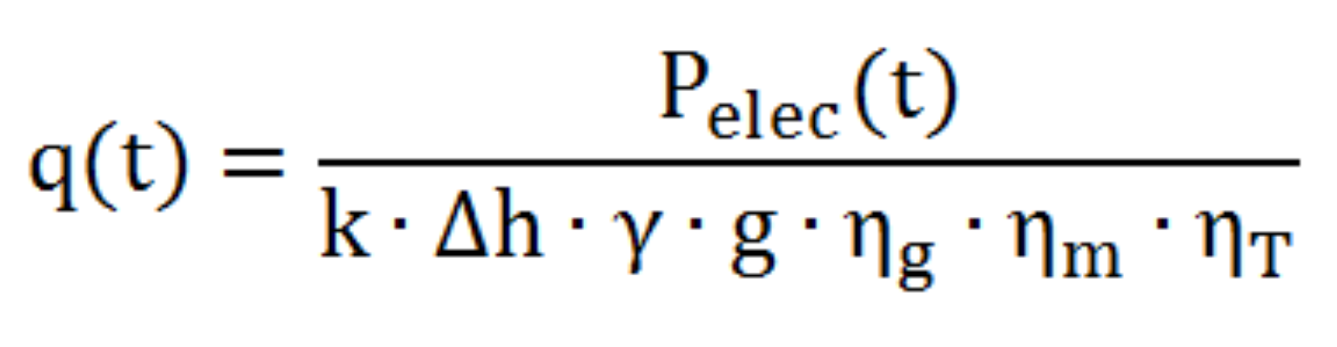
In this way, when faced with a specific demand for power, the hydraulic gate will be opened in proportion to this energy requirement which, in turn, facilitates an increase in water flow at the turbine inlet, in order to increase the kinetic power transmitted and equalise the resistive torque, taking into account certain dynamic inertias of the plant.
This aspect has been simulated to reproduce the real operation of the hydroelectric plant, so that once the value of the electrical power demand is entered, it can be seen how this setpoint is reached dynamically.
The injection of power into the network will be done in a real way if the user wishes, operating with the hardware. Likewise, the software provides the necessary tools to carry out the synchronization of the generator with the electrical grid, facilitating the guided understanding of this procedure, within the framework of the SCADA software.
In this way, the experience allows the student to assimilate the necessary conditions for successful synchronization between the generator and the grid, thanks to the monitoring of this power injection process through the different tools provided by the software. In addition, the student will be able to analyze the response of the plant to an increase or decrease in the volume of work required, observing the variations in flow.
Likewise, a series of practices are provided in island mode so that the user understands the automatic voltage and frequency control that the controller exerts on the generator; all of this implemented in the application’s SCADA software, involving the student so that he or she understands the effect that variations in demand produce on the electrical and mechanical parameters of the generator and how the controller compensates for their fluctuations automatically.
Once the user has started up, he can observe the evolution of the reservoir’s capacity at all times and analyse the emptying speed, thanks to the dynamics of the PSV-HPPS-SOF software, allowing the user to establish a maximum volume of water, in relation to his own inherent potential energy.
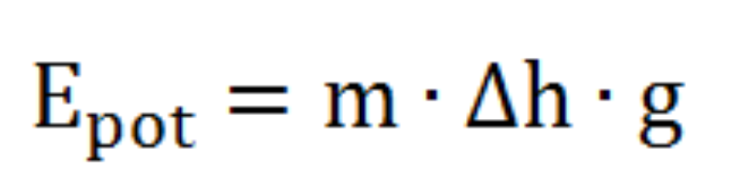

When establishing this total available capacity, the progressive emptying of the reservoir will be observed, in accordance with the discharge flow, depending on the requirements of the energy demanded, the useful water head and the efficiencies of the synchronous generator, turbine, in addition to the performance associated with the dynamic fluid losses which, once again, will be configurable.
All these parameters can be analyzed thanks to the indicators arranged in the different points of the process, in the main screen of the software, located in a clear way in their corresponding work units.
The water will be drained until the reservoir is empty. However, when the water level is below the upper level of the damper, a minimum level alarm will be triggered, which will stop the simulation. When working in synchronism with the network, the user can observe how this stop is gradual, to avoid the sudden acceleration of the turbine caused by a sudden disconnection.

