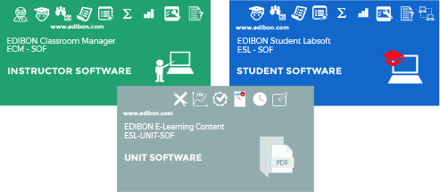

ICAI Innovative Keys formed by: ECM-SOF + ESL-SOF + ESL-UNIT-SOF

ECM-SOF. EDIBON Classroom Manager
INSTRUCTOR SOFTWARE

ESL-SOF. EDIBON Student Labsoft
STUDENT SOFTWARE

- Access to multiple administrators.
- User Data Base Management.
- Administration and assignment of Workgroups, Tasks and Training sessions.
- Creation and Integration of Practical Exercises and Multimedia Resources (PDFs, videos, animations, illustrations, equations).
- Custom Design of Evaluation Methods.
- Creation of own content.
- Creation and assignment of Formulas & Equations.
- Editor and Equation System Solver Engine.
- Updatable Contents.
- Report generation, User Progression Monitoring and
- Statistics.
- Documentation and description of the application modules.
- Student Log-In & Self-Registration.
- Log-in and Registration of Multiple Users.
- Existing Tasks checking & Monitoring.
- Evaluation Methods to prove your knowledge and progression.
- Test self-correction.
- Equation System Solver Engine.
- User Monitoring Learning & Printable Reports.
- Real Time Task Status.
- LOCAL and LAN Operating Mode.
- Evaluation of expressions using SCADA variables in Real Time.
- Documentation and description of the applicatioin modules.

ESL-UNIT-SOF. EDIBON E-Learning content for each unit
UNIT SOFTWARE

- Customized Curriculum for each unit.
- Default contents & scheduled tasks available to be used from the first session.
- Editable Default Content.
- Practical Exercises accomplishment by following the Manual provided by EDIBON.
- Formula Packages related to the different Units.
- Calculations computing and plotting.
- Multimedia-Supported auxiliary resources.
- Solutions and explanations of practical exercises both numeric and graphics.
- Communication with the EDIBON SCADA system in real time.
- Compatible with the SCORM standard.
Imp! With additional small cost, this system can be supplied in your language.








ISO 9001: Gestión de Calidad (para Diseño, Fabricación, Comercialización y Servicio postventa)
Certificado Unión Europea
(seguridad total)
Certificados ISO 14001 y Esquema de Ecogestión y Ecoauditoría (gestión medioambiental)
1
“Worlddidac Quality Charter” y Miembro Platino de Worlddidac

INTRODUCTION

The Interactive Computer Aided Instruction Software, “ICAI”, comprises two applications software and E-Learning Content created by EDIBON for each Technical Teaching Unit:

• EDIBON Classroom Manager (Instructor Software), “ECM-SOF”.

• EDIBON Student Labsoft (Student Software), “ESL-SOF”.

• EDIBON E-Learning content for each unit, “ESL-UNIT-SOF”.

What is ICAI Software?

The Interactive Computer Aided Instruction Software, “ICAI”, is a software to HELP the teacher and the student to carry out the practices incorporating all the novelties included in each of the three system packages.

The Interactive Computer Aided Instruction Software, “ICAI”, incorporates distance learning into the curriculum in response to one of the
instructor’s main tasks, providing the students the right tools to learn by themselves in the most efficient and painless way.
The Interactive Computer Aided Instruction Software, “ICAI”, helps both the teacher and the students. a) It helps the teachers by:
a. Scheduling their classes and tasks easily.
b. Checking in real time what any student is doing and enabling the instructors to teach faster and more efficiently.
c. Supervising the students understanding progress and level, questions and answers as well as the whole class evolution. d. Ensuring more individual attention.
e. Adapting the learning patterns.
f. Reducing the preparation time for lessons. g. Teaching easily.

b) It helps the students by:
a. Enabling them to understand the operation of any EDIBON Teaching Unit and the principles involved easily. This software can be used for all manual computer controlled EDIBON SCADA units.
b. Providing them modern tools so that they are able to get clear ideas and quick understanding. c. Saving time.

Why ICAI software?

Because it helps both the teacher and the student in the practice.
The Interactive Computer Aided Instruction Software, “ICAI”, incorporates all and each one of the EDIBON family equipment.

Wide variety of contents for any Area (Electricity, Electronics, Fluid Mechanics, Thermodynamics…). These contents are divided into:

a. Practical Exercises: Practical Exercises Manual & Multimedia Resources. b. Tests: Two types of Evaluation Methods: Training Test & Exams.
c. Calculations: Formula Packages related to the different Units and a Spreadsheet tool to compute, compare and plot the results obtained in the laboratory and the theoretical ones. It also includes an Equation System Solver Engine.
d. Graphical Results: Custom Reports & Results: Monitoring the Users & Workgroups progression.

Advantages of ICAI Software?

There are many advantages of ICAI, but we can highlight:

- Lets start working from the first day: EDIBON provides a huge variety of default contents & scheduled tasks available to be used from the first session.
- Incorporates updatable contents: The provided material can be periodically updated.

- Lets the easy integration of own resources: You can design/edit/remove your own contents & tasks.

- It has self-correction: All tests are automatically evaluated by ICAI System Software.

- Incorporates multimedia-supported auxiliary resources: Animations, Videos, Pictures, Audios, detailed Question Explanations
and so on that can be shown to expand the student knowledge.

- It allows obtaining printable reports & statistics: Generate and export summarized information in different formats (Tables, Histograms, Progression plots…) related to the current status and results of the jobs planned for individual Users/Units/Tasks/ Workgroups.

GENERAL DESCRIPTION

The Interactive Computer Aided Instruction Software, “ICAI”, comprises two applications software and E-Learning Content created by EDIBON for each Technical Teaching Unit:
• EDIBON Classroom Manager (INSTRUCTOR SOFTWARE), “ECM-SOF”.
• EDIBON Student Labsoft (STUDENT SOFTWARE), “ESL-SOF”.
• EDIBON E-Learning content for each unit (UNIT SOFTWARE), “ESL-UNIT-SOF”.

ECM-SOF. EDIBON Classroom Manager. INSTRUCTOR SOFTWARE

EDIBON Classroom Manager, “ECM-SOF”, is the application that allows the Instructor to register students, manage and assign tasks for workgroups, create own content to carry out Practical Exercises, choose one of the evaluation methods to check the Student knowledge and monitor the progression related to the planned tasks for individual students, workgroups, units, etc... so the teacher can know in real time the level of understanding of any student in the classroom.
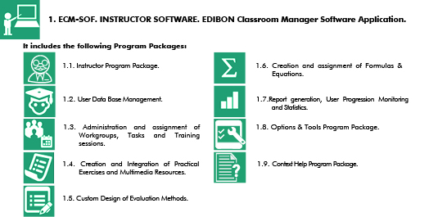

ESL-SOF. EDIBON STUDENT LABSOFT. STUDENT SOFTWARE

EDIBON Student Labsoft, “ESL-SOF”, is the application addressed to the Students that helps them to understand theoretical concepts by means of practical exercises and to prove their knowledge and progression by performing tests and calculations in addition to Multimedia Resources. Default planned tasks and an Open workgroup are provided by EDIBON to allow the students start working from the first session. Reports and statistics are available to know their progression at any time, as well as explanations for every exercise to reinforce the theoretically acquired technical knowledge.
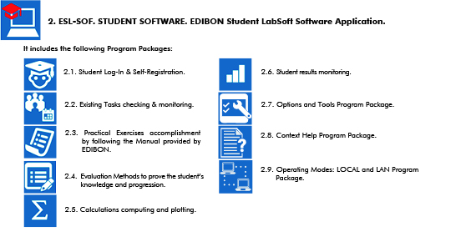

GENERAL DESCRIPTION

ESL-UNIT-SOF. EDIBON E-LEARNING CONTENT FOR EACH UNIT. UNIT SOFTWARE

EDIBON E-Learning content for each unit, “ESL-UNIT-SOF”, is a set of digital resources created by EDIBON that accompanies each Technical Teaching Unit. The resources can be edited or enriched by the instructor adding others if deems it convenient. The content provided by EDIBON includes a practical manual, evaluation exercises, equations and multimedia support material to assimilate the concepts studied with the units.

 3. ESL-UNIT-SOF. EDIBON E-Learning content for each unit.

It includes the following Program Packages:

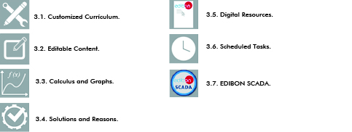

Example of references:

1) Unit: EESTC. Computer Controlled Thermal Solar Energy Unit. Use the reference: ESL-EESTC-SOF.
2) Unit: FME22. Venturi, Bernoulli and Cavitation Unit. Use the reference: ESL-FME22-SOF.

CONFIGURATION EXAMPLE
CONFIGURATION EXAMPLE

1. Configuration example of a Interactive Computer Aided Instruction Software Laboratory, “ICAI”, with:

• 1 instructor.

• 5 students.

• 2 E-Learning contents.

Laboratory 1
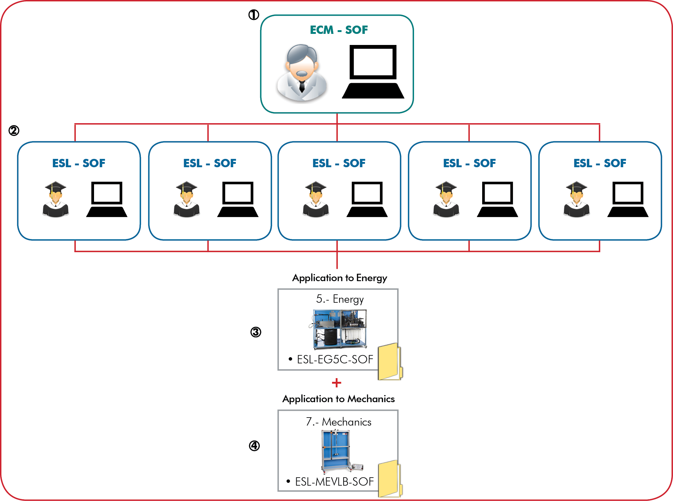

EXAMPLE OF ORDER INFORMATION FOR LABORATORY 1

1 1 ECM-SOF. INSTRUCTOR SOFTWARE. EDIBON Classroom
Manager.

2 5 ESL-SOF. STUDENT SOFTWARE. EDIBON Student Labsoft.
3 1 EDIBON E-Learning content for ESL-EG5C-SOF.

4 1 EDIBON E-Learning content for ESL-MEVLB-SOF.

The Interactive Computer Aided Instruction Software, “ICAI”, in addition to all its features and advantages, allows the use:
a) Through E-learning mode.
b) Through the Distance Learning mode in the use of manual units.
c) Technical Distance Learning, “ECL. EDIBON CLOUD LEARNING”, in the case of the use of an EDIBON unit with SCADA and/or with all EXPANSIONS of each EDIBON SCADA.

CONFIGURATION EXAMPLE

2. Configuration example of two Interactive Computer Aided Instruction Software Laboratories, “ICAI”, with:
• 2 instructors.
• 5 students in each laboratory.

• Different E-Learning contents in both laboratories.
Laboratory 2

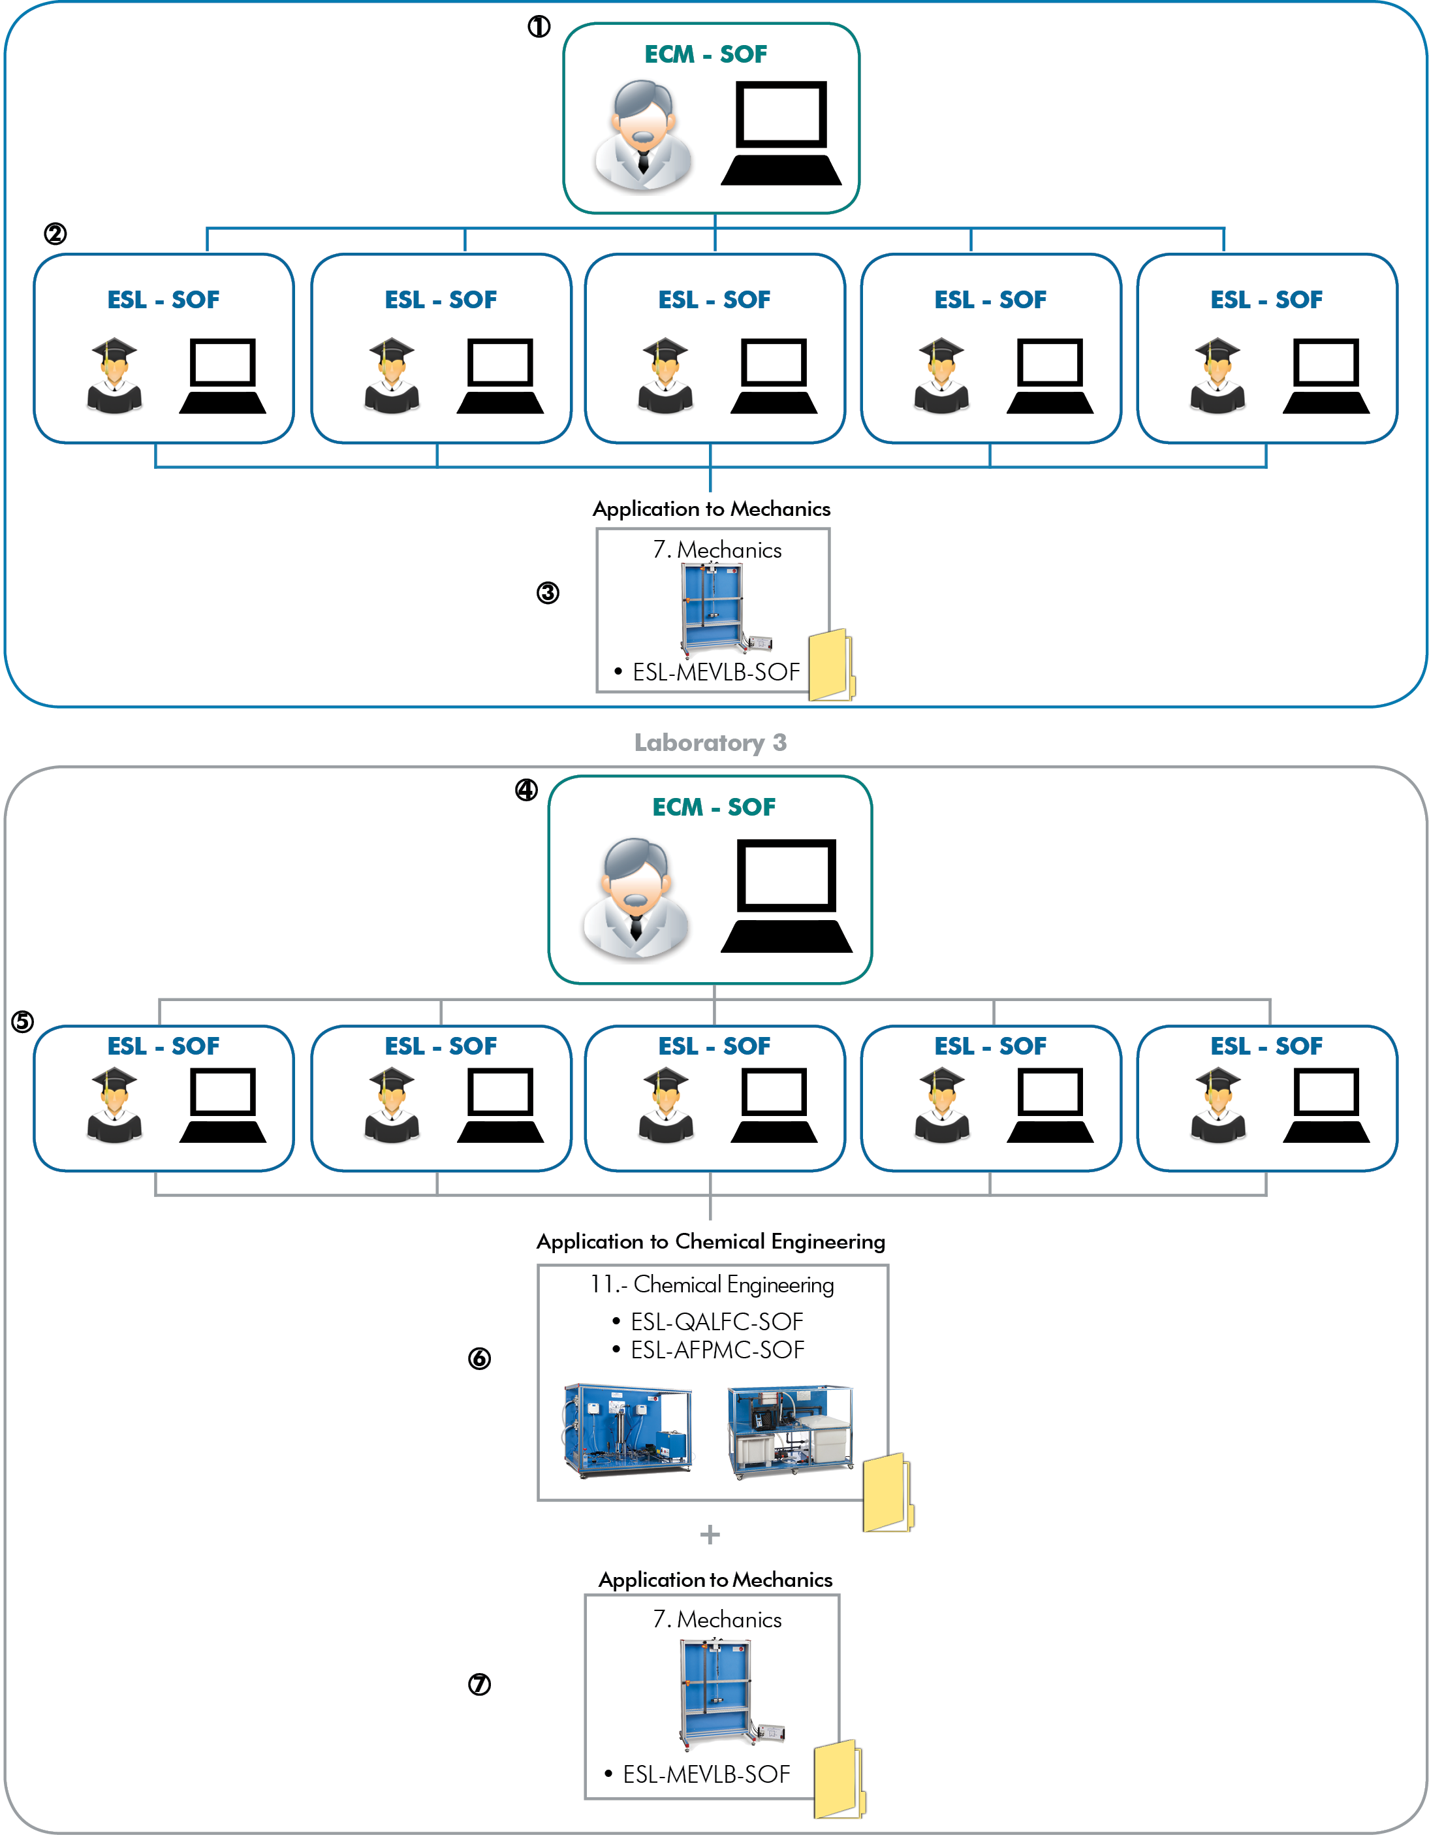

CONFIGURATION EXAMPLE

EXAMPLE OF ORDER INFORMATION FOR LABORATORY 2
AND FOR LABORATORY 3

Laboratory 2

1 1 ECM-SOF. Classroom Manager (Instructor Software).

2 5 ESL-SOF. Student Labsoft (Student Software).

3 1 EDIBON E-Learning content for ESL-MEVLB-SOF.
Laboratory 3

4 1 ECM-SOF. Classroom Manager (Instructor Software).

5 5 ESL-SOF. Student Labsoft (Student Software).

6 1 E-Learning content for ESL-QALFC-SOF.
1 E-Learning content for ESL-AFPMC-SOF.

7 1 E-Learning content for ESL-MEVLB-SOF.

ICAI SCREENS

ECM-SOF. EDIBON CLASSROOM MANAGER (Instructor Software)
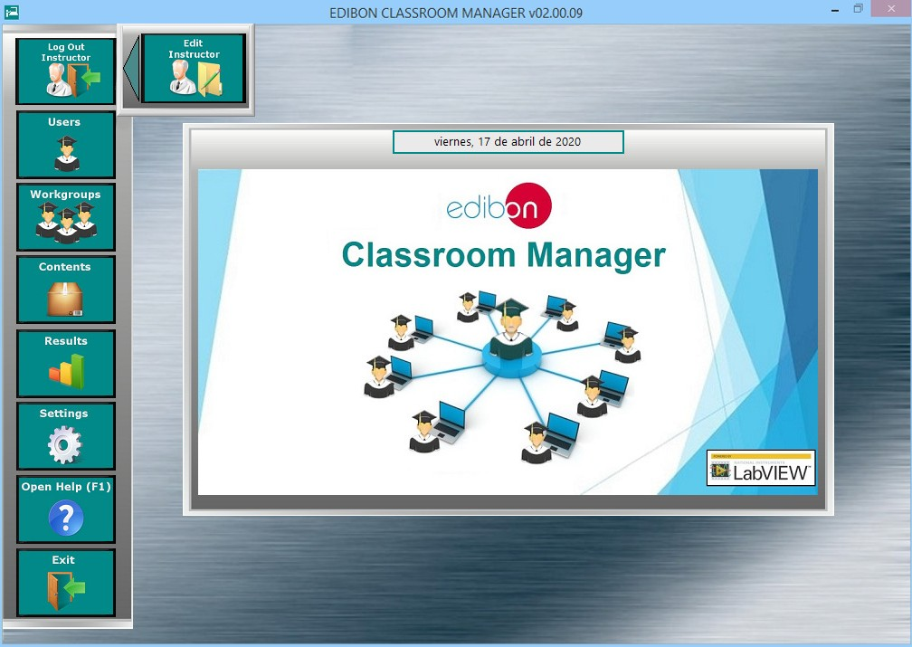

1. ECM-SOF. Classroom Manager (Instructor Software)

1.1. Instructor Program Package. (Go to page 9).

1.2. User Data Base Management. (Go to page 10).

1.3. Administration and assignment of Workgroups, Tasks and Training sessions. (Go to page 11).

1.4. Creation and Integration of Practical Exercises and Multimedia Resources. (Go to page 13).

1.5. Custom Design of Evaluation Methods. (Go to page 15).

1.6. Creation and assignment of Formulas & Equations. (Go to page 17).

1.7. Report generation, User Progression Monitoring and Statistics. (Go to page 19).

1.8. Options & Tools Program Package. (Go to page 24).

1.9. Context Help Program Package. (Go to page 25).

ECM-SOF. EDIBON CLASSROOM MANAGER (Instructor Software)

1.1. Instructor Program Package.

ECM-SOF. EDIBON Classroom Manager Software Application main screen
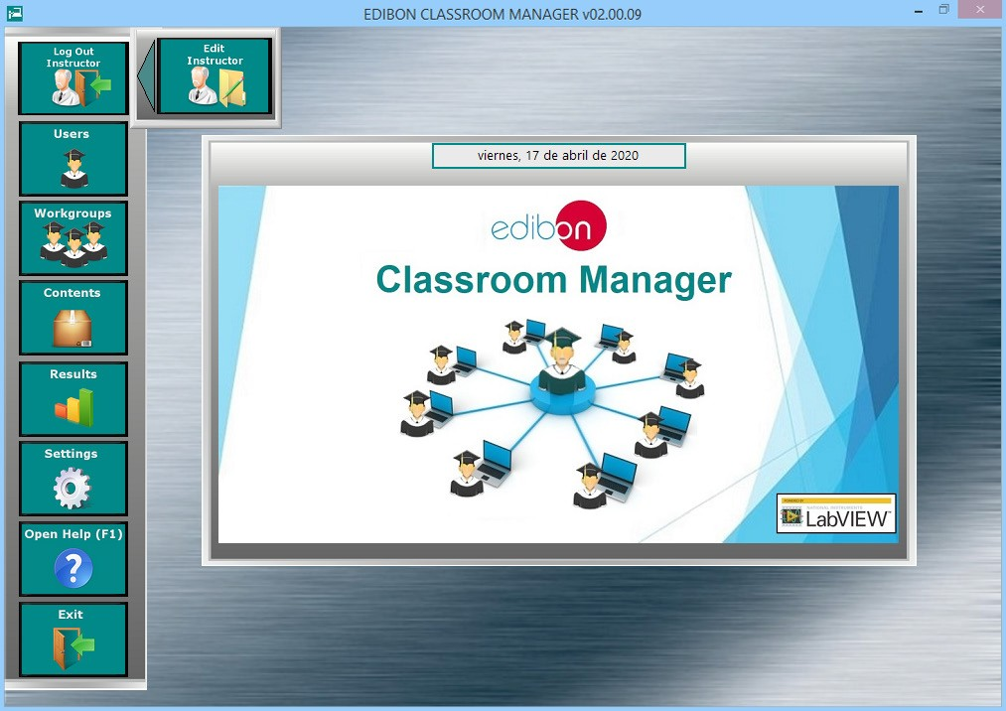

The Instructor Program Package includes the following modules:

1.1.1. Instructor Add, Delete, View and Edit Program Package.

ECM-SOF. EDIBON Classroom Manager Software Application screen
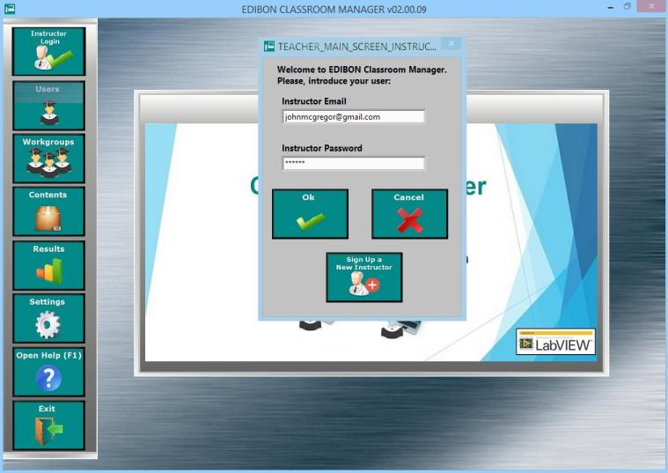

ECM-SOF. EDIBON CLASSROOM MANAGER (Instructor Software)
1.2. User Data Base Management.

ECM-SOF. EDIBON Classroom Manager Software Application main screen
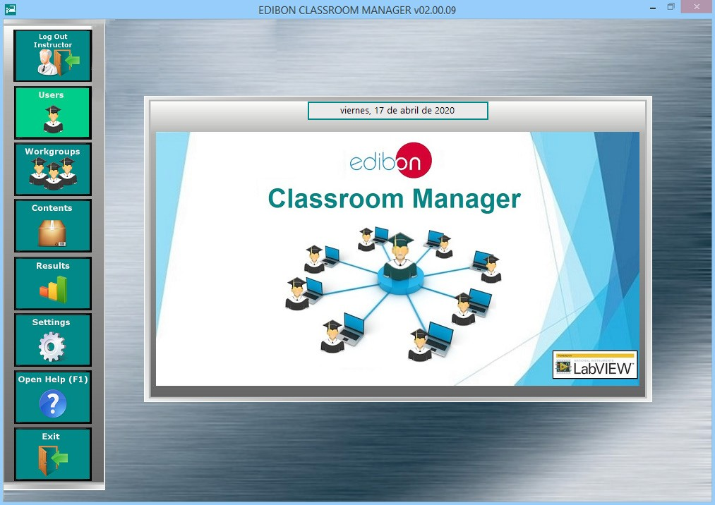

The Users Program Package includes the following modules:

1.2.1. Independent User Data Base. All the information about the registered users is stored here. This Data Base is exclusively managed by the Instructor.
1.2.2. Addition, deletion, viewing and editing of users. These features provide the Instructor total control over the User Data
Base.
1.2.3. User Search Engine, allowing to find a specific student.
1.2.4. User Sort Tool, allowing to organize the students list.
1.2.5. User-Friendly management interface.

USER DATA BASE MANAGEMENT Program Package screen
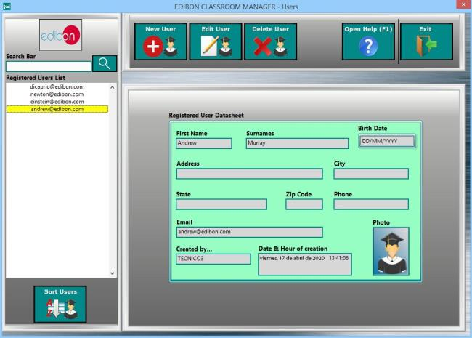

ECM-SOF. EDIBON CLASSROOM MANAGER (Instructor Software)

1.3. Administration and assignment of Workgroups, Tasks and Training sessions.

ECM-SOF. EDIBON Classroom Manager Software Application main screen
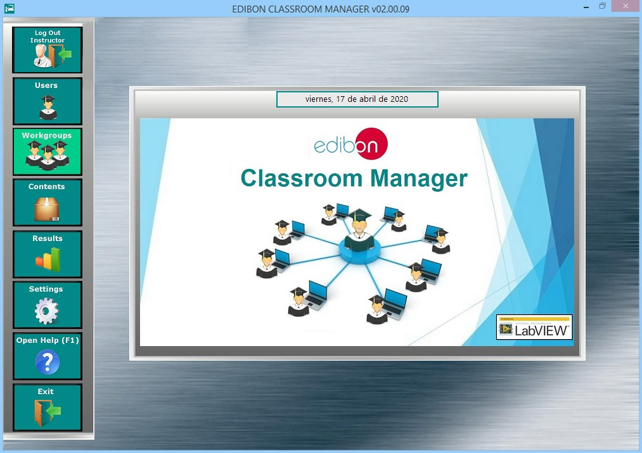

The Administration and assignment of Workgroups, Tasks and Training sessions Package includes the following modules:

1.3.1. Addition, deletion, viewing and editing of user Workgroups. These features provide the Instructor total control over any existing Workgroup.
1.3.2. Default Workgroup with Default planned Tasks to start working from the first day. and pre-configured by EDIBON for each one of your EDIBON Teaching Units.
1.3.3. Task Progression and Status control, presenting the current status of the planned jobs for each individual task in a sum- mary table format.
1.3.4. Printable Report for Workgroups in a summary table format to export the information presented in this software to a pretty similar format.
1.3.5. Workgroups Status Monitoring. As Instructor, you will be up to date about the status of the scheduled jobs for any Work- group and any of its members.
1.3.6. Restore Default settings without needing to the reinstall the software again.

ADMINISTRATION AND ASSIGNMENT OF WORKGROUPS, TASKS AND TRAINING SESSIONS Program Package - Main Screen
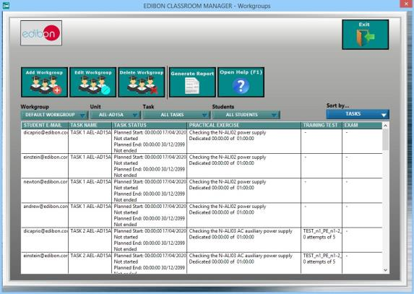

ECM-SOF. EDIBON CLASSROOM MANAGER (Instructor Software)

1.3. Administration and assignment of Workgroups, Tasks and Training sessions. (continuation)
1.3.7. Two kind of Access to a Workgroup:
a) Limited: Only the Instructor determines which users can access. b) Open: Every registered user will be able to access.
1.3.8. Assignment of Units and users to each Workgroup allowing to work with one or more specific Units.
1.3.9. Multi-User for each Unit and Multi-Unit for each user. Consequently, several users can work with a specific Unit as well as any user.

ADMINISTRATION AND ASSIGNMENT OF WORKGROUPS, TASKS AND TRAINING SESSIONS Program Package - Users & Units Assignment Screen

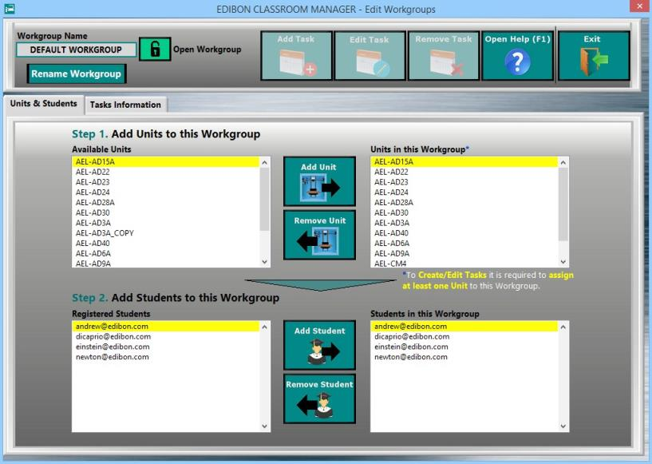

1.3.10. Assignment of an unlimited number of Tasks to work with each one of the Units assigned to any Workgroup.
1.3.11. Multi-Contents for each Task to understand the main concepts inherent to each Unit.
1.3.12. Time Control and maximum number of attempts for each job scheduled for each task.

ADMINISTRATION AND ASSIGNMENT OF WORKGROUPS, TASKS AND TRAINING SESSIONS Program Package - Tasks Assignment Screen
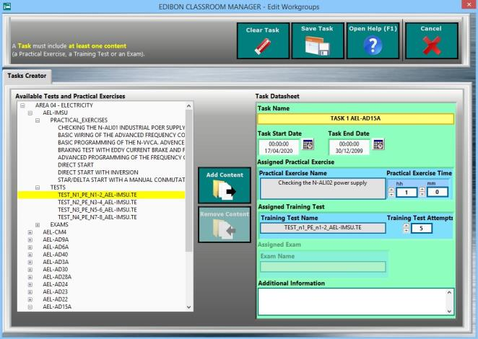

ECM-SOF. EDIBON CLASSROOM MANAGER (Instructor Software)

1.4. Creation and Integration of Practical Exercises and Multimedia Resources.

ECM-SOF. EDIBON Classroom Manager Software Application main screen
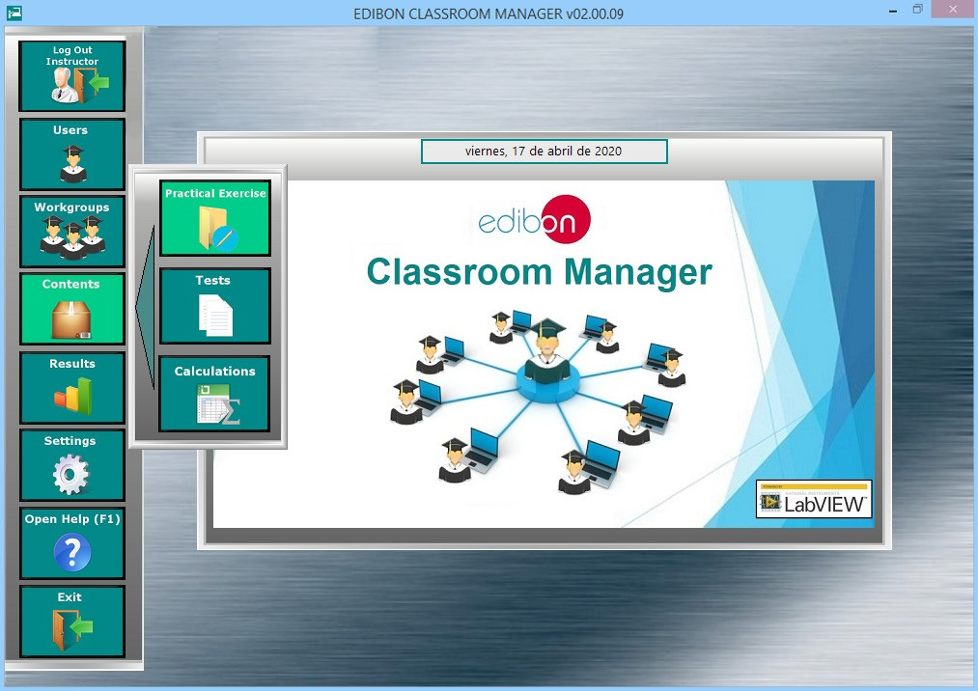

1.4. The Creation and Integration of Practical Exercises and Multimedia Resources Package includes the following modules:

1.4.1. Addition, deletion, viewing and editing of Practical Exercises. These features provide the Instructor total control to configure any
Practical Exercise.
1.4.2. Practical Exercises Sections & Contents Index, providing an overview of the number of Practical Exercises to perform with each Unit.
1.4.3. A complete set of Practical Exercises with default Multimedia Resources (Audios, Videos, Animations, Pictures...) are provided by EDIBON for each one of your Units.

CREATION AND INTEGRATION OF PRACTICAL EXERCISES AND MULTIMEDIA RESOURCES Program Package – Sections & Contents Index Screen
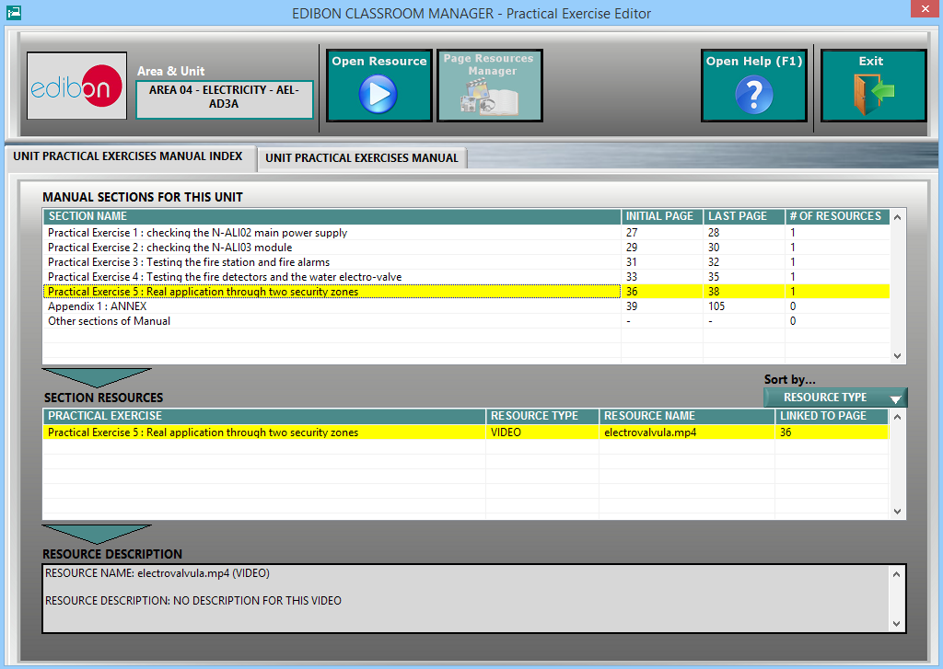

ECM-SOF. EDIBON CLASSROOM MANAGER (Instructor Software)

1.4. Creation and Integration of Practical Exercises and Multimedia Resources. (continuation)

1.4.4. PDF format for Practical Exercises Manual.
1.4.5. Practical Exercises Manual Navigation Tools allowing to move faster through the manual as well as to focus on some specific sections of it.

CREATION AND INTEGRATION OF PRACTICAL EXERCISES AND MULTIMEDIA RESOURCES Program Package – PDF Manual Screen

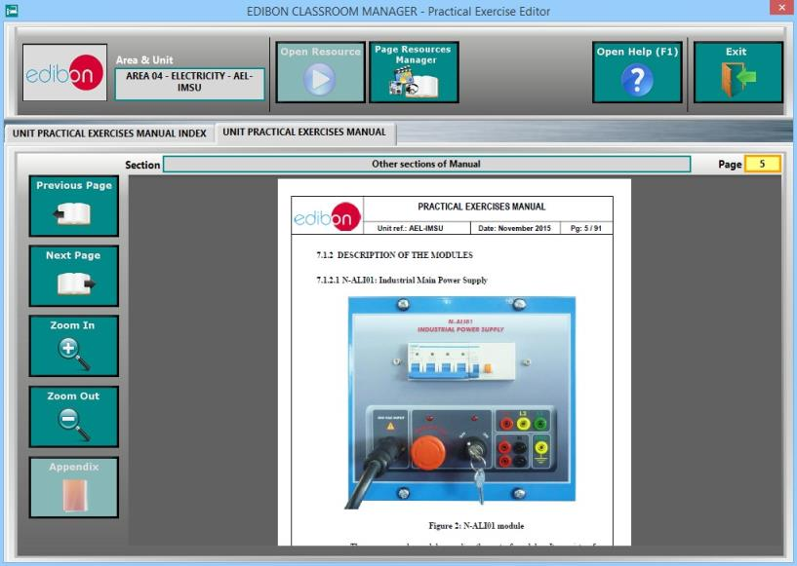

1.4.6. Practical Exercise Multimedia Resources Management allowing managing your own Multimedia Resources, attached to the
Practical Exercises Manual.

CREATION AND INTEGRATION OF PRACTICAL EXERCISES AND MULTIMEDIA RESOURCES Program Package – Multimedia Resources Management Screen
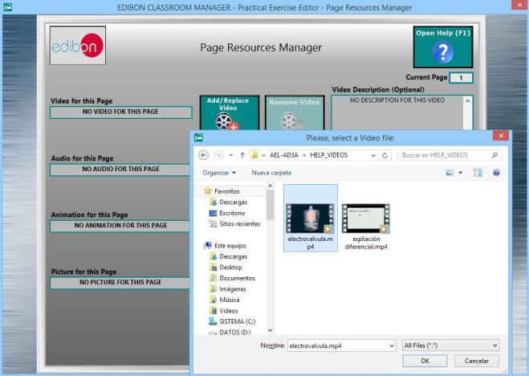

ECM-SOF. EDIBON CLASSROOM MANAGER (Instructor Software)

1.5. Custom Design of Evaluation Methods.

ECM-SOF. EDIBON Classroom Manager Software Application main screen
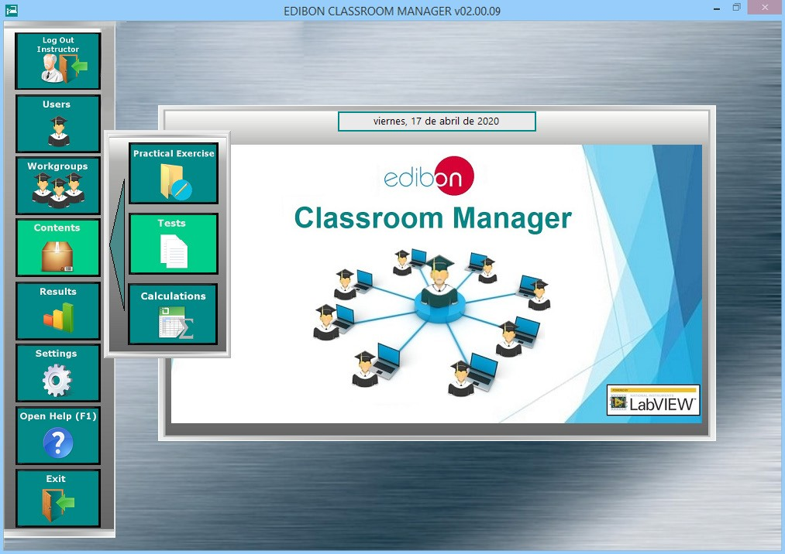

The Custom Design of Evaluation Methods Program Package includes the following modules:

1.5.1. Addition, Deletion, Viewing and Editing of Training Tests and Exams. These features provide the Instructor total control to configure any Training Test and Exam.
1.5.2. Test Errors & Warnings Checker, providing additional help and tips during the Test creation/edition process.
1.5.3. Multi-Choice and Numeric Result Questions, aided by Multimedia Resources to evaluate the knowledge acquired by the users in a more versatile way.

CUSTOM DESIGN OF EVALUATION METHODS Program Package – Main Screen with Multi-Choice Question
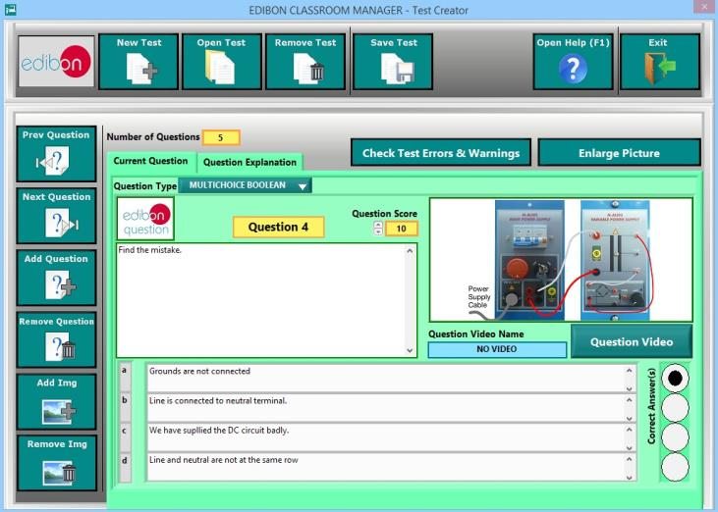

ECM-SOF. EDIBON CLASSROOM MANAGER (Instructor Software)

1.5. Custom Design of Evaluation Methods (continuation)

1.5.4. Multimedia Resources Management. Attach your own Pictures and Videos to each individual Question as well as to its
explanation.

CUSTOM DESIGN OF EVALUATION METHODS Program Package – Main Screen: Multimedia Resources edition

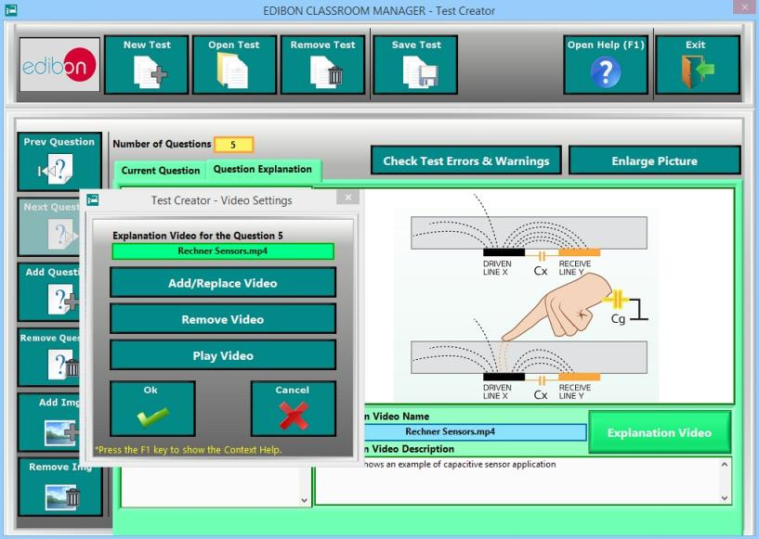

CUSTOM DESIGN OF EVALUATION METHODS Program Package – Question Explanation Video

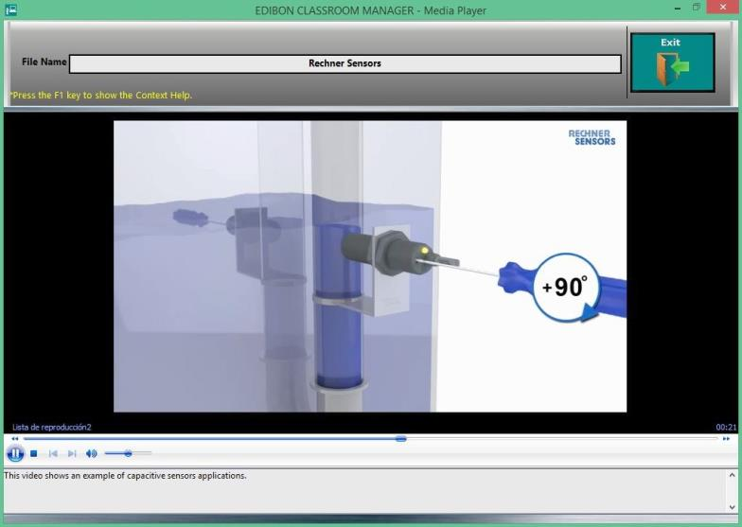

ECM-SOF. EDIBON CLASSROOM MANAGER (Instructor Software)

1.6. Creation and assignment of Formulas & Equations.

ECM-SOF. EDIBON Classroom Manager Software Application main screen
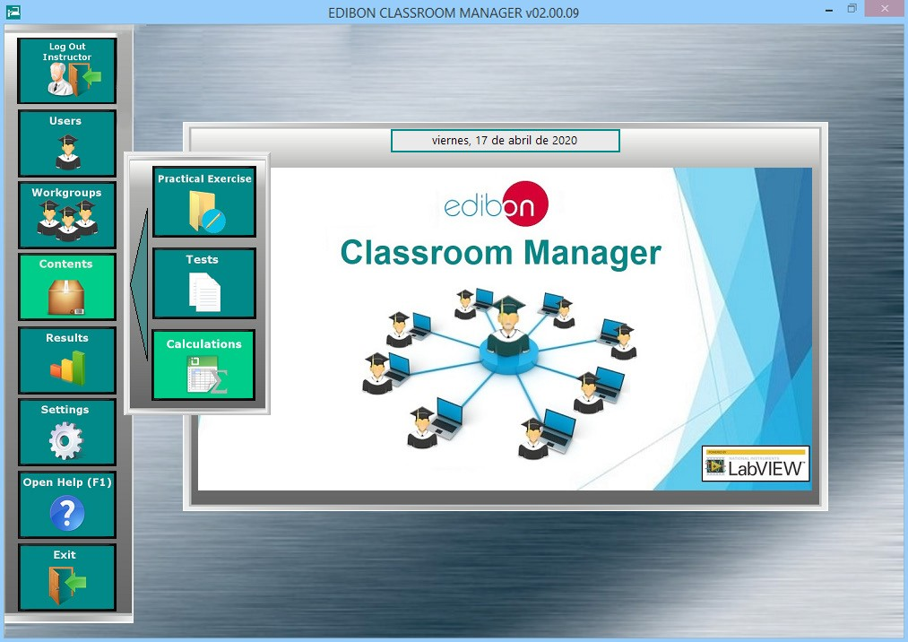

The Creation and assignment of Formulas & Equations Program Package includes the following software package:

1.6.1. Formula Creator Program Package.
The Formula Creator Program Package includes the following modules:
1.6.1.1. Formula Viewer. All formulas of all units can be displayed, edited, copied to another unit and removed.
1.6.1.2. Several expressions linked to the Practical Exercises of the different Units.

CREATION AND ASSIGNMENT OF FORMULAS & EQUATIONS Program Package - Formula Viewer screen
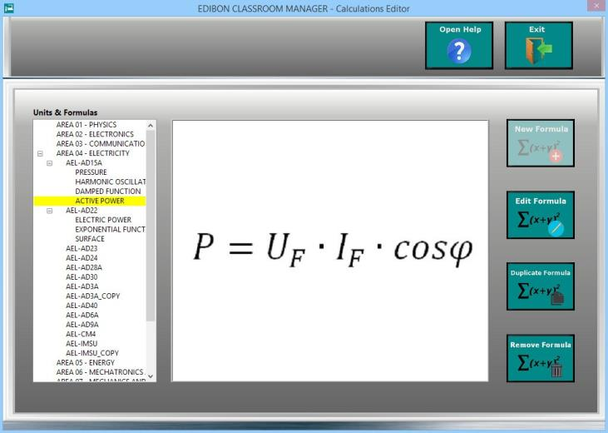

ECM-SOF. EDIBON CLASSROOM MANAGER (Instructor Software)

1.6. Creation and assignment of Formulas & Equations (continuation)

1.6.1. Formula Creator Program Package (continuation)
1.6.1.3. Formula Editor for Practical Exercise of the different Units. This feature allows to create new formulas and to edit the existing ones.
1.6.1.4. Unit and Parameter Viewer to add/edit/remove all the parameters (variables & constants) of a formula.

CREATION AND ASSIGNMENT OF FORMULAS & EQUATIONS Program Package - Formula Editor screen (I)

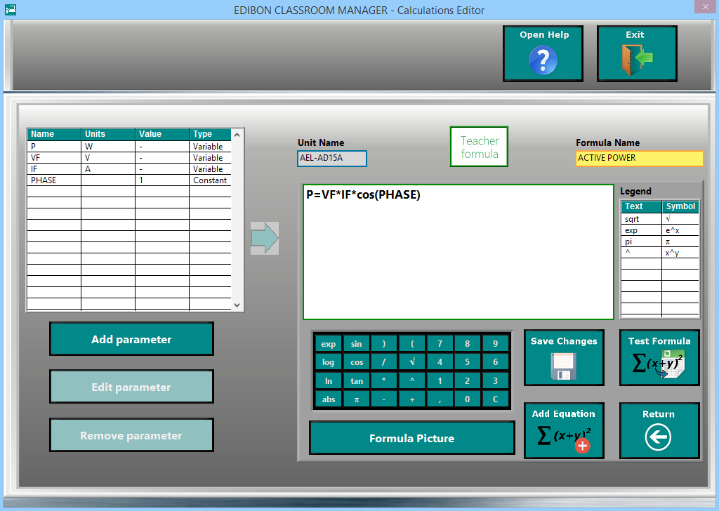

1.6.1.5. Formula Preview.
1.6.1.6. Formula Tester. Every Formula can be tested by using the Spreadsheet & Formulas Package.
1.6.1.7. Auxiliary Formula Picture automatically generated by the software or manually added by the Instructor.

CREATION AND ASSIGNMENT OF FORMULAS & EQUATIONS Program Package- Formula Editor screen (II)
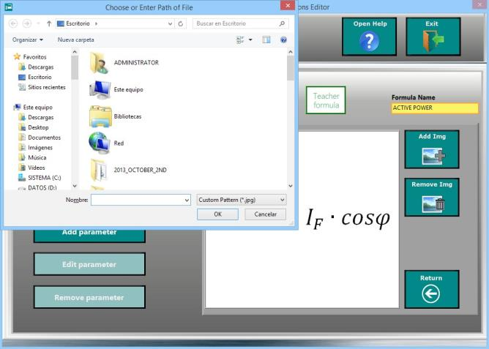

ECM-SOF. EDIBON CLASSROOM MANAGER (Instructor Software)

1.7. Report generation, User Progression Monitoring and Statictics.

ECM-SOF. EDIBON Classroom Manager Software Application main screen
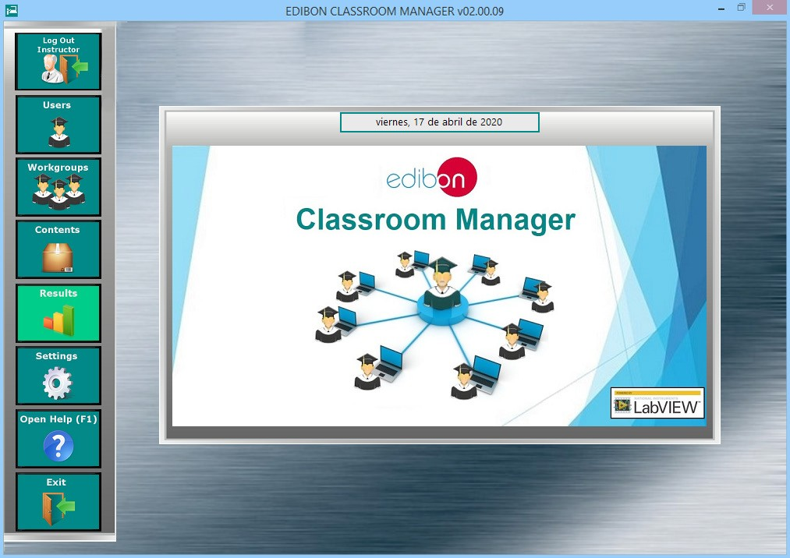

The Report generation, User Progression Monitoring and Statictics Package includes the following software package:

1.7.1. Reports & Results Management Program Package.
The Reports & Results Management Program Package includes the following modules:
1.7.1.1. Detailed Result sorted by Workgroups, by Work-Units, by Tasks and by Users. These results are presented in a sum- mary table format.
1.7.1.2. Viewing and deletion of specific Results. The Instructor is able to open a specific result to view it into detail as well as to remove the ones he/she considers.

REPORT GENERATION, USER PROGRESSION MONITORING AND STATICTICS Program Package - Main Screen
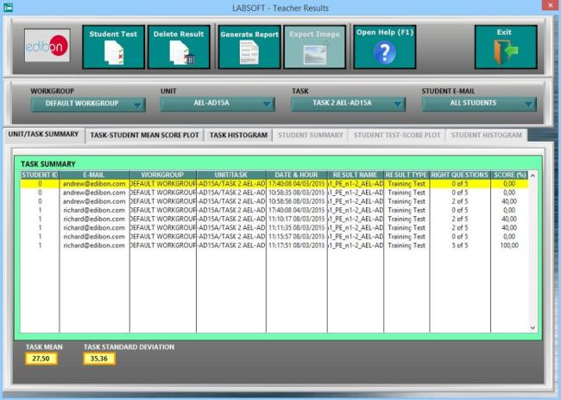

ECM-SOF. EDIBON CLASSROOM MANAGER (Instructor Software)

1.7. Report generation, User Progression Monitoring and Statictics (continuation).

1.7.1. Reports & Results Management Program Package (continuation).

1.7.1.3. Result Statistics: Some statistics such as Mean Scores and Standard Deviations as well as representations such as
Histograms are shown.

REPORTS & RESULTS MANAGEMENT Program Package - Result Statistics (I)
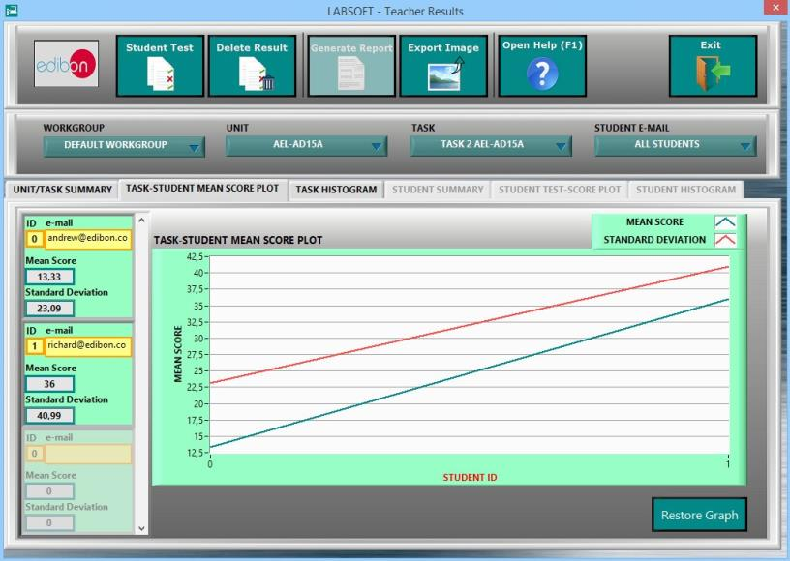

REPORTS & RESULTS MANAGEMENT Program Package - Result Statistics (II)

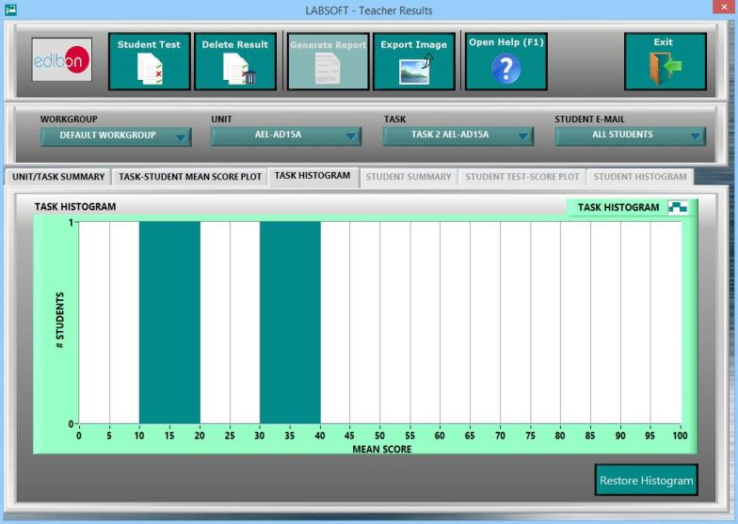

ECM-SOF. EDIBON CLASSROOM MANAGER (Instructor Software)

1.7. Report generation, User Progression Monitoring and Statictics (continuation).

1.7.1. Reports & Results Management Program Package (continuation).
1.7.1.4. Detailed User Progression: Spreadsheet, Graphics & Text.

REPORTS & RESULTS MANAGEMENT Program Package - Student Scores Progression

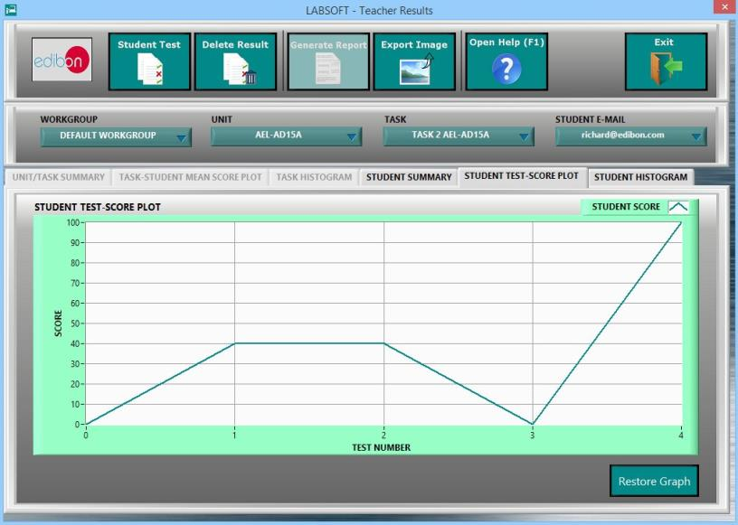

REPORTS & RESULTS MANAGEMENT Program Package - Student Scores Histogram

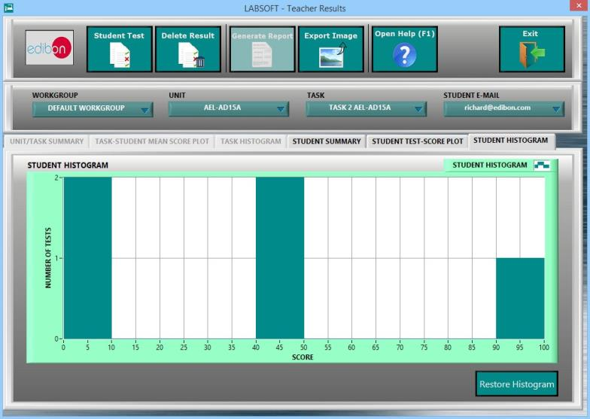

ECM-SOF. EDIBON CLASSROOM MANAGER (Instructor Software)

1.7. Report generation, User Progression Monitoring and Statictics (continuation).

1.7.1. Reports & Results Management Program Package (continuation).

1.7.1.5. Detailed Test Results: Specific results can be opened to generate a detailed view of the Questions with the chosen
answers in contrast with the correct answers, the obtained marks and Explanations for each individual question.

REPORTS & RESULTS MANAGEMENT Program Package - Detailed Test Result (I): Answers & Marks

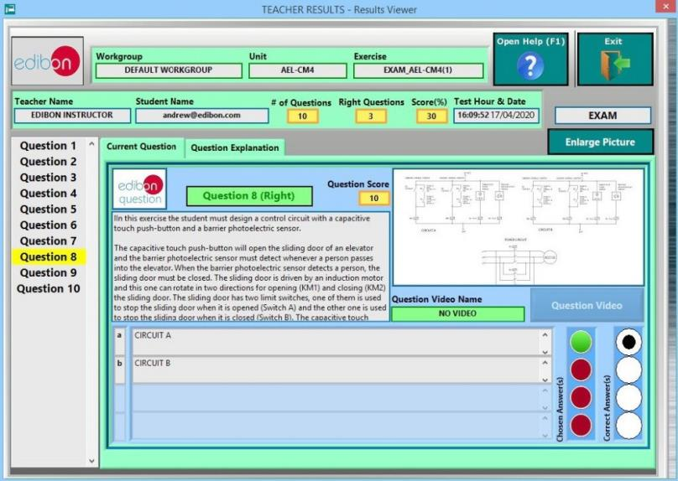

REPORTS & RESULTS MANAGEMENT Program Package - Detailed Test Result (II): Answers & Marks

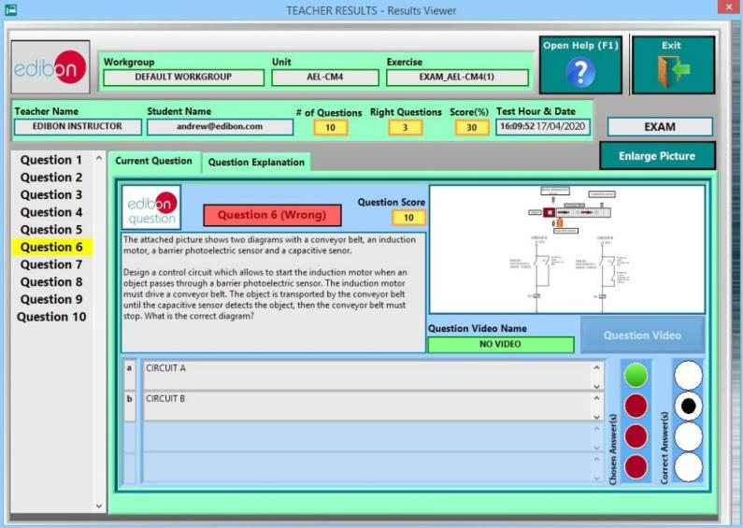

ECM-SOF. EDIBON CLASSROOM MANAGER (Instructor Software)
1.7. Report generation, User Progression Monitoring and Statictics (continuation).
1.7.1. Reports & Results Management Program Package (continuation)
1.7.1.5. Detailed Test Results (continuation)

REPORTS & RESULTS MANAGEMENT Program Package - Detailed Test Result (III): Question Explanation
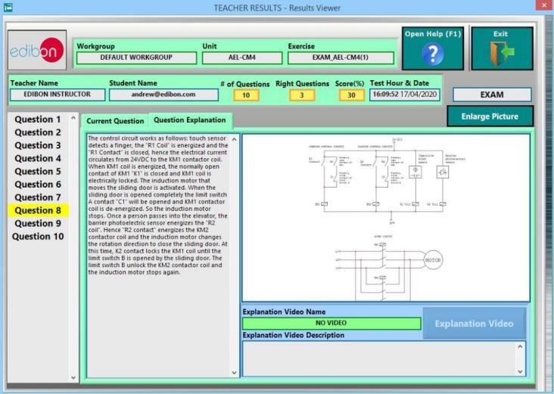

1.7.1.6. Printable Reports allowing to display summary tables graphs and that can be exported to HTML formatted tables and
JPEG Images.

REPORTS & RESULTS MANAGEMENT Program Package - Printable Reports (I): HTML
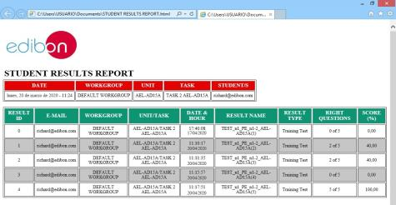

REPORTS & RESULTS MANAGEMENT Program Package - Printable Reports (II): JPEG Picture
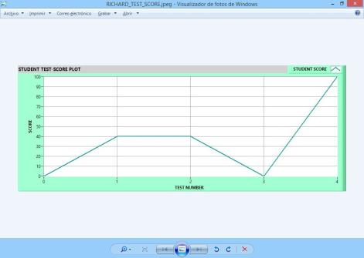

ECM-SOF. EDIBON CLASSROOM MANAGER (Instructor Software)

1.8. Options & Tools Program Package

ECM-SOF. EDIBON Classroom Manager Software Application main screen
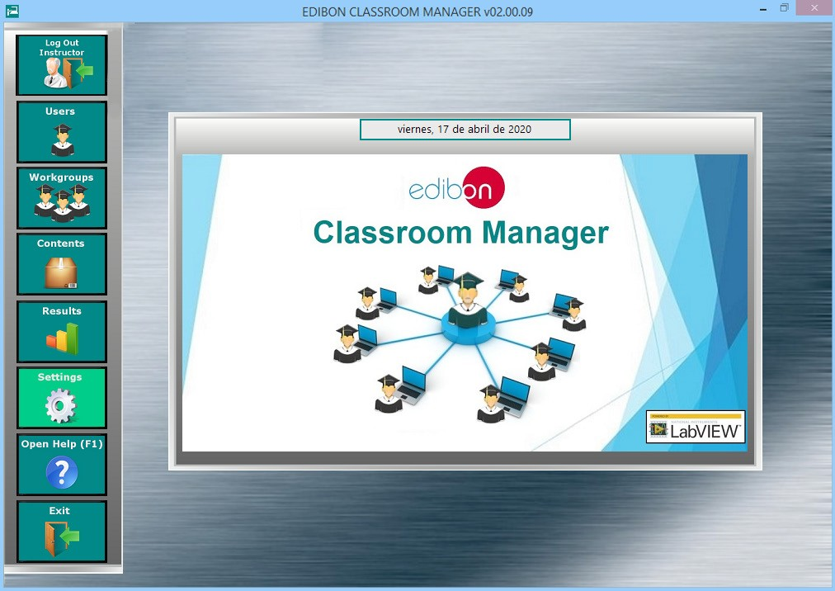

The Options & Tools Program Package includes the following modules:

1.8.1. Easy and Secure Connection between Manager and Users in a quick, easy and reliable way.
1.8.2. Self-Registration for users. The instructor can enable/disable this feature, which allows the students to register by themselves in the User Data Base.
1.8.3. Data Base Backups, to keep a copy of the Workgroups Data Base factory and last session status.
1.8.4. Restore Default Settings, to reset the Workgroups Data Base to its factory status without needing to reinstall the software again.

OPTIONS & TOOLS Program Package screen

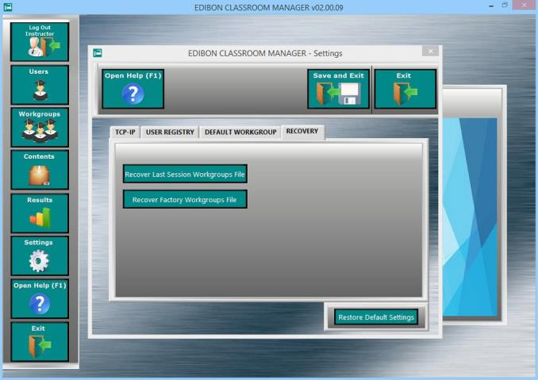

ECM-SOF. EDIBON CLASSROOM MANAGER (Instructor Software)

1.9. Context Help Program Package

CONTEXT HELP Program Package - EDIBON Classroom Manager Software Application main screen
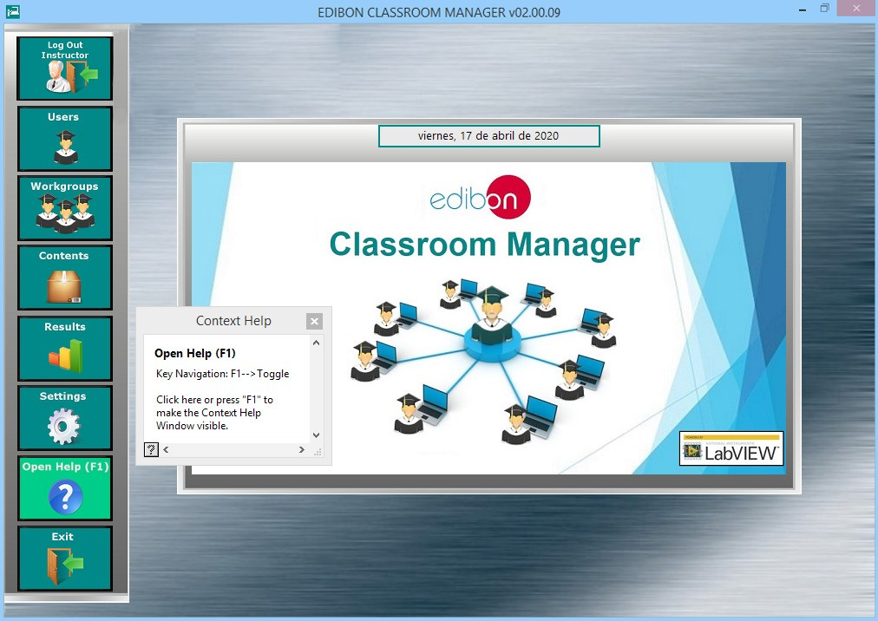

The Context Help Program Package includes the following modules:

1.9.1. Floating Window for the Context Help. This window displays short explanations of the functionalities that any control or indicator can perform.
1.9.2. Enable and Disable Help. You can activate/desactivate the Context Help window at any moment.
1.9.3. Available anytime and anywhere.

CONTEXT HELP Program Package screen
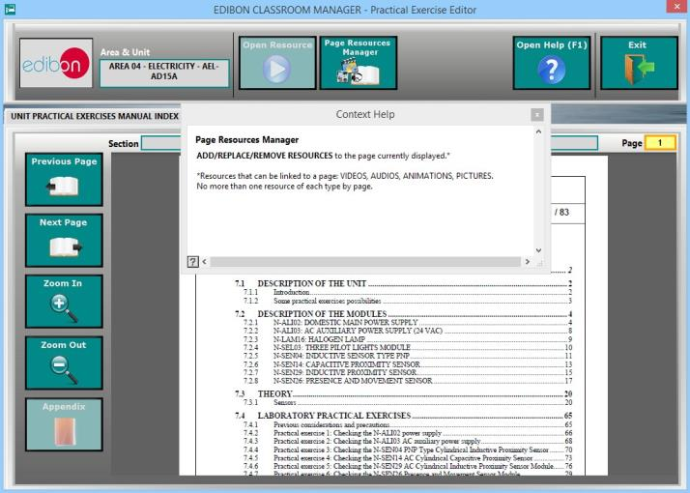

ESL-SOF. EDIBON STUDENT LABSOFT (Student Software)

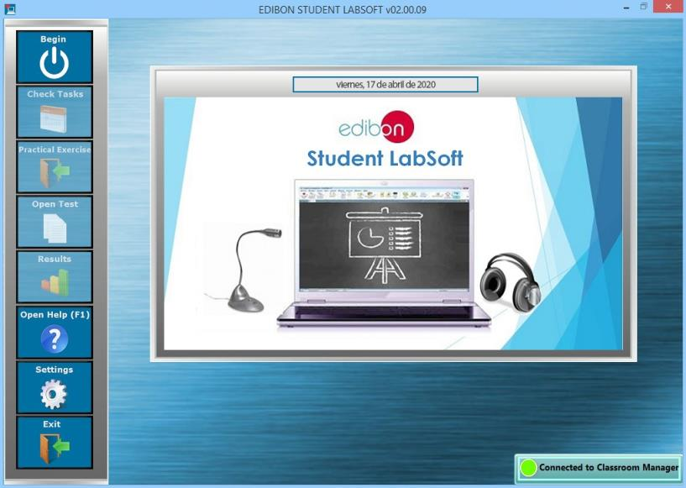

ESL-SOF. EDIBON student labsoft includes the following program packages:

2.1. Student Log-In &Self-Registration. (Go to page 27).

2.2. Existing Tasks checking & monitoring. (Go to page 28).

2.3. Practical Exercises accomplishment by following the Manual provided by EDIBON. (Go to page 29).

2.4. Evaluation Methods to prove the student’s knowledge and progression. (Go to page 31).

2.5. Calculations computing and plotting. (Go to page 33).

2.6. Student results monitoring. (Go to page 34).

2.7. Options and Tools Program Packages. (Go to page 38).

2.8. Context Help Program Package. (Go to page 39).

2.9. Operating Modes: LOCAL and LAN Program Package. (Go to page 40).

ESL-SOF. EDIBON STUDENT LABSOFT (Student Software)

2.1. Student Log-In & Self Registration.
ESL-SOF. EDIBON Student LabSoft Software Application main screen
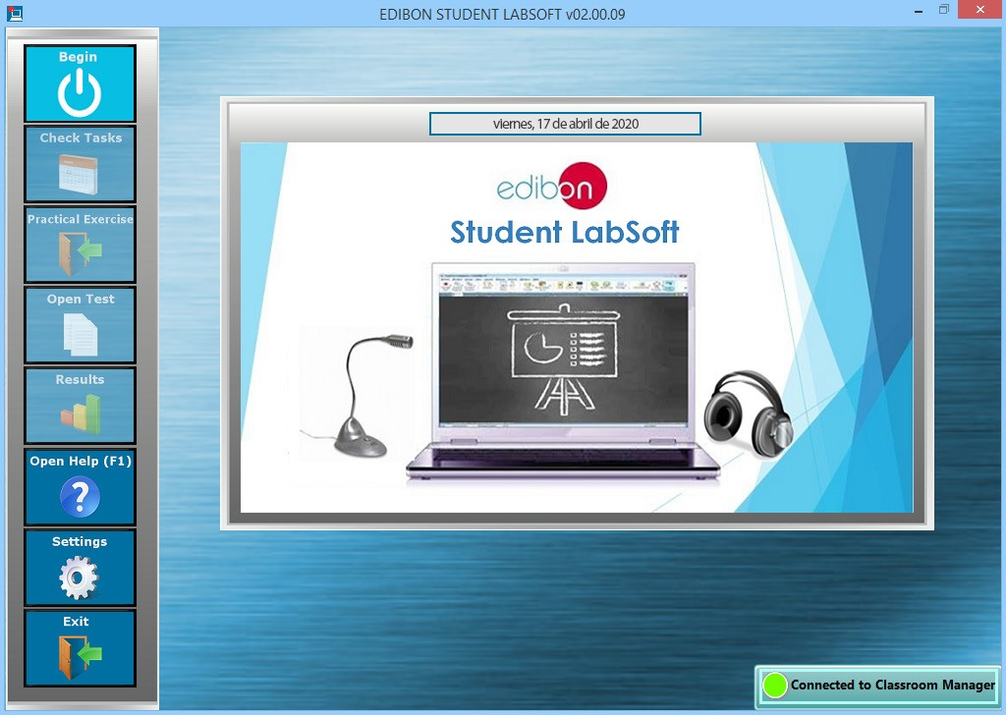

The Student Log-In & Self Registration Packages includes the following modules:

2.1.1. User Self Logging for Multiple Users. One or more users can log themselves at the same time and in the same computer, allowing them to work individually or in groups.

Student Log-In & Self Registration Package - User Log screen
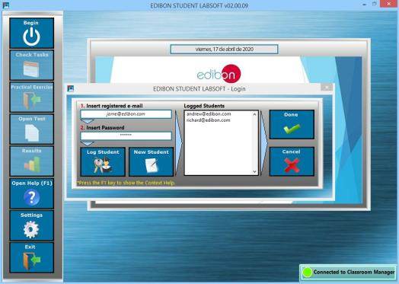

2.1.2. User Self Register. One or more users can register their own user in the same computer.

Student Log-In & Self Registration Package - User Registry screen
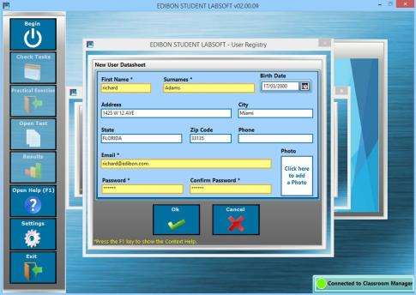

ESL-SOF. EDIBON STUDENT LABSOFT (Student Software)

2.2. Existing Tasks checking & monitoring.

ESL-SOF. EDIBON Training Software Application main screen
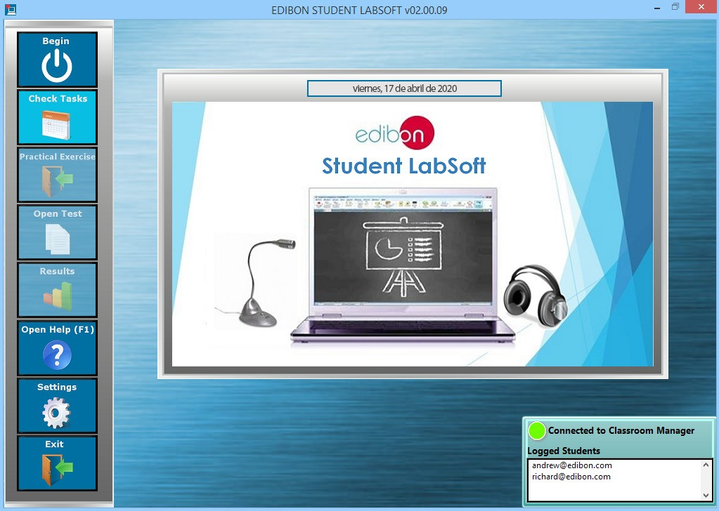

The Existing Tasks checking & monitoring Package includes the following modules:
2.2.1. Scheduled Tasks Selection, with specific information about the contents of each individual task, for each Workgroup and Unit,
in a summary table format.
2.2.2. Multi-User Scheduled Task Progression Status, in a summary table format. This second table allowing to gather the
state of realization of the jobs assigned to a specific task for each logged user.

EXISTING TASKS CHECKING & MONITORING Program Package - Scheduled Tasks screen
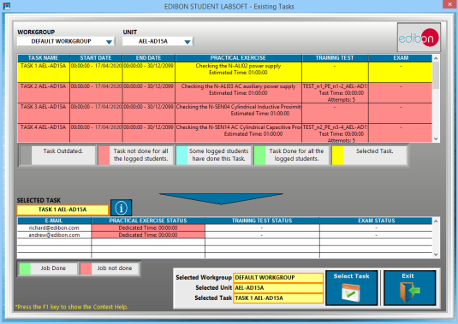

2.2.3. User Current Task Status Indicator allows to displays the state of realization of the selected task for each logged user and is available during the whole session.

EXISTING TASKS CHECKING & MONITORING Program Package – Task Status Indicator, integrated in the ESL-SOF Application main screen
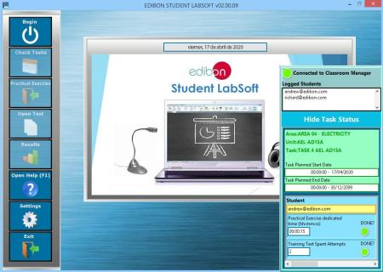

ESL-SOF. EDIBON STUDENT LABSOFT (Student Software)

2.3. Practical Exercises accomplishment by following the Manual provided by EDIBON.

ESL-SOF. EDIBON Student LabSoft Software Application main screen
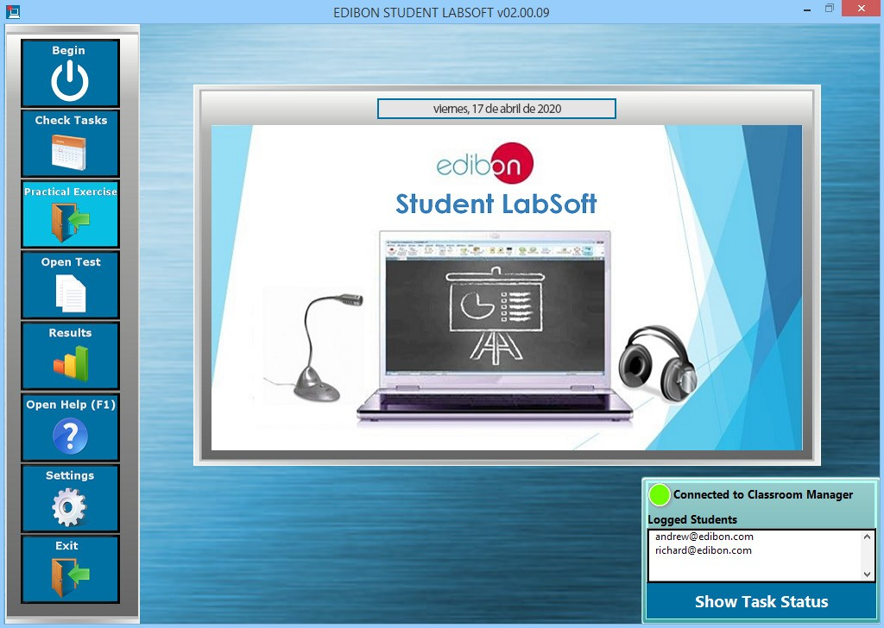

The Practical Exercises accomplishment by following the Manual Provided by EDIBON Program Package includes the following modules:
2.3.1. Practical Exercises Manual in PDF Format.
2.3.2. Practical Exercises Manual Navigation Tools to move faster through the manual as well as to focus on some specific sections of it.
2.3.3. Windows basic tools shortcuts are included in this software interface: Notepad, Calculator and Web Browser.

PRACTICAL EXERCISES Program Package main screen
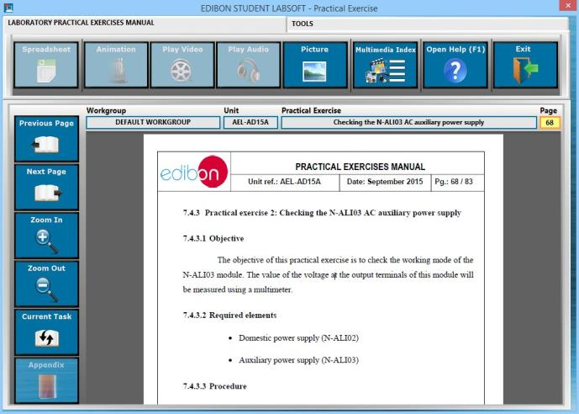

ESL-SOF. EDIBON STUDENT LABSOFT (Student Software)

2.3. Practical Exercises accomplishment by following the Manual provided by EDIBON. (continuation)

2.3.4. Updatable Multimedia Resources. Every resource added/replaced/removed by the Instructor using EDIBON ClassroomManager will be downloaded once the connection is set.
2.3.5. Multimedia Resources Index: This section presents a compilation of all the Multimedia Resources (Audio, Videos,
Animations and Pictures) which are available for each one of the sections of the Practical Exercises Manual.

PRACTICAL EXERCISES Program Package – Multimedia Resources Index

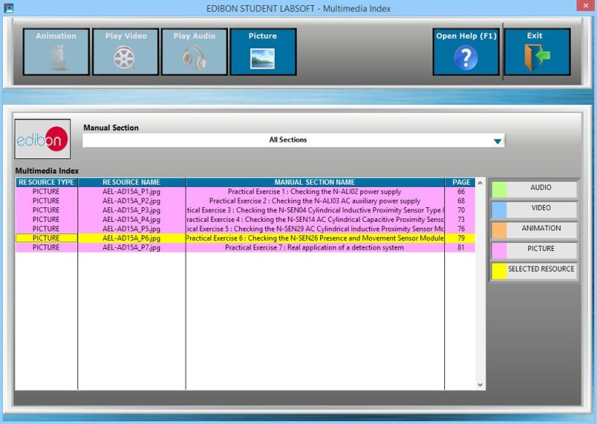

PRACTICAL EXERCISES Program Package – Picture Viewer

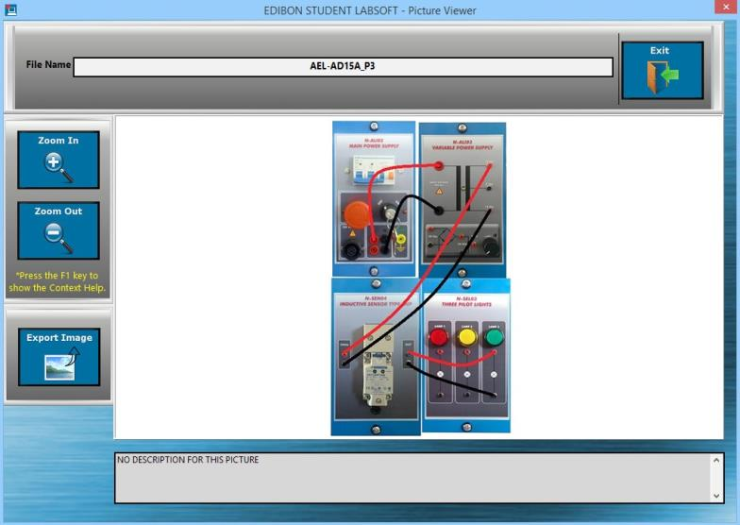

ESL-SOF. EDIBON STUDENT LABSOFT (Student Software)

2.4. Evaluation Methods to prove the student’s knowledge and progression.

ESL-SOF. EDIBON Student LabSoft Software Application main screen
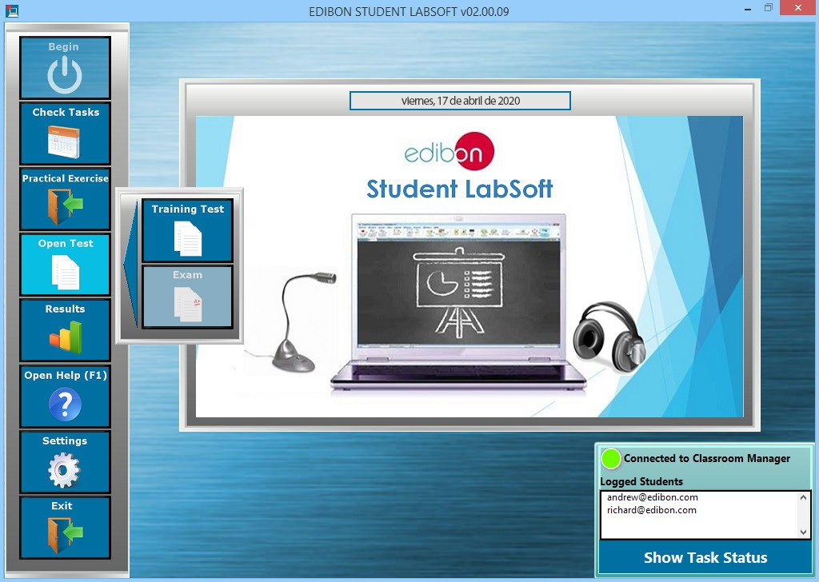

The Evaluation Methods Program Package includes the following modules:
2.4.1. Two different Evaluation Methods: Training Test & Exam:
a) Training test: can be performed several times. They are intended to revise the main concepts shown in the Practical Exercises. b) Test: can only be done once.
2.4.2. Multi-Choice and Numeric Result Questions, aided by Multimedia Resources to evaluate the knowledge acquired by the users in a more versatile way.
2.4.3. Updatable Contents. Every content added/replaced/removed by the Instructor using EDIBON Classroom Manager will be
downloaded once the connection is set.

EVALUATION METHODS Program Package - Multi-Choice Question for a Training Test
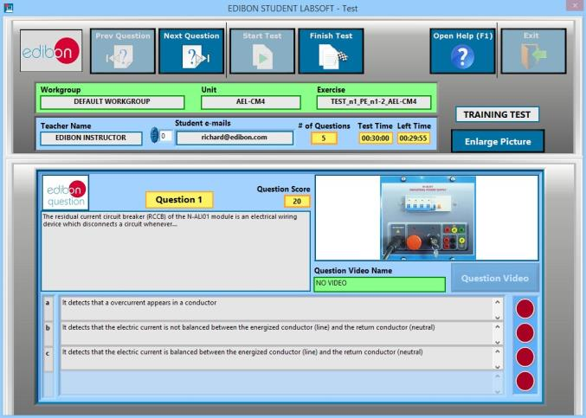

ESL-SOF. EDIBON STUDENT LABSOFT (Student Software)

2.4. Evaluation Methods to prove the student’s knowledge and progression. (continuation)

EVALUATION METHODS Program Package – Numeric Result Question for an Exam

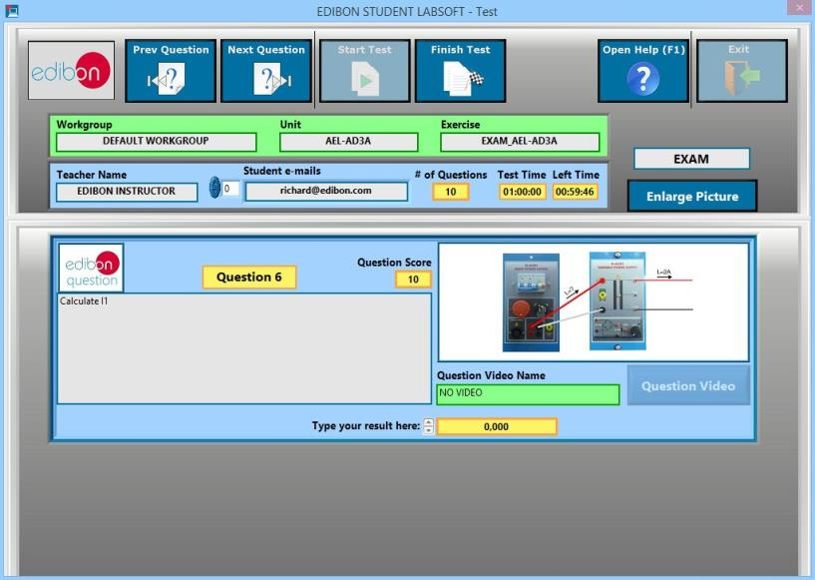

TRAINING TEST & EXAM Program Package – Picture Viewer: Enlarged Question Picture

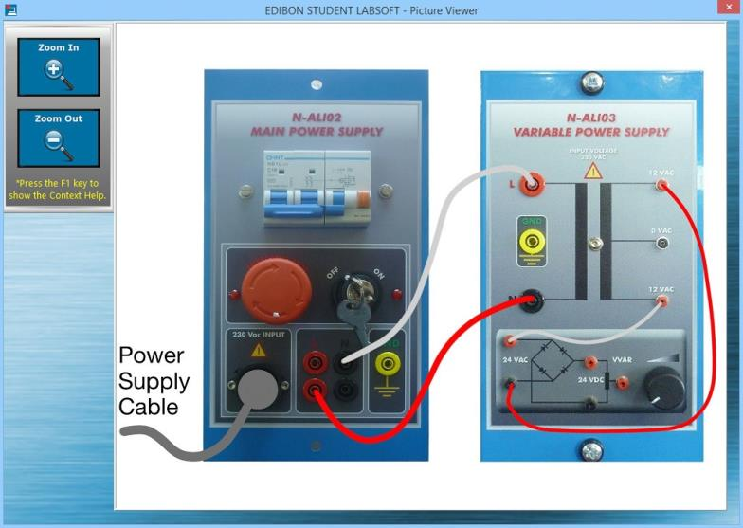

ESL-SOF. EDIBON STUDENT LABSOFT (Student Software)

2.5. Calculations computing and plotting

The Calculations computing and plotting Program Package includes the following software package:

2.5.1. Spreadsheet & Formulas Program Package.

The Spreadsheet & Formulas Program Package includes the following modules:

2.5.1.1. Formula Viewer. All the formulas of a specific unit are displayed and calculations can be done by users.

2.5.1.2. Spreadsheet for Input and Output variables taken from the Expressions and Formulas. Output variables values will be generated each time all the input variables values be introduced.
2.5.1.3. Calculation Records for further evaluations. The user can keep the introduced values even after exiting this pro-

gram package, avoiding losing them.

SPREADSHEET & FORMULAS Program Package main screen

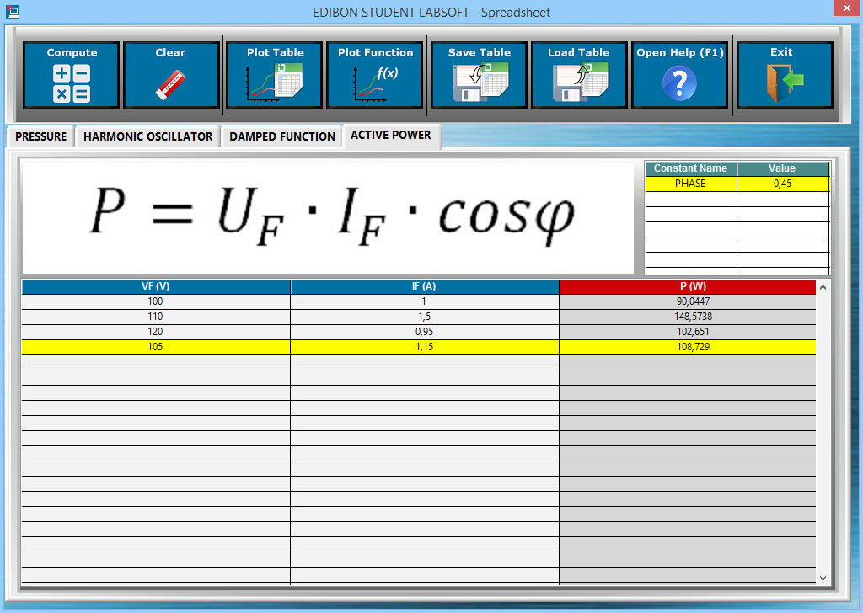

ESL-SOF. EDIBON STUDENT LABSOFT (Student Software)

2.6. Student results monitoring

ESL-SOF. EDIBON Student Labsoft Software Application main screen
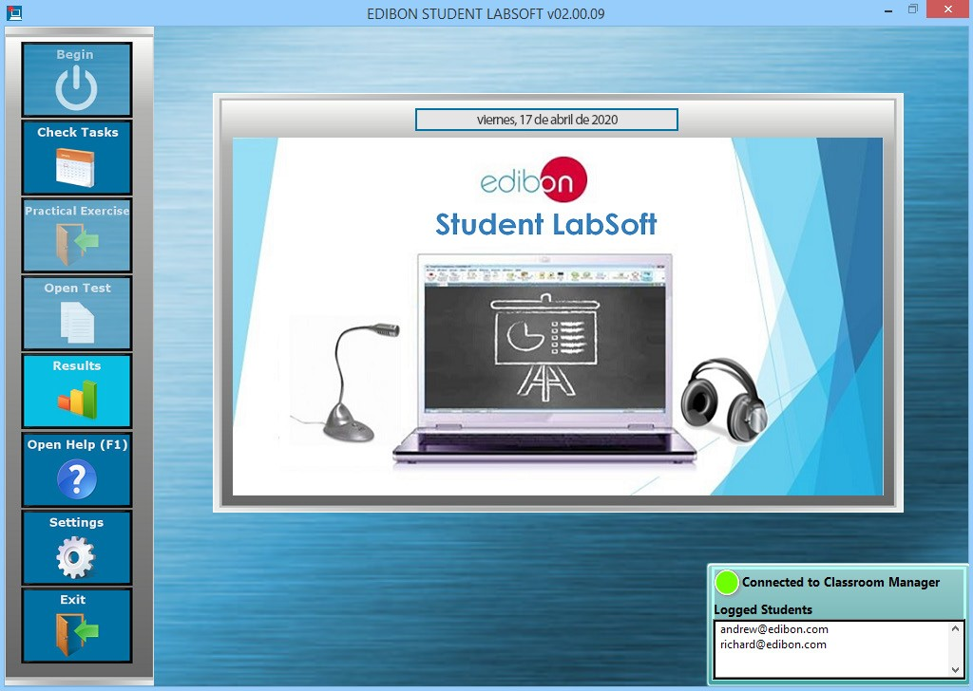

The Student Results Monitoring Program Package includes the following software package:

2.6.1. User Result & Reports Program Package.
The User Result & Reports Program Package includes the following modules:
2.6.1.1. Progress Representation: Spreadsheet, Graphic and Text.
2.6.1.2. Individual User Results summary table. Compilation of all the results obtained by each particular user.

USER RESULT & REPORTS Program Package - Main Screen
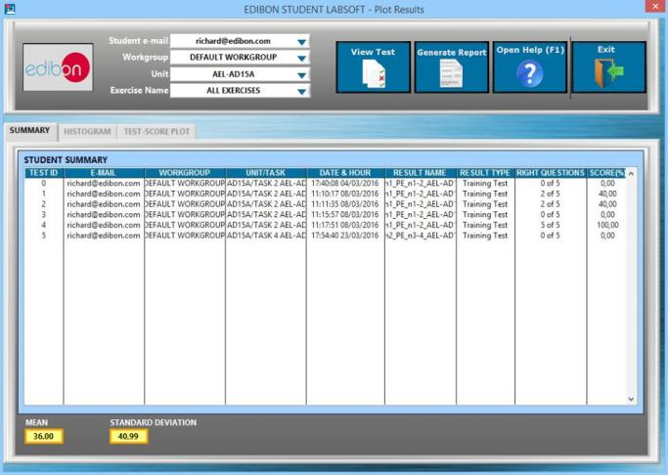

ESL-SOF. EDIBON STUDENT LABSOFT (Student Software)

2.6. Student results monitoring (continuation)
2.6.1. User Result & Reports Program Package (continuation)
2.6.1.3. User Progressions in a XY graph representation in which the user can evaluate the evolution of his/her results working with a particular Unit.

USER RESULT & REPORTS Program Package - Student Scores Progression

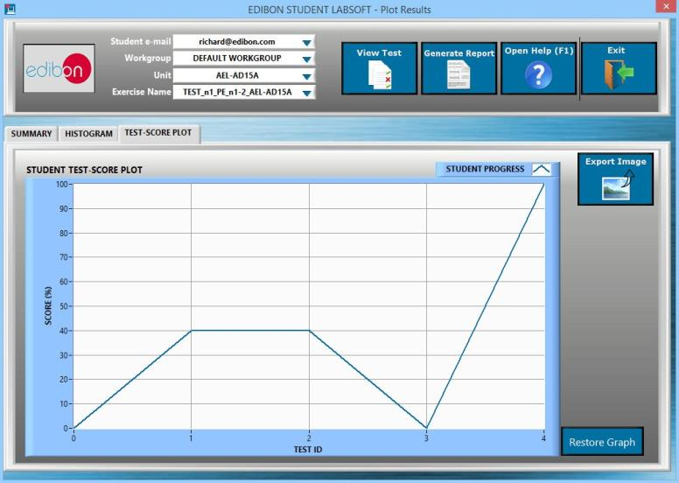

2.6.1.4. Result Statistics: Some statistics such as Mean Scores and Standard Deviations as well as representations such as Histograms are shown.

USER RESULT & REPORTS Program Package - Student Scores Histogram
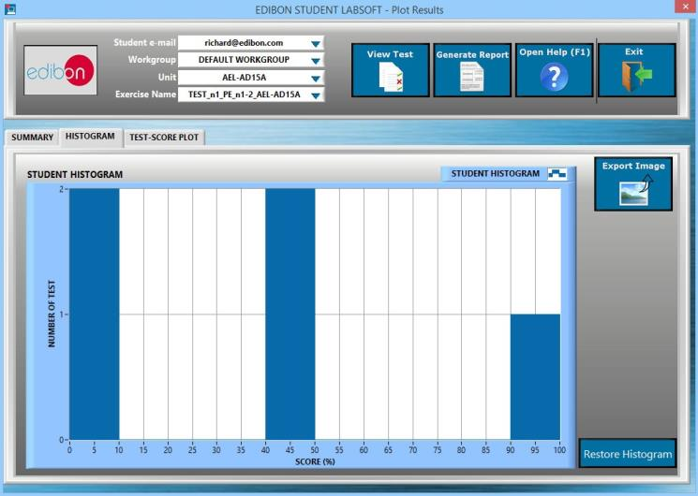

ESL-SOF. EDIBON STUDENT LABSOFT (Student Software)

2.6. Student results monitoring (continuation)
2.6.1. User Result & Reports Program Package (continuation)

2.6.1.5. Detailed Test Results: Specific results can be opened to generate a detailed view of the Questions with the cho-
sen answers in contrast with the correct answers.

USER RESULT & REPORTS Program Package - Detailed Test Result (I): Answers & Marks

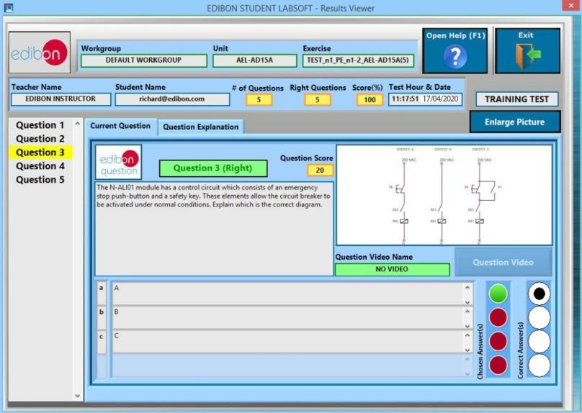

USER RESULT & REPORTS Program Package - Detailed Test Result (II): Question Explanation

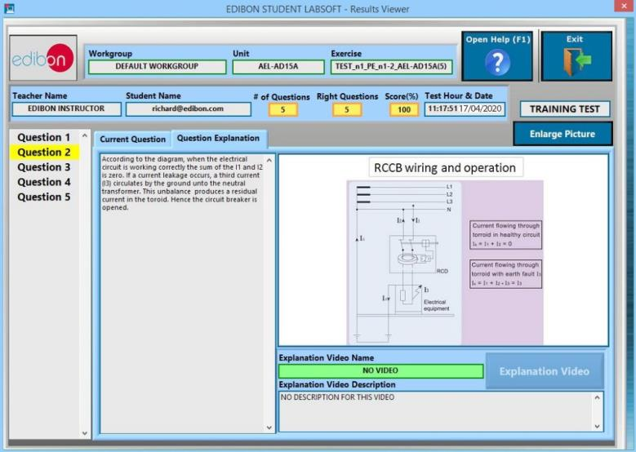

ESL-SOF. EDIBON STUDENT LABSOFT (Student Software)

2.6. Student results monitoring (continuation)
2.6.1. User Result & Reports Program Package (continuation)
2.6.1.6. Printable Reports: allowing to display summary tables graphs and that can be exported to HTML formatted tables and JPEG Images.

USER RESULT & REPORTS Program Package - Printable Reports (I): HTML

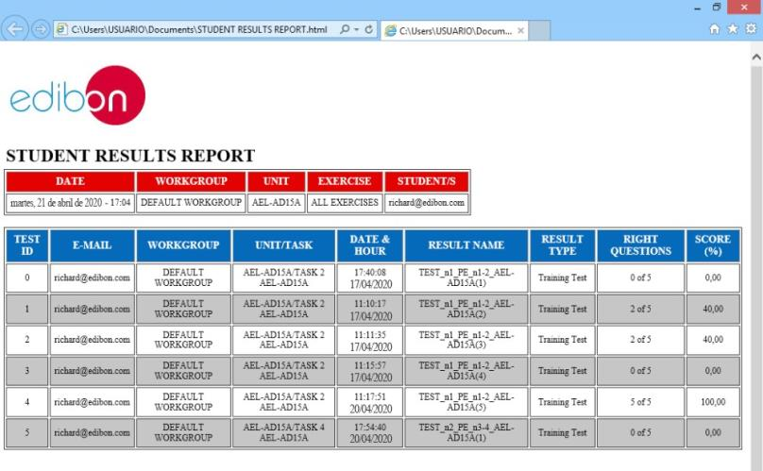

USER RESULT & REPORTS Program Package - Printable Reports (II): JPEG Picture

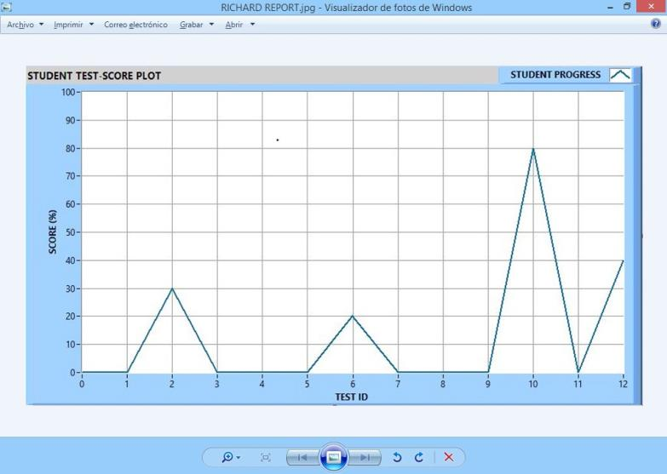

ESL-SOF. EDIBON STUDENT LABSOFT (Student Software)

2.7. Options & Tools Program Package

ESL-SOF. EDIBON Student Labsoft Software Application main screen
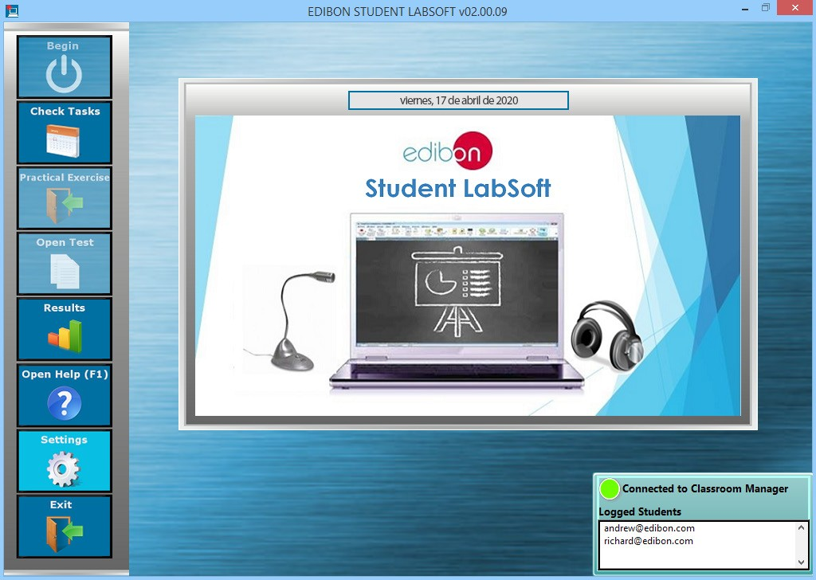

The Options & Tools Program Package includes the following modules:
2.7.1. Easy Setting for a LAN Connection allowing to introduce the Instructor’s IP-address and Port the connection with the
EDIBON Classroom Manager computer will be set.

OPTIONS & TOOLS Program Package

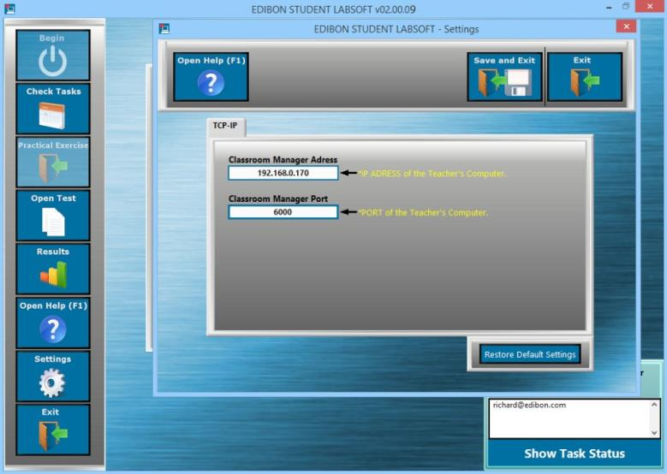

ESL-SOF. EDIBON STUDENT LABSOFT (Student Software)

2.8. Context Help Program Package

CONTEXT HELP Program Package - EDIBON Student Labsoft Software Application main screen
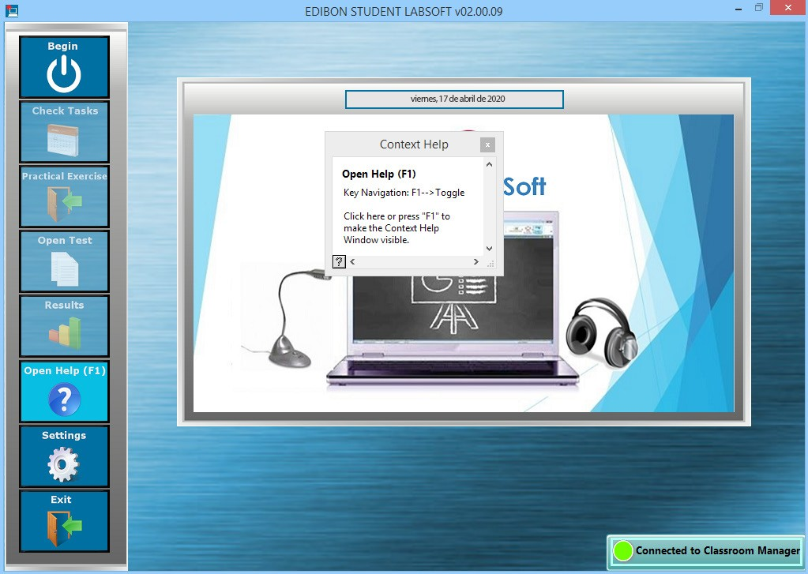

The Context Help Program Package includes the following modules:
2.8.1. Floating Window for the Context Help. This window displays short explanations of the functionalities that any control or indicator can perform.
2.8.2. Enable and Disable Help. You can activate/deactivate the Context Help window at any moment.
2.8.3. Available anytime and anywhere.

CONTEXT HELP Program Package – Floating Window
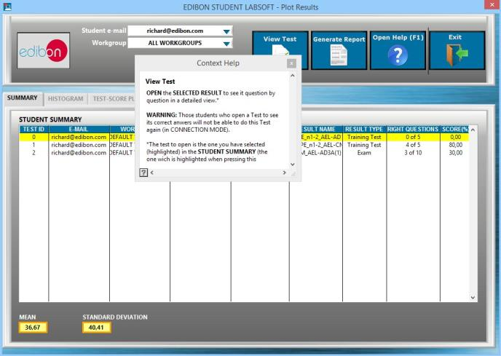

ESL-SOF. EDIBON STUDENT LABSOFT (Student Software)

2.9. Operating Modes: LOCAL and LAN Program Package
The Operating Modes Program Package includes the following modules:
2.9.1. LOCAL Mode:
- Available EDIBON Practical Exercises, Training Tests and Multimedia Resources.
- Available EDIBON formulas and expressions.
- Auto Result Saving. Generated results are saved in a local Database.
- Training Test Results Viewer.
- Available Training Test Explanations.
- Printable Reports.

LOCAL MODE: EDIBON Student Labsoft Software Application main screen
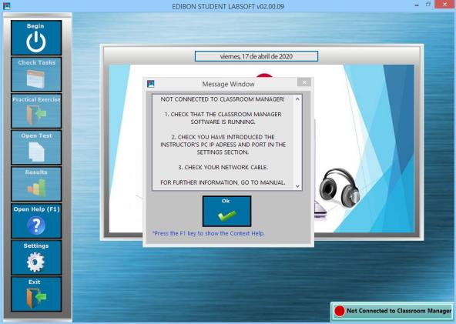

2.9.2. LAN Mode:
- Available Default Workgroup for Users, provided by EDIBON.
- Available Log-In and Registry for Multiple Users.
- Available EDIBON Scheduled Tasks for Default Workgroup.
- User Progressions for Default Workgroup.
- Task Status Viewer for Default Workgroup.
- User Database.
- Custom Workgroups.
- Custom Scheduled Tasks.
- Task Progression & Status for Registered Users in Classroom Manager Database.
- Custom Practical Exercises.
- Custom Training Tests and Exams.
- Custom Formula & Expression.
- Updatable Multimedia Resources & Contents for Tasks.
- Available Training Test and Exam Explanations.
- All local mode features.

LAN MODE: EDIBON Student Labsoft Software Application main screen
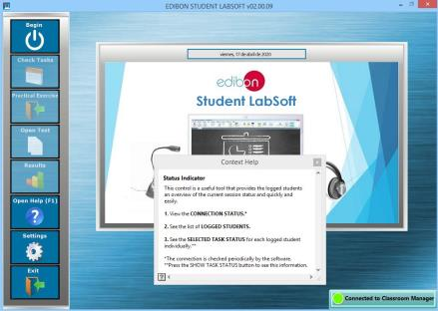

ESL-UNIT-SOF. EDIBON E-LEARNING CONTENT FOR EACH UNIT.

3. ESL-UNIT-SOF. EDIBON E-Learning content for each unit.

3.1. Customized Currículum. (Go to page 42).

3.2. Editable Content. (Go to page 47).

3.3. Calculus and Graphs. (Go to page 48).

3.4. Solutions and Reasons. (Go to page 49).

3.5. Digital Resources. (Go to page 50).

3.6. Scheduled Tasks. (Go to page 51).

3.7. EDIBON SCADA. (Go to page 52).

ESL-UNIT-SOF. EDIBON E-LEARNING CONTENT FOR EACH UNIT.

3.1. Customized Currículum.
3.1.1. Workgroups & Tasks Program Package
Example of applications for:

1. Physics

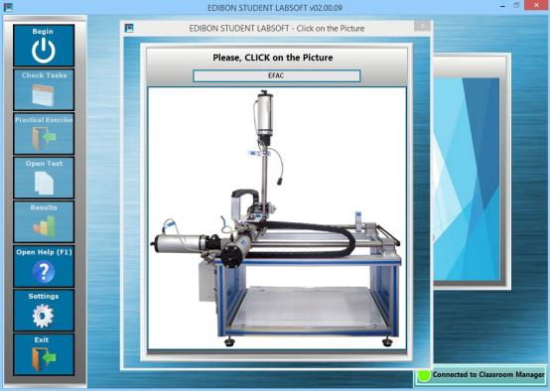

2. Electronics
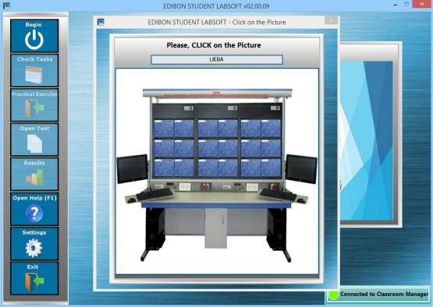

3. Communications
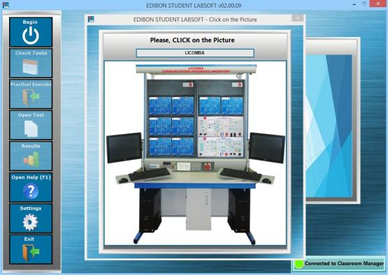

ESL-UNIT-SOF. EDIBON E-LEARNING CONTENT FOR EACH UNIT.

3.1.1. Workgroups & Tasks Program Package (continuation)

Example of applications for:

4. Electricity

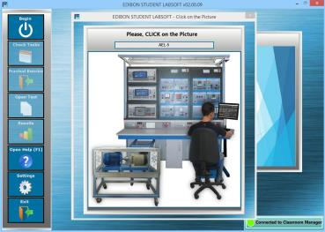

5. Energy
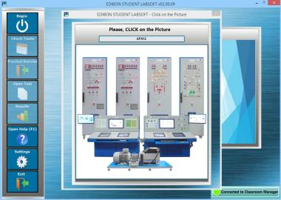

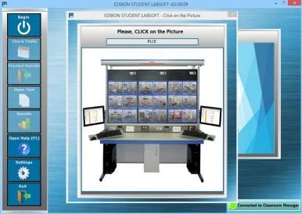
6. Mechatronics

ESL-UNIT-SOF. EDIBON E-LEARNING CONTENT FOR EACH UNIT.

3.1.1. Workgroups & Tasks Program Package (continuation)

Example of applications for:

7. Mechanics

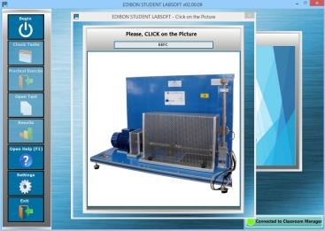

8. Fluid Mechanics
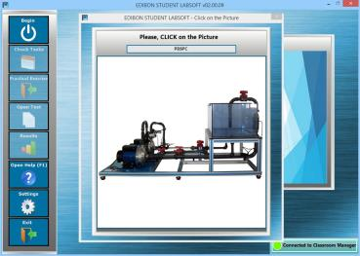

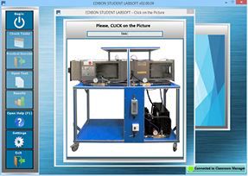
9. Thermodynamics & Thermotechnics

ESL-UNIT-SOF. EDIBON E-LEARNING CONTENT FOR EACH UNIT.

3.1.1. Workgroups & Tasks Program Package (continuation)

Example of applications for:

10. Process Control

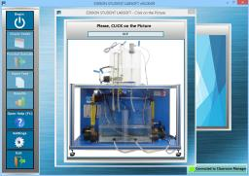

11. Chemical Engineering

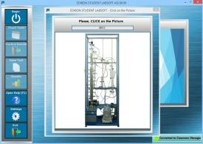

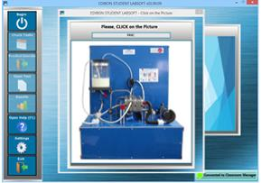
12. Food & Water Technologies

ESL-UNIT-SOF. EDIBON E-LEARNING CONTENT FOR EACH UNIT.

3.1.1. Workgroups & Tasks Program Package (continuation)

Example of applications for:

13. Environment

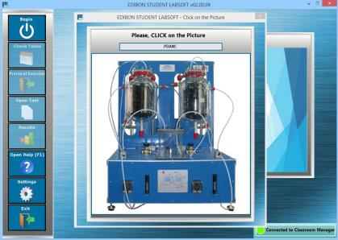

14. Biomedical Engineering

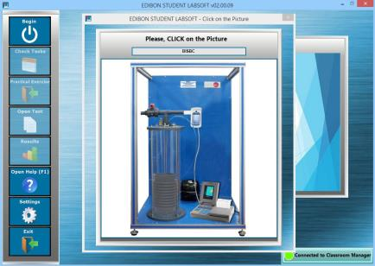

ESL-UNIT-SOF. EDIBON E-LEARNING CONTENT FOR EACH UNIT.

3.2. Editable Content
3.2.1. Multimedia Resource Editing Program Package

Multimedia Resource Editing Program Package - Inclusion of a personalized manual by the instructor
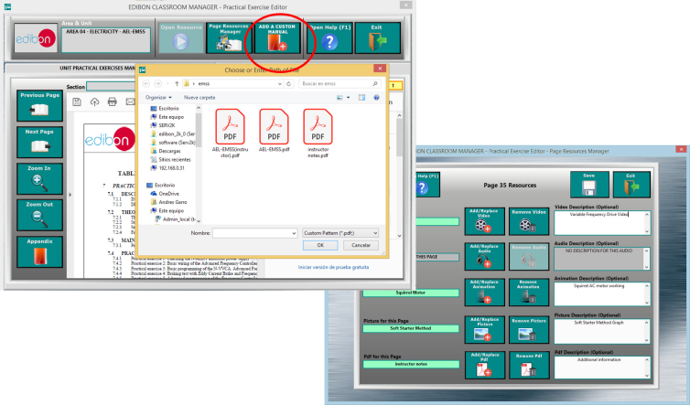

3.2.2. Multimedia Resources Management. Attach your own Pictures and Videos to each individual Question as well as to its
explanation.

EDITABLE CONTENT Program Package – Main Screen: Multimedia Resources edition
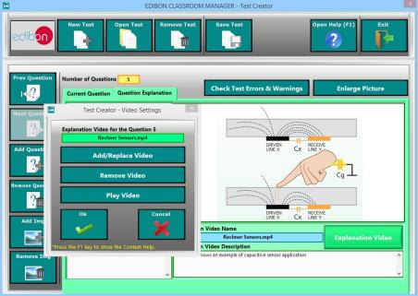

TRAINING TEST & EXAM Program Package – Question Explanation Video
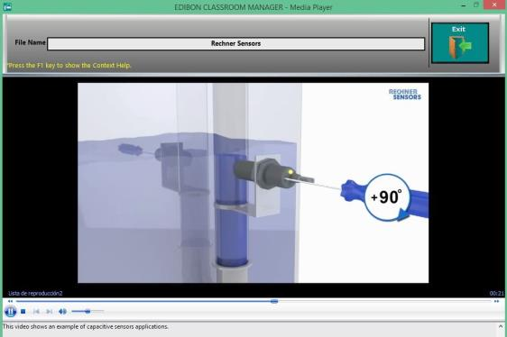

ESL-UNIT-SOF. EDIBON E-LEARNING CONTENT FOR EACH UNIT.

3.3. Calculus and Graphs
3.3.1. Plotted Spreadsheet. The user can represent in a XY graph the values introduced in the Spreadsheet for the Input and
Output variables of a specific formula.

PLOTTED SPREADSHEET Program Package - Plotted Data from Spreadsheet

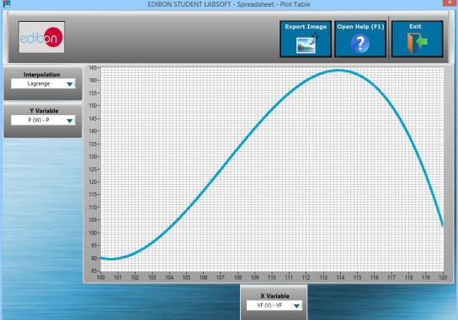

3.3.2. Spreadsheet & Formulas Program Package
3.3.2.1. Variety of Interpolation Algorithms representing a finite number of values in a XY graph, several interpolation
methods (linear interpolation, cubic Hermite, splines, Lagrange…) are available to get the best approach in each
case: - Linear. - Spline. - Cubic. - Hermite. - Lagrange.

SPREADSHEET & FORMULAS Program Package - Plotted output vs input variables
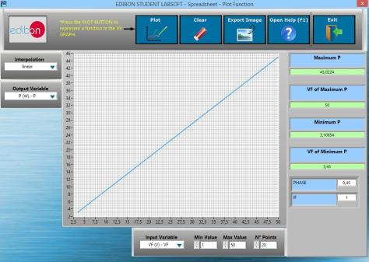

3.3.2.2. Exportable Data. All the graphs generated as well as the values introduces in the Spreadsheet tables can be exported.
SPREADSHEET & FORMULAS Program Package - Plot Exportation
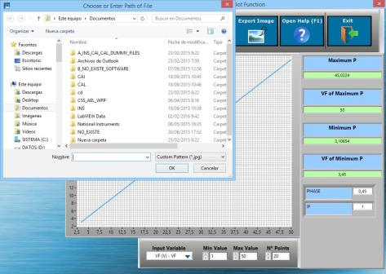

ESL-UNIT-SOF. EDIBON E-LEARNING CONTENT FOR EACH UNIT.

3.4. Solutions and Reasons

SOLUTIONS AND RESAONS Program Package – Main Screen with Question Explanation

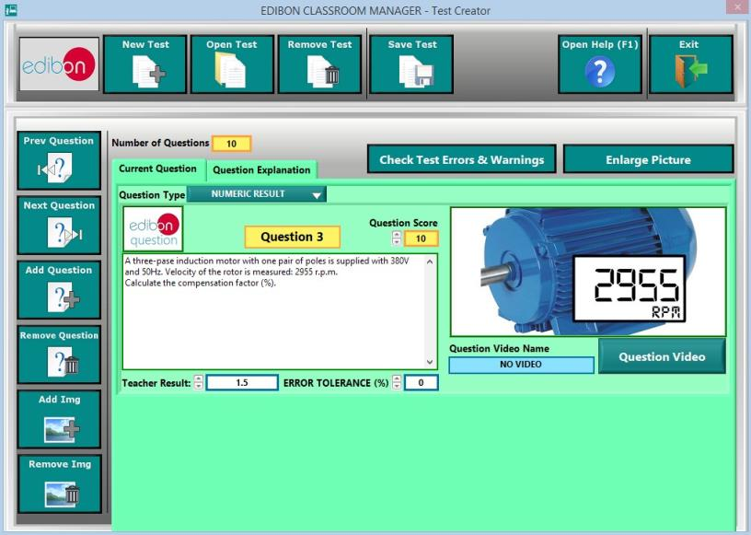

3.4.1. Question and Explanations, aided by Multimedia Resources allowing to explain the answers to the users.

SOLUTIONS AND RESAONS Program Package – Main Screen with Question Explanation

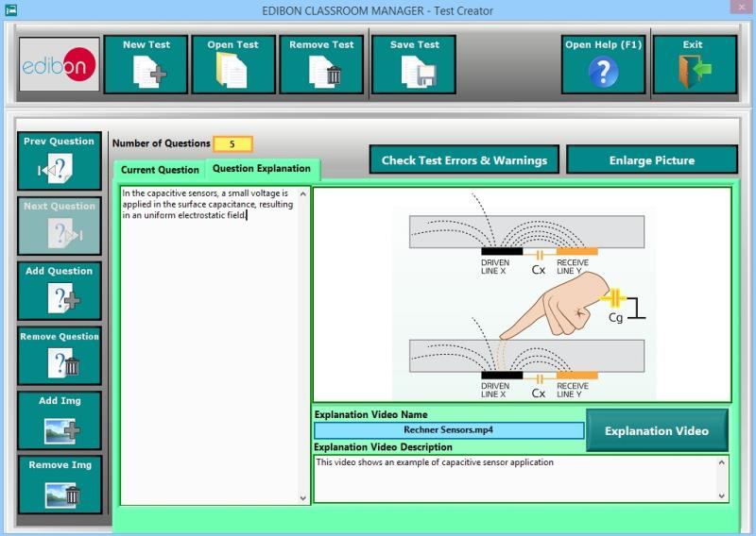

3.4.2. Collection of Training Tests and Exams provided by EDIBON for each Unit to allowing to start working from the first day.

ESL-UNIT-SOF. EDIBON E-LEARNING CONTENT FOR EACH UNIT.

3.5. Digital Resources
ESL - UNIT - SOF. Digital resources of each unit.

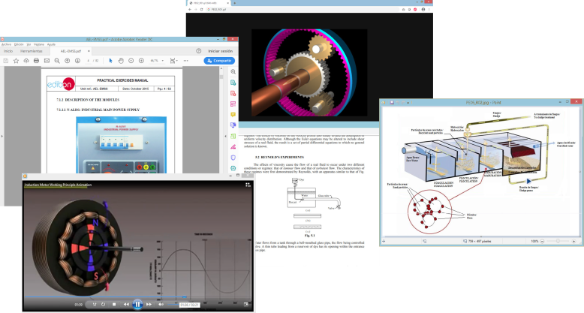

3.5.1. Auxiliary Multimedia Resources Program Package: Digital content available and updateable at any time to better understand the concepts studied in the practical exercises.

Auxiliary Multimedia Resources Program Package - Edition and index of multimedia resources
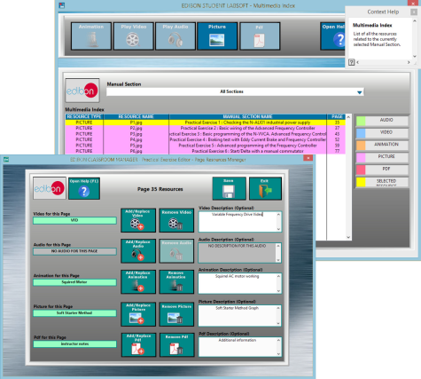

3.5.2. SCORM Program Package: Web content available for online LMS learning platforms such as “Moodle”.

SCORM Program Package - Practical exercises and tests available for LMS platforms

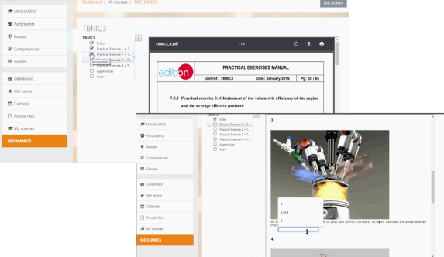

ESL-UNIT-SOF. EDIBON E-LEARNING CONTENT FOR EACH UNIT.

3.6. Scheduled Tasks.

ESL-UNIT-SOF. SCHEDULES TASKS program package.

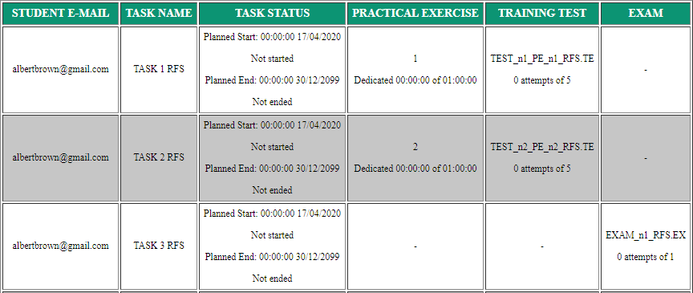

3.6.1. Task Self-Generation Program Package: Tasks scheduled and available for use in the first session.

Task Self-Generation Program Package - Tasks avaialble for use by the users in the first session
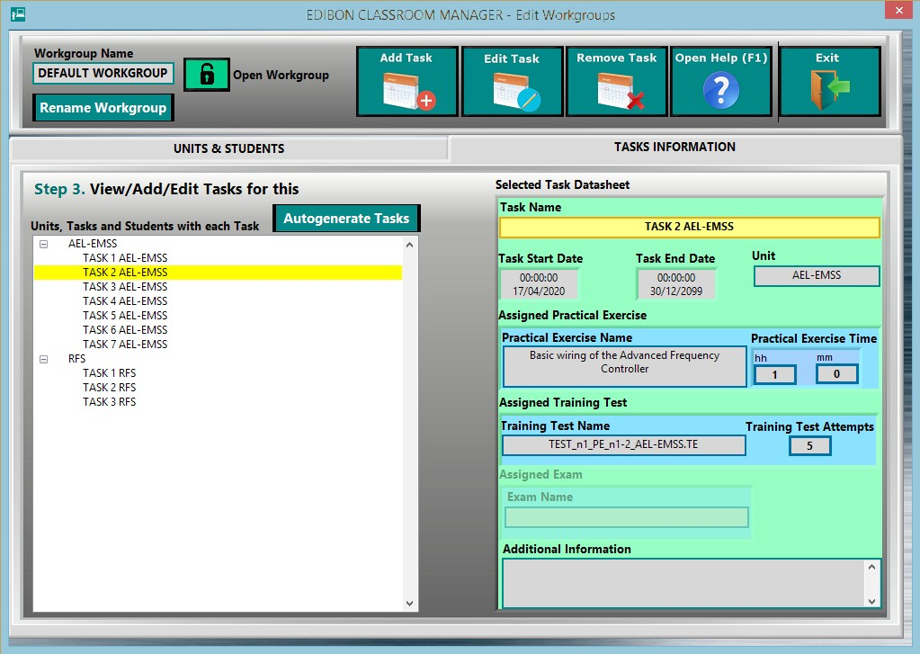

ESL-UNIT-SOF. EDIBON E-LEARNING CONTENT FOR EACH UNIT.

3.7. EDIBON SCADA

ESL-UNIT-SOF. EDIBON SCADA Program Package
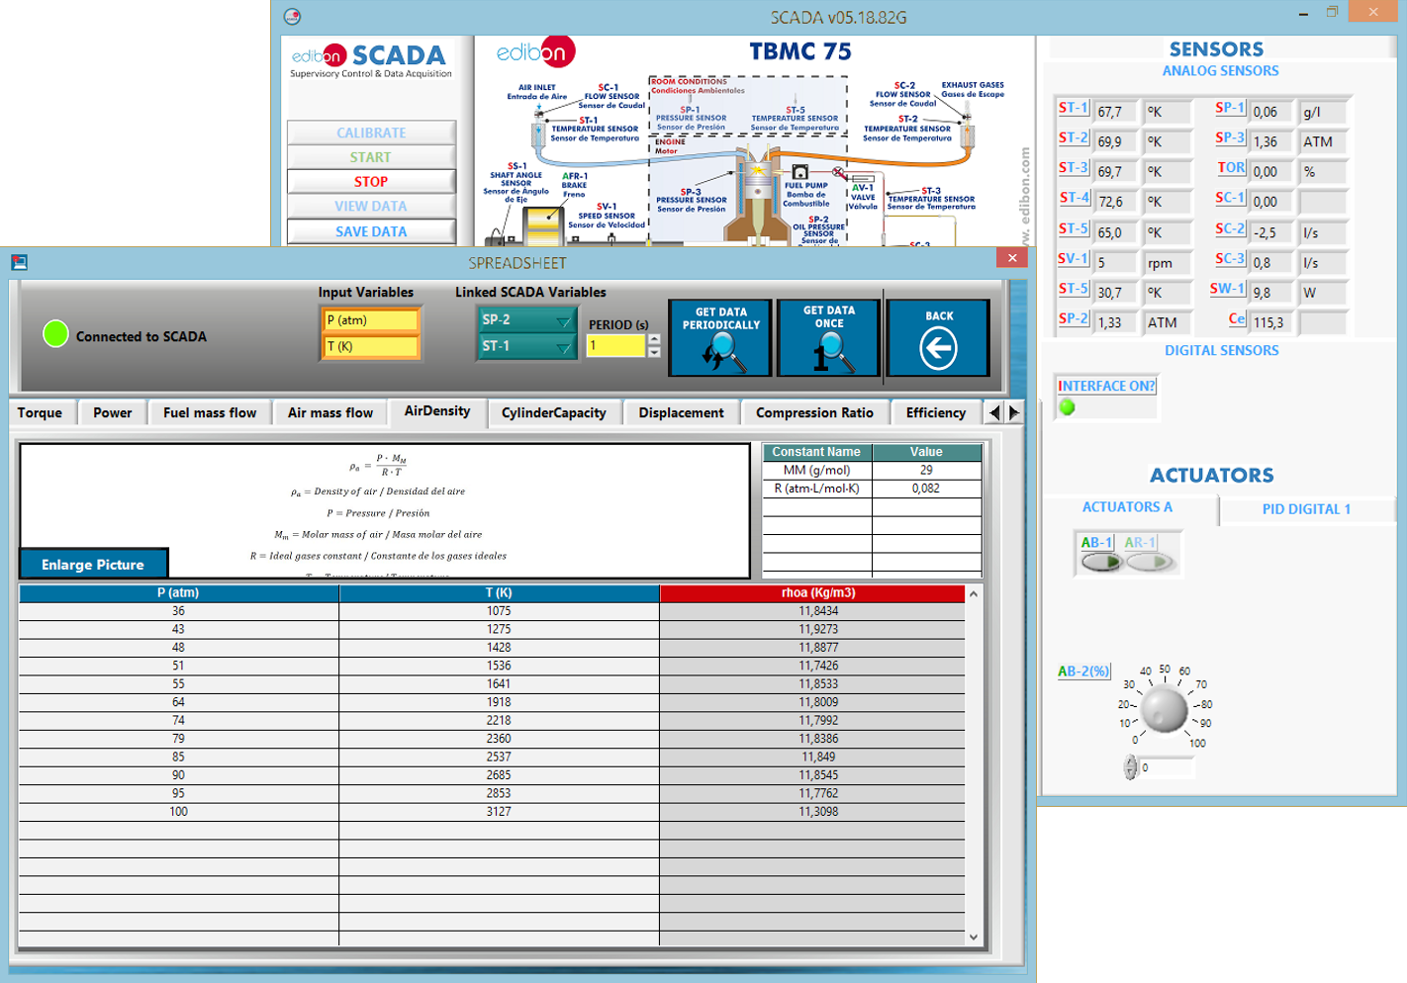

3.7.1. SCADA Program Package for Reading system variables: Access to measurements and states of the SCADA system processes of the equipment in Real Time or on demand.

SCADA Program Package for Reading system variables - Access to measurements and states of the SCADA system

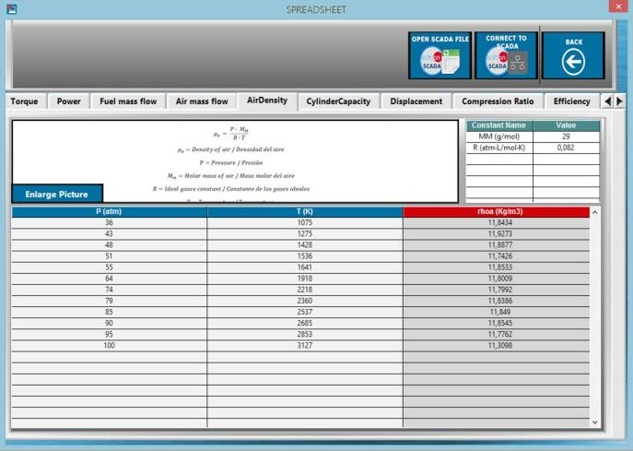

ESL-UNIT-SOF. EDIBON E-LEARNING CONTENT FOR EACH UNIT.

3.7.2. SCADA Program Package for Reading SCADA files. Loading files from the SCADA system

SCADA Program Package for Reading SCADA files - Reading of SCADA application files in ICAI

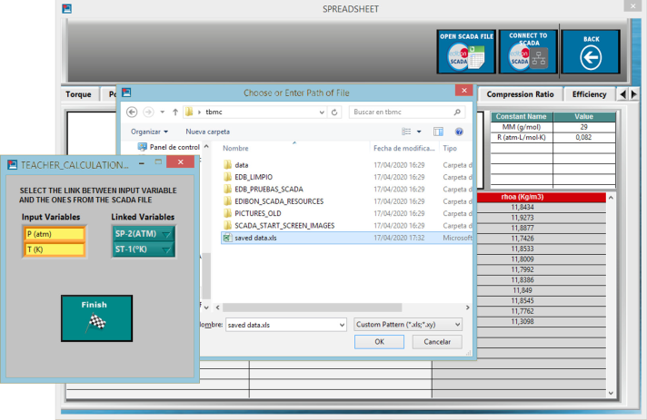

53

