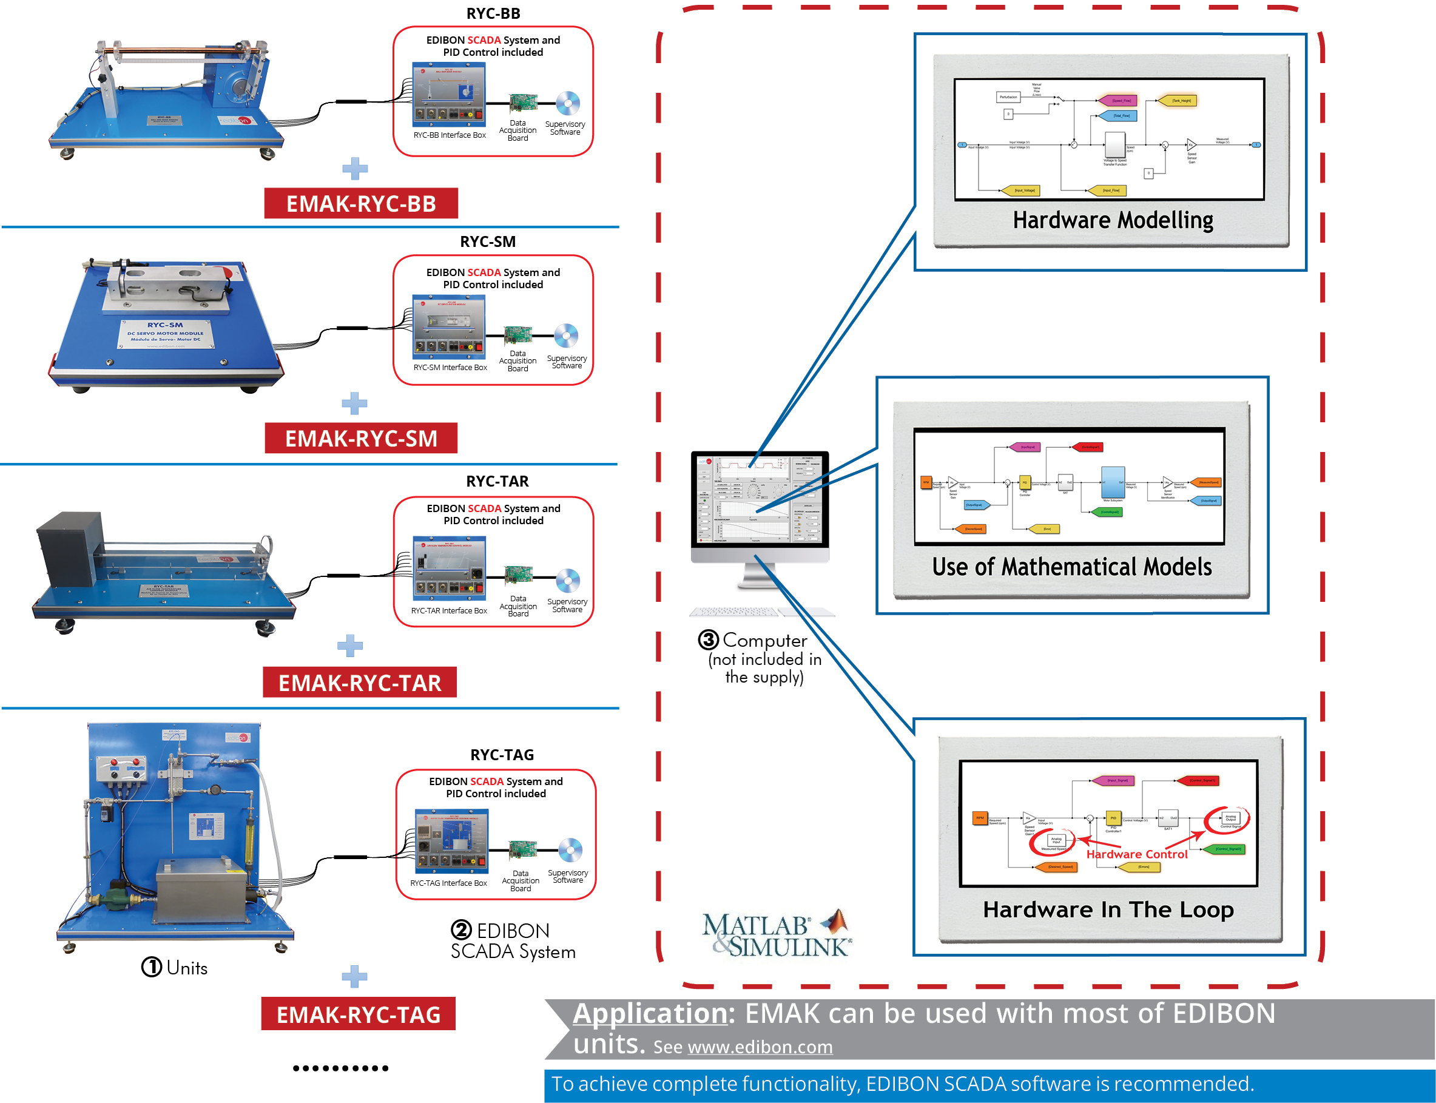

Key features:
- Introduction to programming in a practical way with EDIBON TECHNICAL TEACHING EQUIPMENT.
- Development environment with real hardware using MATLAB® in the engineering R&D field.
- Customized open-source software (OSS) for each unit.
- Signal processing, analysis, configuration and interpretation.
- Comparison of theoretical results versus experimentally obtained results.
- Calculations based on obtained results.
- Experimental study of systems.
- Research of different control methods in a real system.
- Control algorithm modeling.
- Real time display of signals from the sensors.
- Analog and digital control of hardware elements, such as valves, pumps, turbines, etc.
- Software Development Kit (SDK): set of libraries and practical exercises based on several examples of gradual complexity.
- Script editing (.m, .slx, .mdl, .mlapp).
- Detailed help documentation that introduces all the required concepts and supported by didactic resources and guided practical exercises.

ISO 9001: Quality Management (for Design, Manufacturing, Commercialization and After-sales service)
European Union Certificate
(total safety)
Certificates ISO 14001 and ECO- Management and Audit Scheme (environmental management)
1
“Worlddidac Quality Charter” and Platinum Member of Worlddidac

INTRODUCTION

At present, all those software tools focused on engineering technical processes are highly valued, since they allow to predict the operation of the systems that are being developed, minimizing the risks and expenses. Among all the existing ones, it is important to highlight the importance of MATLAB® and Simulink®, since all kinds of tasks can be carried out without leaving the same programming environment; both the previous ones, such as the calculation of dynamic modeling and the simulation of a specific system, and the regulation and control once it has been developed.

GENERAL DESCRIPTION

EDIBON MATLAB® Kit, “EMAK”, is a software package, based on MATLAB® and Simulink® environment, offered as an optional item together with EDIBON TECHNICAL TEACHING EQUIPMENT.

MATLAB® and Simulink® are two of the software tools most widely used in engineering schools around the world. Therefore, having a deep knowledge of these tools means a great step in the professional development of a competitive engineer, obtaining a clear advantage in industrial environments.

The combination of these software with EDIBON TECHNICAL TEACHING EQUIPMENT results in one of the most powerful learning tools in terms of the study, analysis, interpretation and modeling of real systems. The range of possibilities offered by this combination includes both the measurement of the physical variables involved in a particular process and the design of own control algorithms for an unprecedented optimization of the processes carried out in the design.

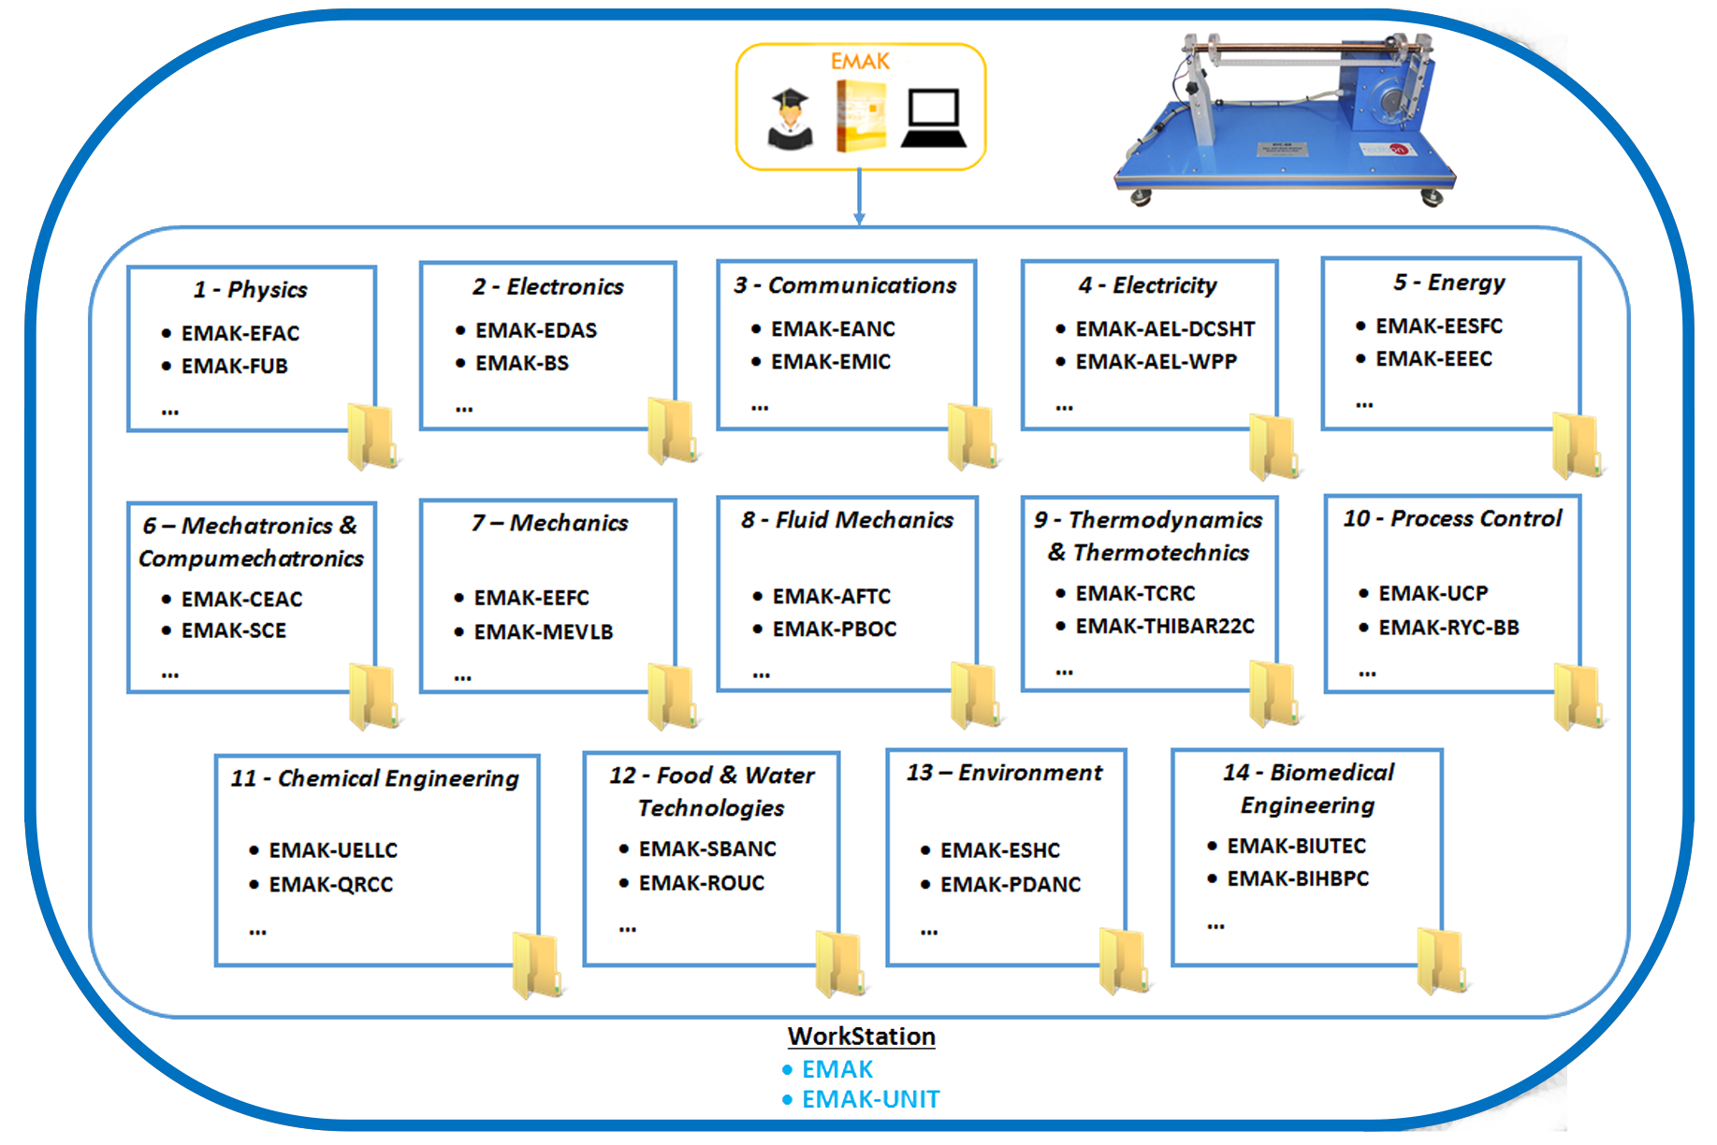

TECHNICAL SPECIFICATIONS

The EMAK requires:

MATLAB® R2019a or higher (32/64bits): Signal Processing Toolbox TM.
System Identification Toolbox TM. Control System Toolbox TM.
Data Acquisition Toolbox Support Package for National Instruments NI-DAQmx Devices. Simulink®:
Simulink Control Design TM. Simulink Desktop Real-Time TM.
EDIBON TECHNICAL TEACHING EQUIPMENT.

EDIBON MATLAB® Kit includes:

Practical exercises to start working with MATLAB® and Simulink® development environment. Practical exercises to start working with EDIBON TECHNICAL TEACHING EQUIPMENT.
A collection of scripts (.m, .slx, .mdl, .mlapp) to study the processes and study fields applied to EDIBON TECHNICAL TEACHING EQUIPMENT.

EDIBON TECHNICAL TEACHING EQUIPMENT supplied with MATLAB®:

Contact EDIBON.

POSSIBLE PRACTICAL EXERCISES

1.- Basic practical exercises to get started with MATLAB® and Simulink® and build simple applications.

2.- Basic practical exercises to get started with EDIBON TECHNICAL TEACHING EQUIPMENT.

3.- Practical and theoretical exercises to perform complex mathematical operations, create and edit formulas, manipulate matrices and obtain variables and characteristic process parameters.

4.- Practical exercises for data acquisition and control.

5.- Practical exercises to develop customized SCADA applications, as well as to perform the main settings, such as sampling frequency, amount of data or the parameters of a PID control, among others.

6.- Practical exercises for signal processing, such as design of different digital filters or measurement performance (FFT, harmonics, etc.).
Customized signal processing algorithms may be implemented.

7.- Practical exercises for signal filtering to study transients, refine data and remove non desired components, such as noise.

8.- Practical exercises to plot signals for the implementation of different graphic representations of acquired signals, calculations and process variables to observe trends, patterns and changes in real time.

9.- Practical exercises to study automatic regulation, such as implementing closed loop control algorithms. Examples: PID, ON/OFF
control, PWM, Auto Tunning, etc.

10.- Development and assessment of different transfer functions of a control system from a theoretical point of view for later application in a real system.

11.- Practical exercises for the modelling of dynamic/kinematic systems. Practical exercises using the Hardware in the Loop technique applied to complex systems in real time.

MAIN SCREENS OF EDIBON EMAK

Example of SCADA application implemented with MATLAB® by EDIBON.
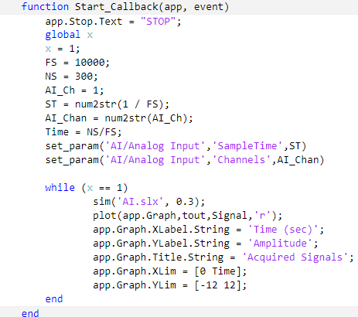

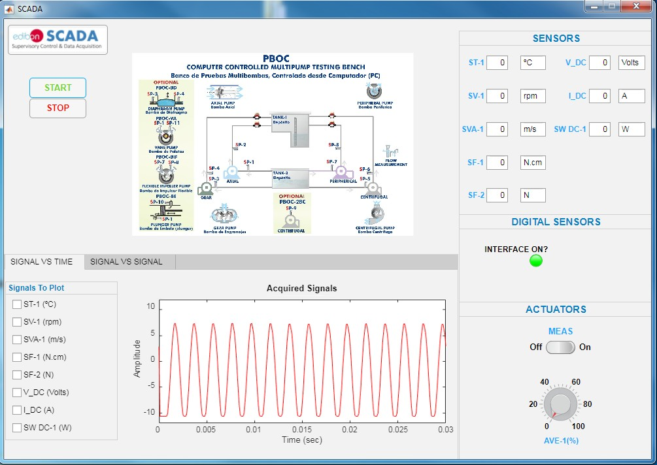

Closed loop control model implemented with Simulink®.

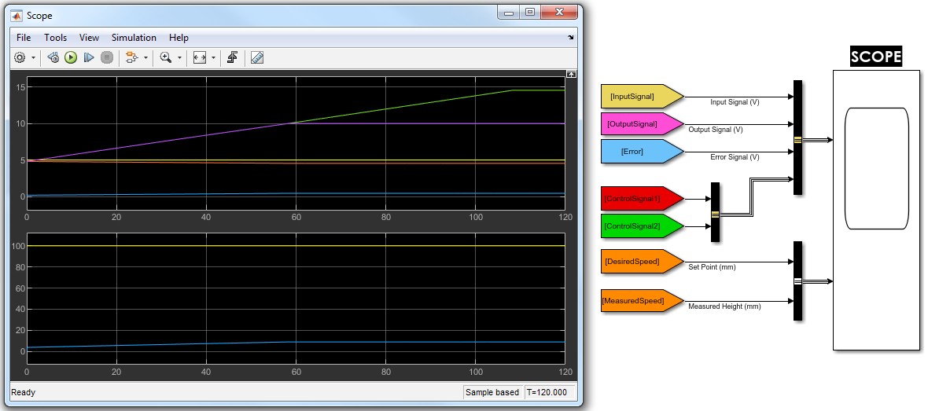

MAIN SCREENS OF EDIBON EMAK

Simple Simulink® applications for the use of National Instruments hardware. Analog and digital I/O.
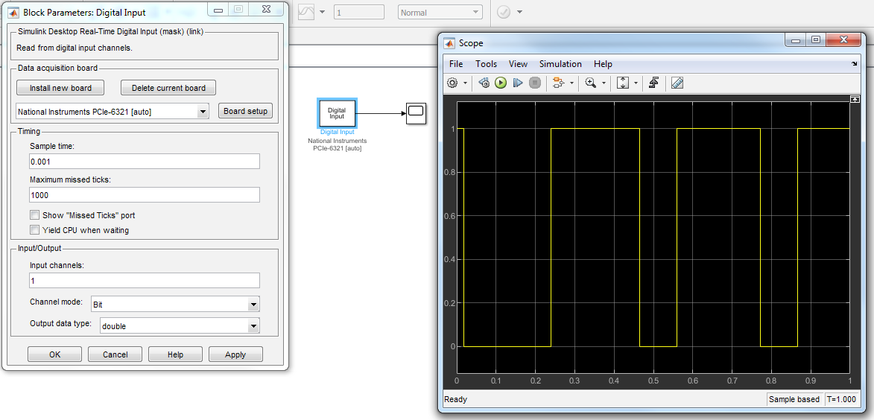

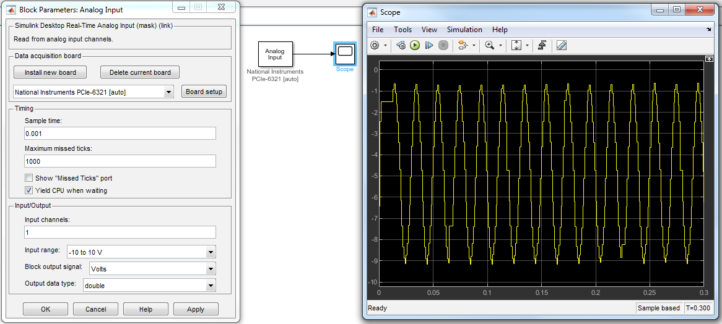

Making a simple PID controller with Simulink®

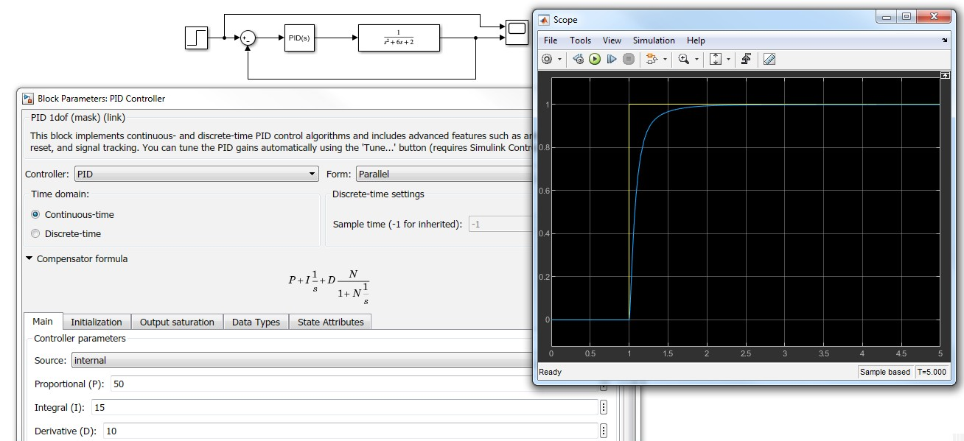

ORDER INFORMATION

Contact EDIBON commercial department to check prices and availability of:

• EDIBON units compatible with EMAK.

• Practical exercises and script package (.m, .slx, .mdl, .mlapp).

6

