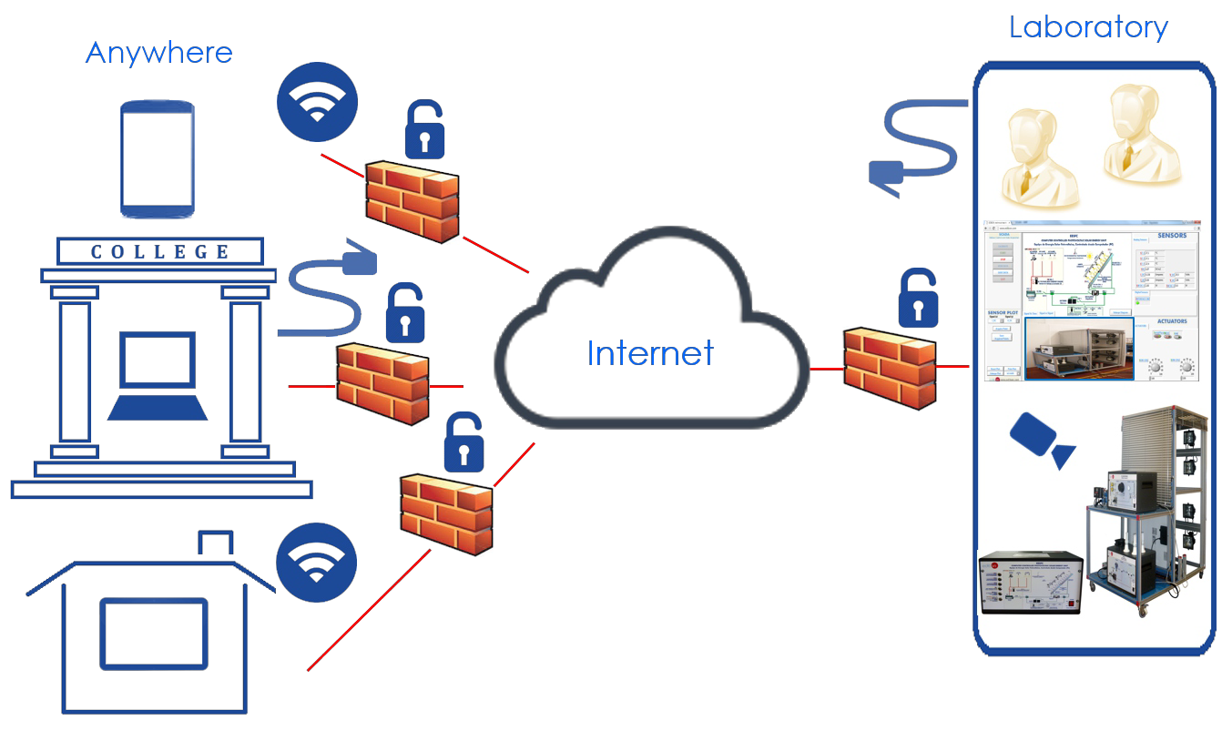

Key features:

Advanced Remote App Platform.
User Platform with powerful tools to manage and administrate Laboratories online. EDIBON Units can be operated anywhere and anytime.
Several Users can work with one Unit or one user with several Units. Storage & Access to Data in the Cloud.
Collaboration with user communities worldwide via EDIBON Chats & Forums. User registration and self-registration in the Cloud.
Monitoring of user tasks and progress. Suggestions and points of view of EDIBON Units. Exchange of experiences with EDIBON Units Available live EDIBON Webinars.
Available EDIBON Tutorials & Webinars at any time. Support from EDIBON Engineers.
Compatible with multiple devices and OS.
No software installation required.

ISO 9001: Quality Management (for Design, Manufacturing, Commercialization and After-sales service)

European Union Certificate
(total safety)
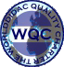

Page 1
Certificates ISO 14001 and
ECO-Management and Audit Scheme
(environmental management)
Worlddidac Quality Charter Certificate and Worlddidac Member

INTRODUCTION

Cloud Computing provides information, shared resources, storage and software services supported by a network (usually Internet). The main advantages of this technology are:
 Reliability: Centralized and efficient system.

 Security and Privacy: Restricted Access and Confidentiality.

 Flexibility: Location and Device independence.

 Cost Reduction & Time Saving: Simultaneity. Multiple users can work at the same time.

GENERAL DESCRIPTION

EDIBON Cloud Learning is a Cloud Computing solution designed to control EDIBON Technology based Laboratories remotely in a simple and easy way.

EDIBON Cloud Learning is divided in two platforms:

- Users Online Platform

The main advantages of the Users Online Platform are:

The administrators have full control over their Laboratories thanks to the powerful Class-Administrator Tool that allows the users management, logs visualization and progression monitoring. It also enables to assign users permissions to let them control EDIBON Units or just display them. Furthermore, the administrator can upload & download Measurements, data and Multimedia resources.

The users can learn interactively in a flexible environment as if they were in the Laboratory, accessing through the Remote App to work with EDIBON Units. Several users can work with one unit or one user with several units. The users can also Upload and Download Measurements, data and graphs, Multimedia resources and Reports.

- Remote App Platform

Thanks to the Remote App Platform, the users can control EDIBON Units & EDIBON SCADA Software as if they were in the laboratory and share their expertise with the Users Community.

SOFTWARE MAIN SCREENS

Users Online Platform – Main screen
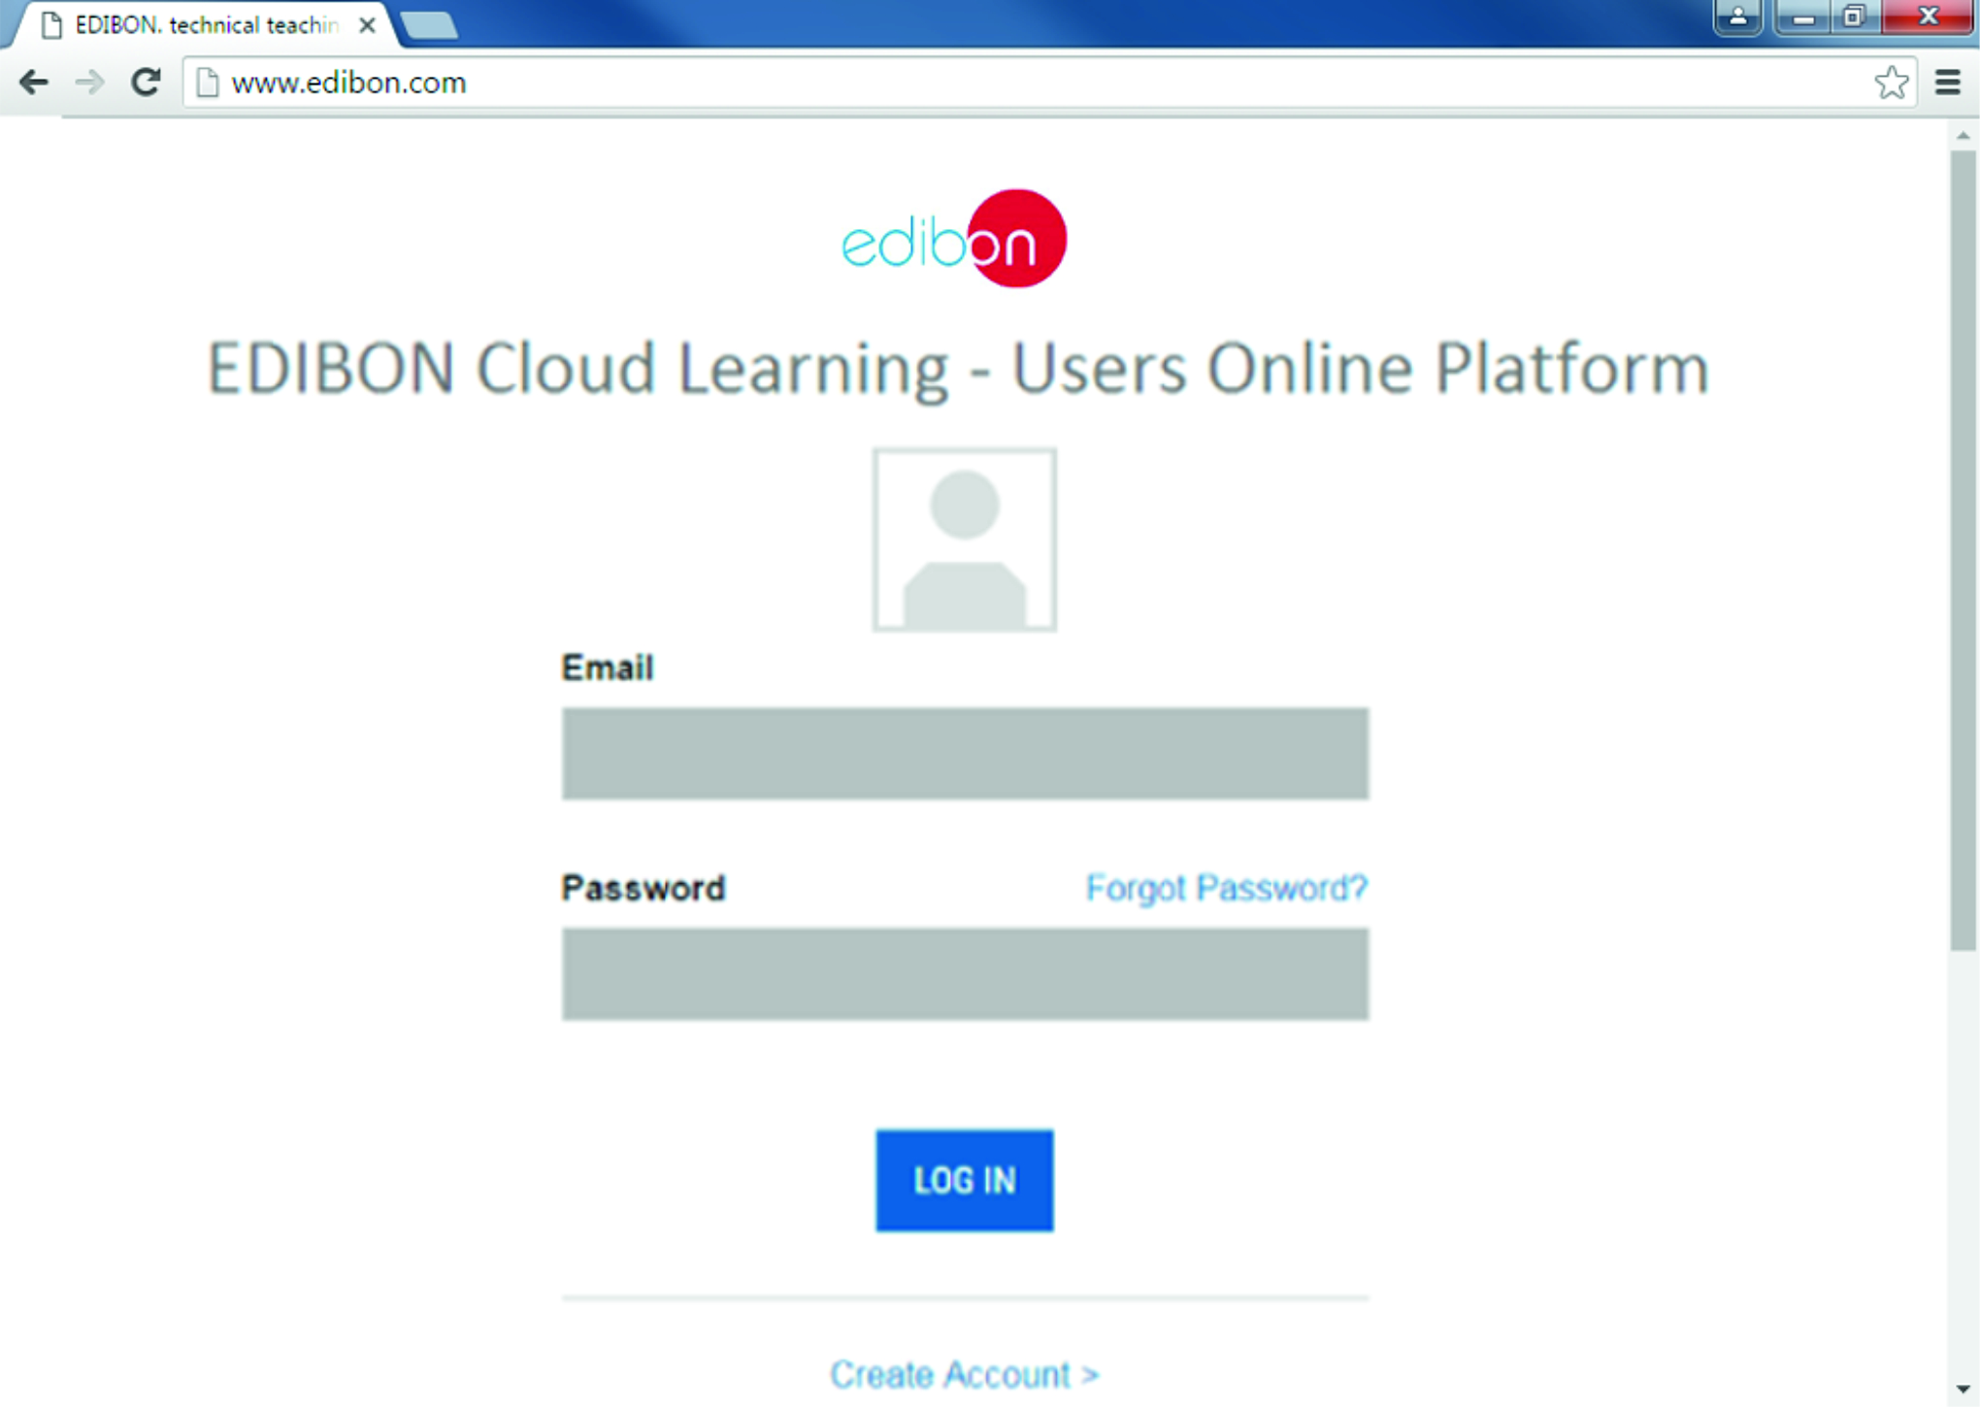

Users Online Platform – Users Results
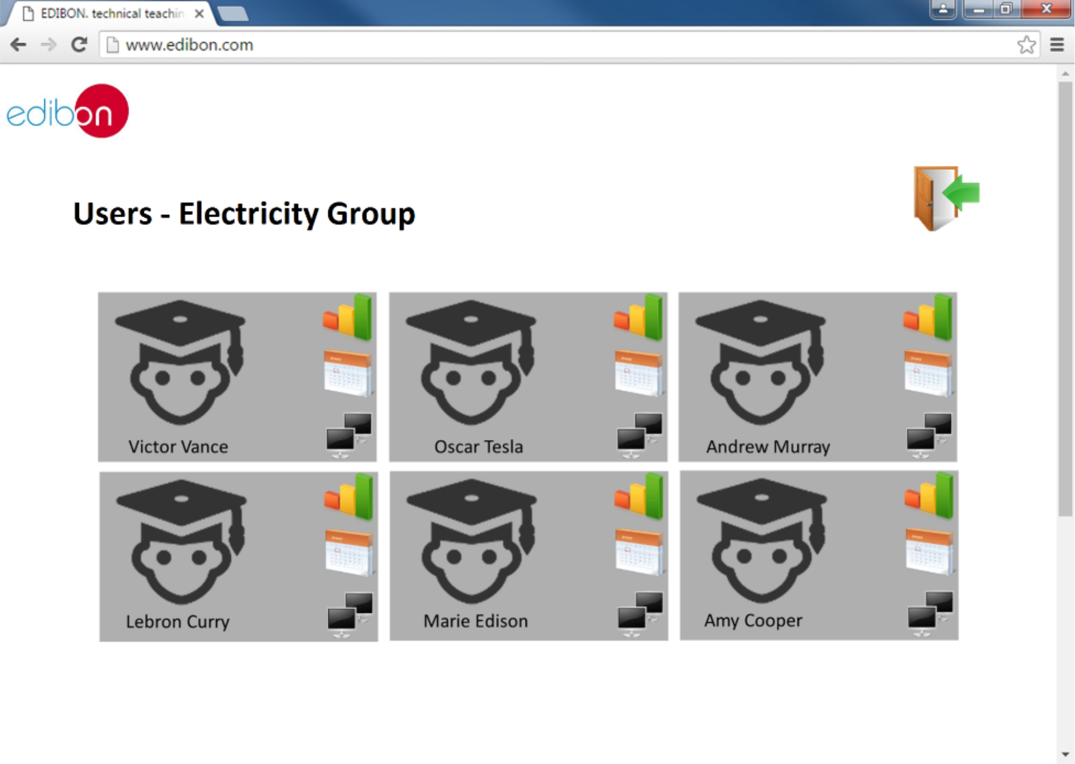

SOFTWARE MAIN SCREENS

Users Online Platform – Users tasks screen
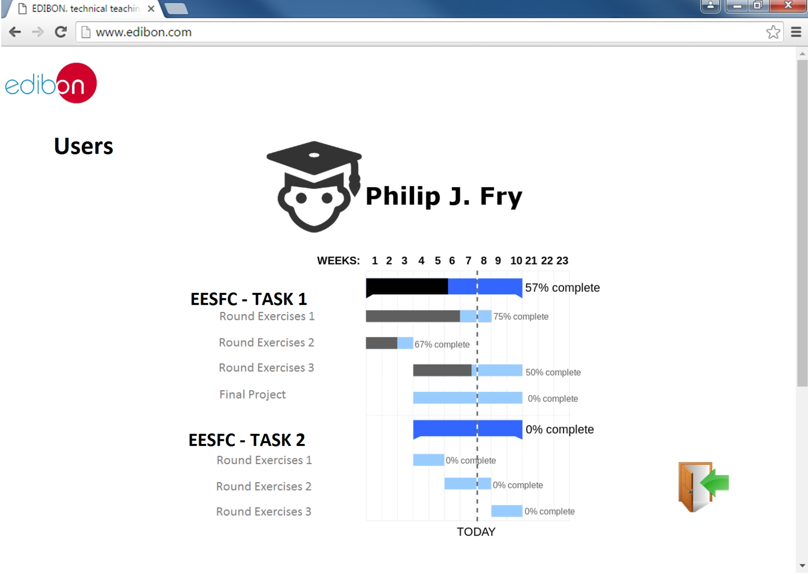

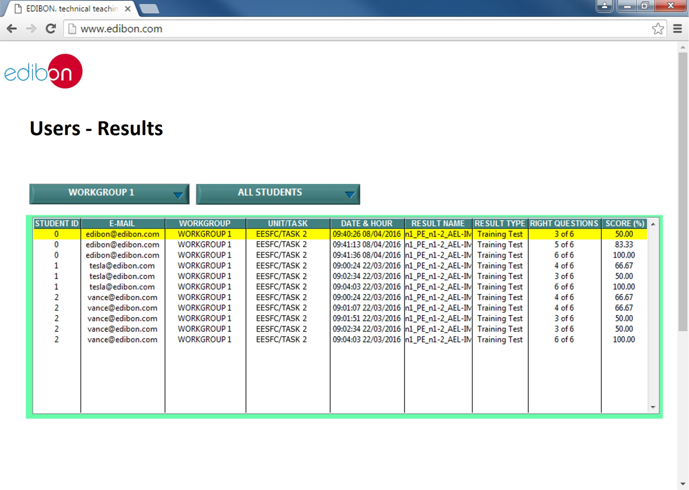
Users Online Platform – Results

SOFTWARE MAIN SCREENS
Remote App – EDIBON SCADA Software

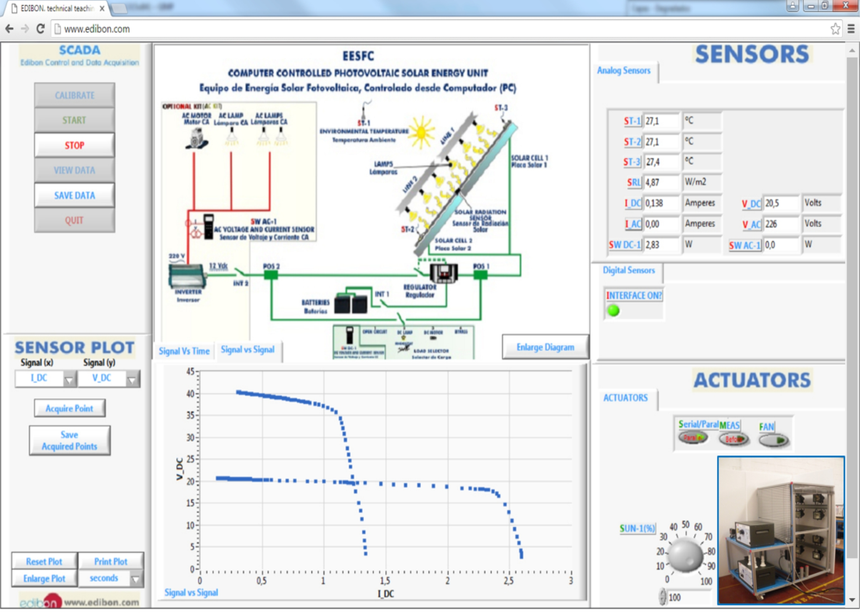

Remote App – EDIBON Unit

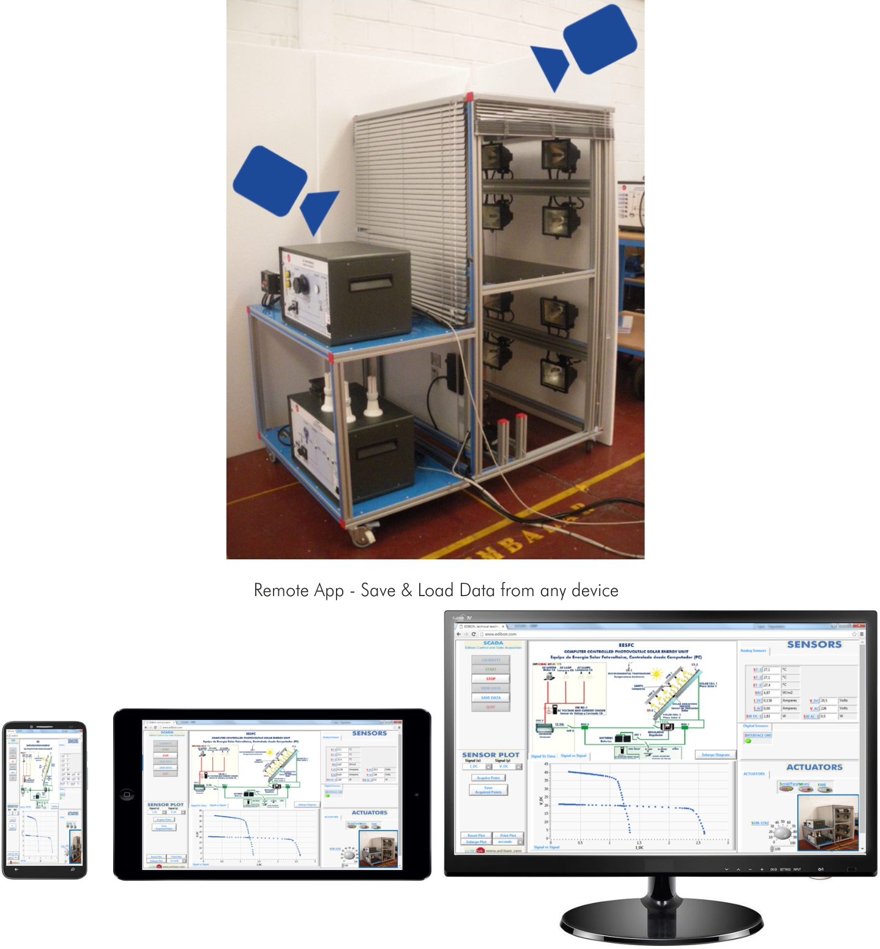

SOFTWARE MAIN SCREENS

Remote App – Live Streaming & EDIBON Chat
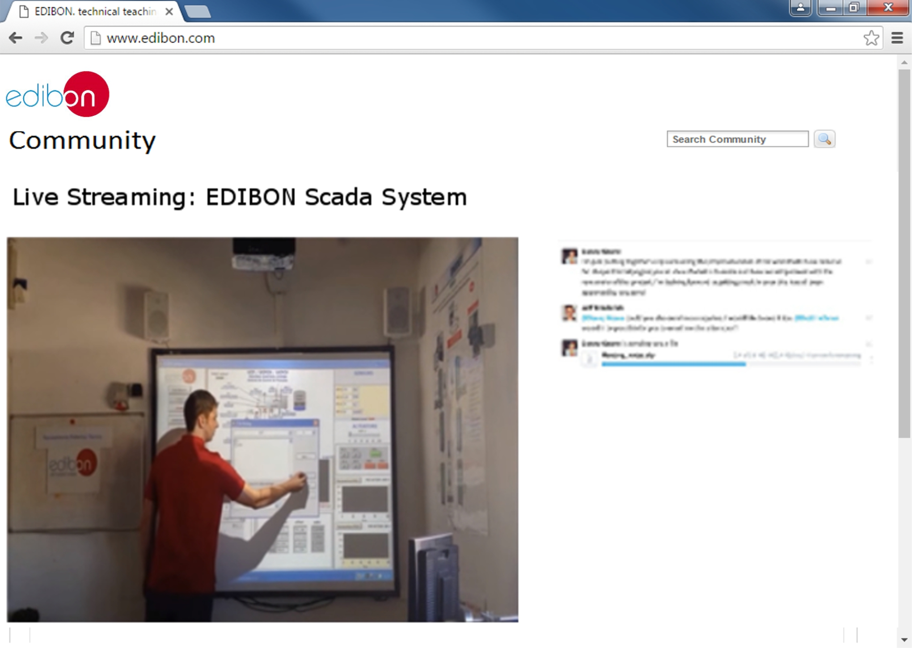

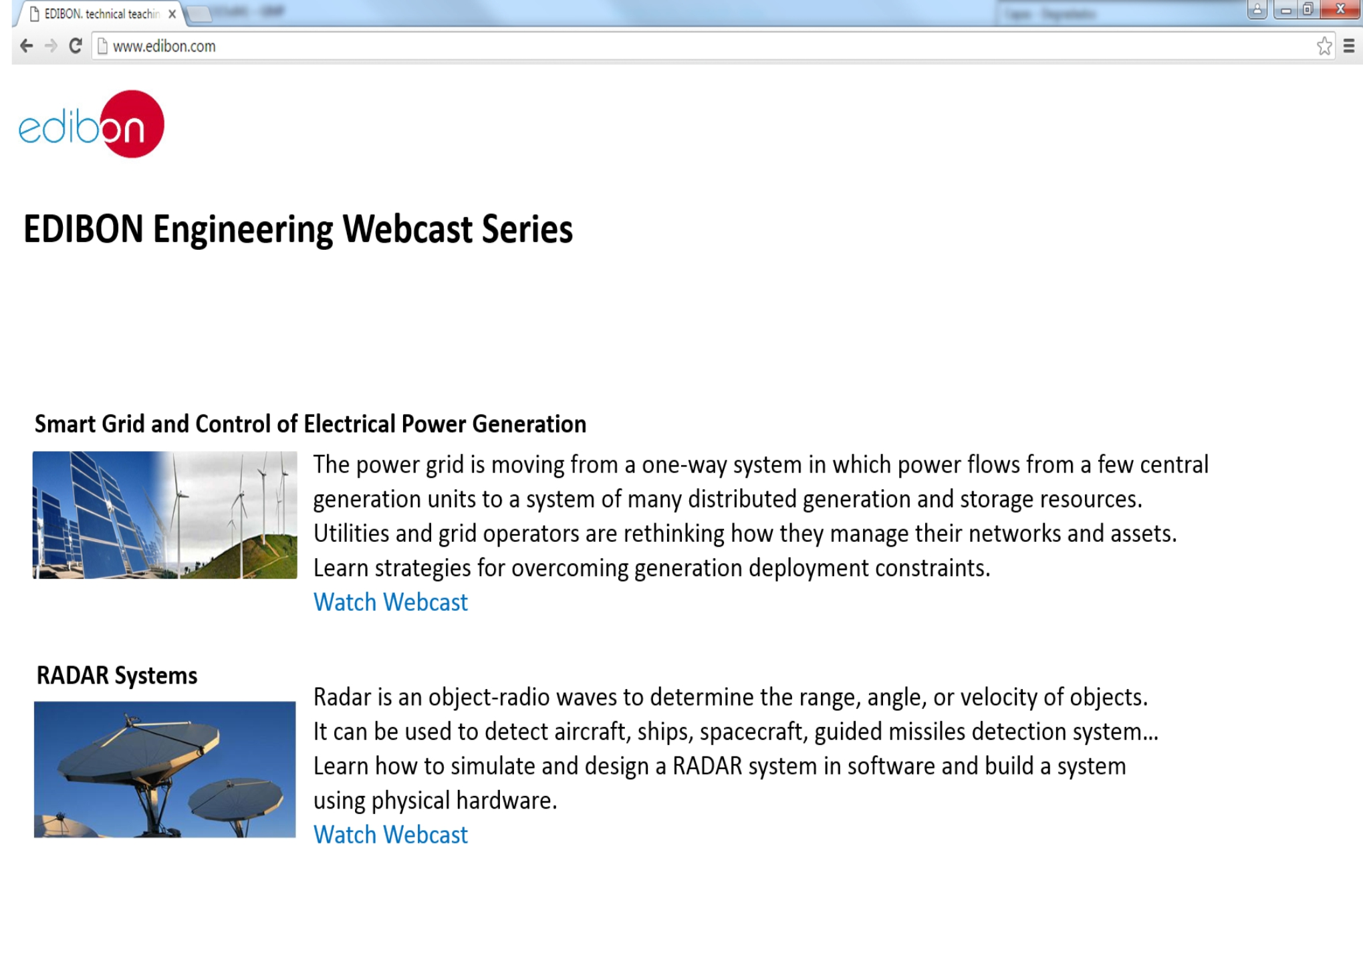
Remote App – EDIBON Webcast Series

SOFTWARE MAIN SCREENS

Remote App – Share your expertise
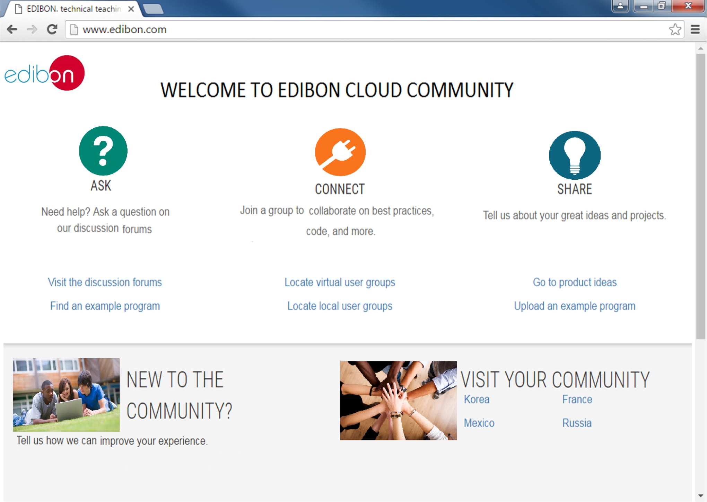

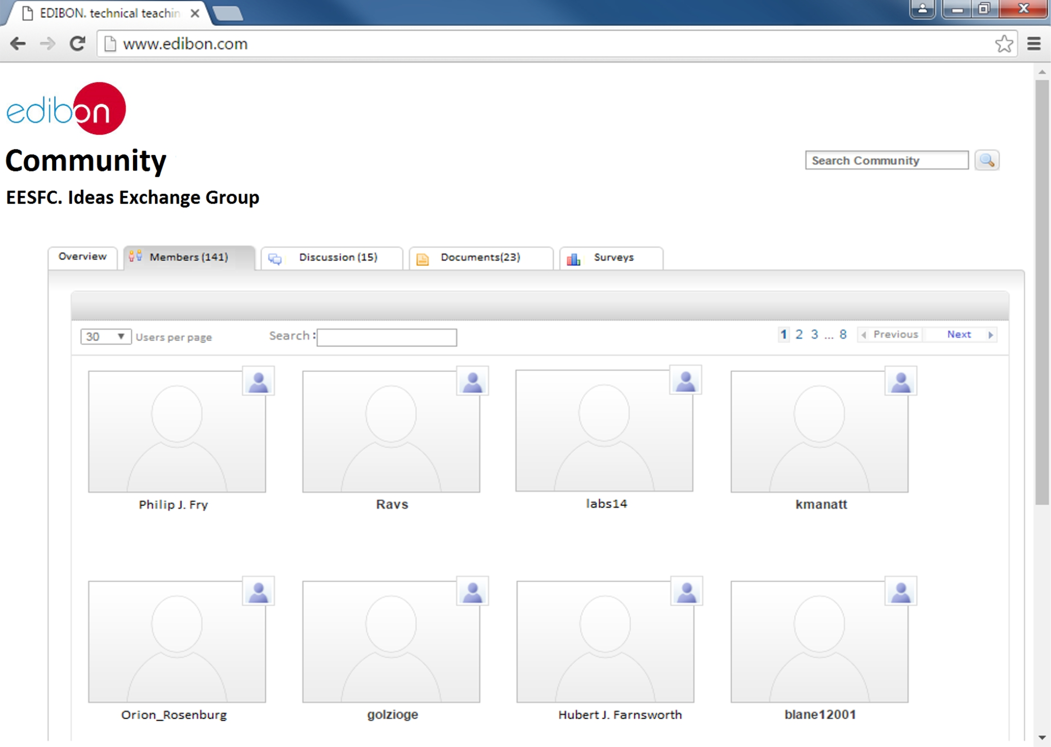
Remote App – A worldwide community

SOFTWARE MAIN SCREENS

Remote App – User Profile & File Exchange
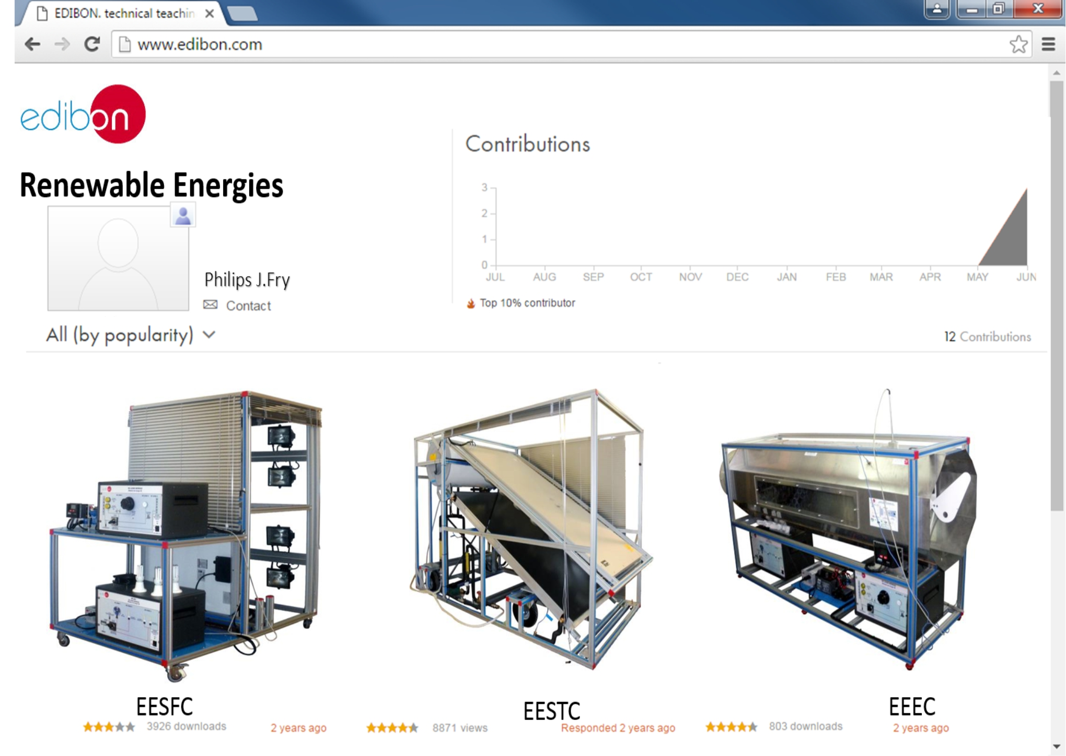

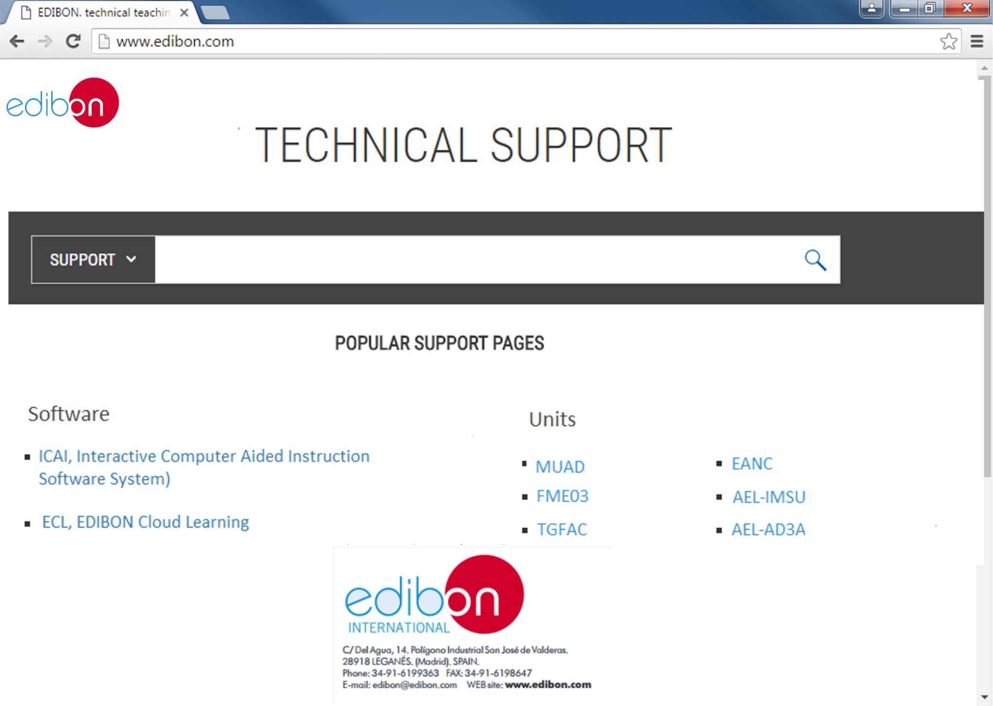
Remote App – Technical Support

SOFTWARE MAIN SCREENS
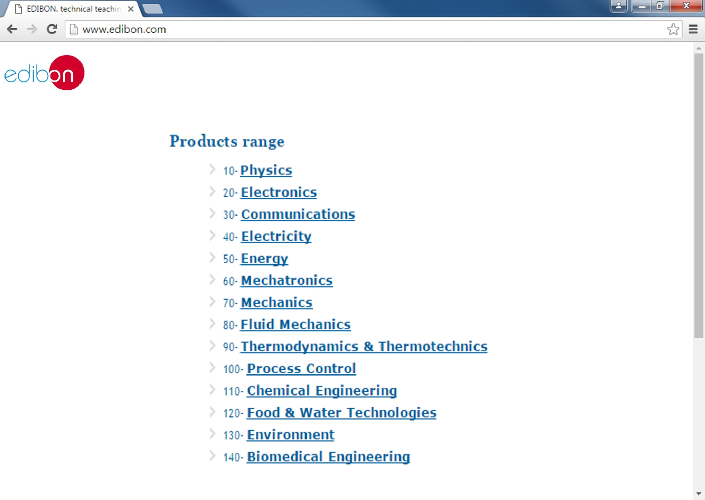
Remote App – EDIBON Shop

Page 9

