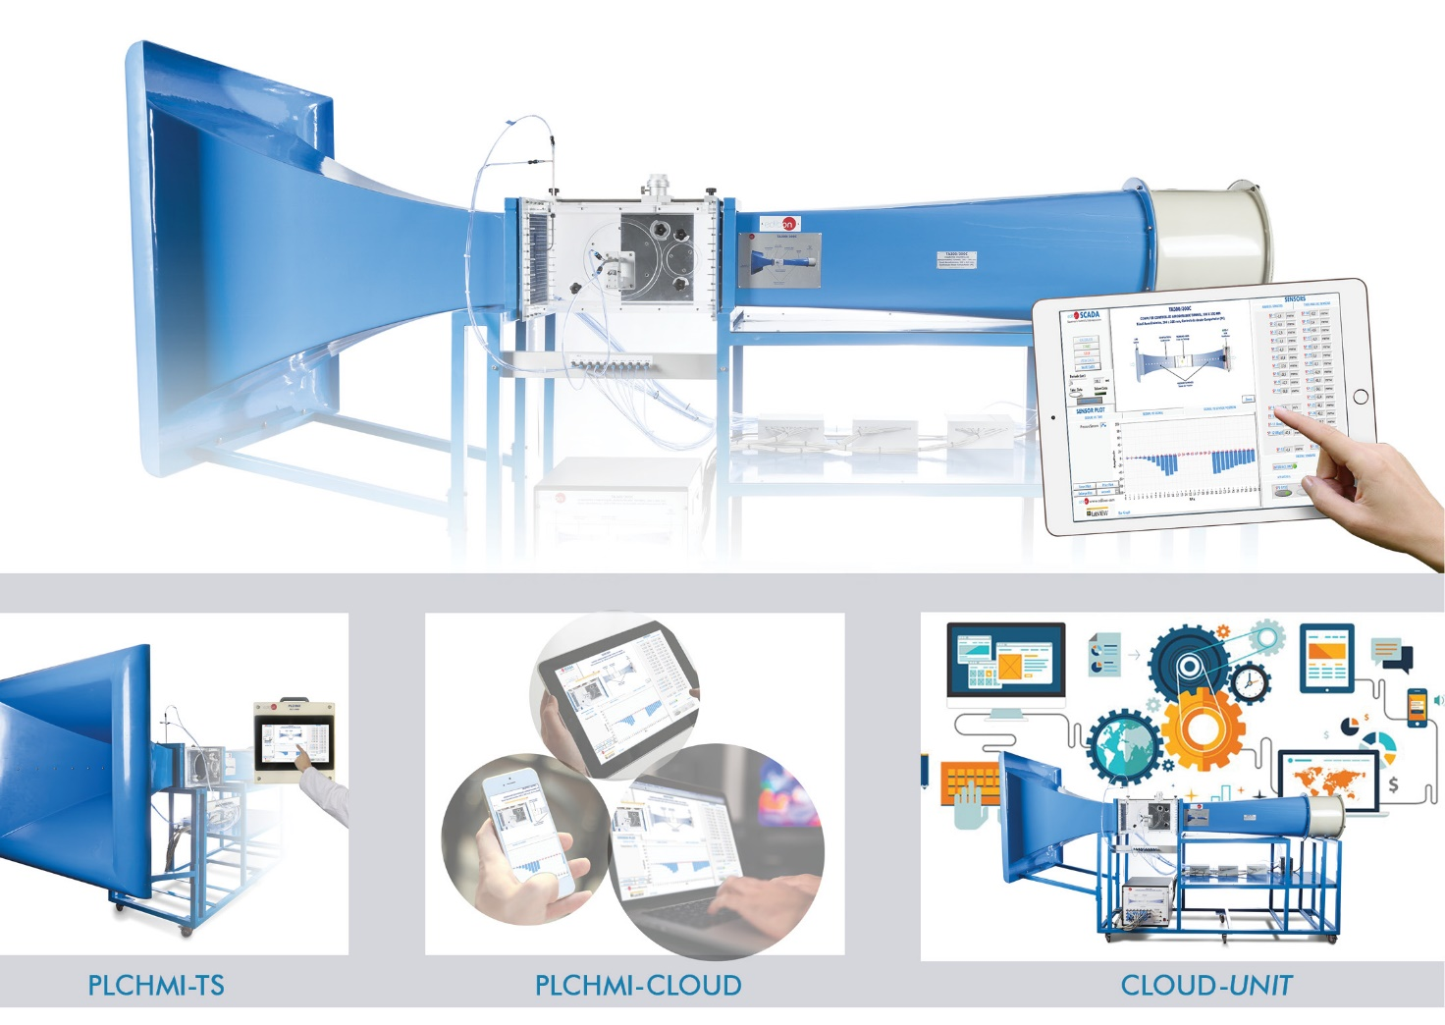

Key features:

• Compact interface based on an industrial programmable logic controller (PLC).
• Portable touch screen with a human machine interface (HMI) to provide local or remote control (interface and HMI connection through Ethernet cable).
• Possibility to simultaneously operate from HMI and PC.
• Possibility to migrate the HMI software application to smart devices such as smartphone, tablet, etc. for remote control.
• Possibility of remote viewing and control over a local network (rugged, wireless router).
• Friendly, flexible and easy to use application.
• Remote acquisition, control, calculation and recording.
• Multiple users are able to control, acquire and process experiment remotely.
• Users are able to manipulate saved and live data from the experiment.
• Possibility to monitor the user connection status and session time.
• Low network bandwidth of 1Mbps for Internet connection.
• View and streaming hardware. Possibility to visualize multiple processes of the experiment in real time.

ISO 9001: Quality Management (for Design, Manufacturing, Commercialization and After-sales service)
European Union Certificate
(total safety)
Certificates ISO 14001 and ECO- Management and Audit Scheme (environmental management)
1
“Worlddidac Quality Charter” and Platinum Member of Worlddidac

INTRODUCTION

Today, many industrial applications are controlled by programmable logic controllers (PLC). The PLC can be considered a purpose-built computer. The PLC has many advantages over other control systems, including flexibility, low cost, operating speed, reliability and ease of programming. These PLC, in many applications, are accompanied by HMI (Human Machine Interface) in order to monitor and control the industrial process locally.

The expansion for PLC and HMI, “PLCHMI”, is the PLC-HMI set designed by EDIBON. Its objective is to work together with any other EDIBON unit that carries out the control of a process. It allows the user to operate and control EDIBON unit from a HMI and/or from the EDIBON SCADA software.

GENERAL DESCRIPTION

The expansion for PLC and HMI, “PLCHMI“, is a system composed of an interface that includes PLC modules such as CPU, digital I/O module, analog I/O module, communications module, etc. and a control box with HMI display (required elements (at least one): “PLCHMI-TS“, “PLCHMI-TS15” and/or “PLCHMI-TS21”).

The PLC interface is the module that contains the PLC controller, different analog and digital I/O modules and the necessary communication modules to communicate with different devices such as HMI, PC, tablet, etc. To communicate with the HMI and/or a PC, the unit has two Ethernet ports. There is also a SCSI connector to connect the PLC interface with unit that carries out process control. In addition, the PLC interface could be provided with any other connector or communication port (USB, DB-9 or DB-25 serial connector, etc.) to establish a communication between the expansion and the process control unit.

The HMI control box contains a touch panel (required elements (at least one): “PLCHMI-TS“, “PLCHMI-TS15” and/or “PLCHMI-TS21”) to monitor and control the process control unit. By means of the HMI screen the variables and results of the process can be visualized graphically as well as to control the different actuators. Communication with the control interface is via Ethernet.

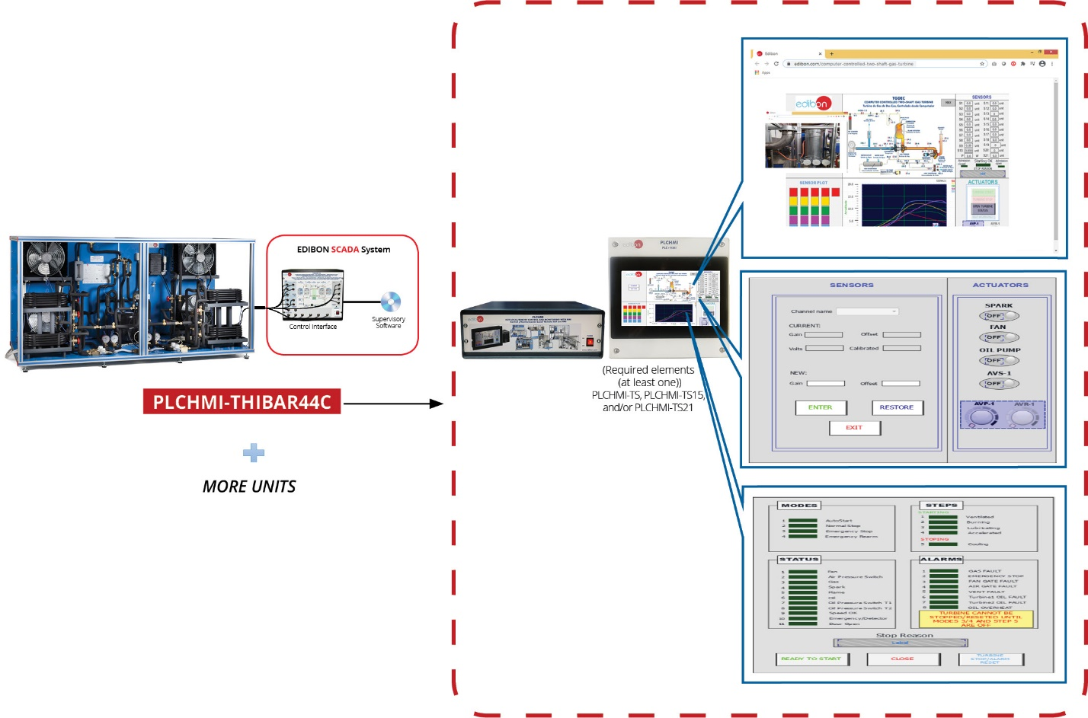

T

REQUIRED ELEMENTS (at least one) (Not included)

PLCHMI-TS: 10” TOUCH SCREEN KIT FOR PLCHMI:
PLCHMI-TS15: 15” TOUCH SCREEN KIT FOR PLCHMI:
PLCHMI-TS21: 21” TOUCH SCREEN KIT FOR PLCHMI:
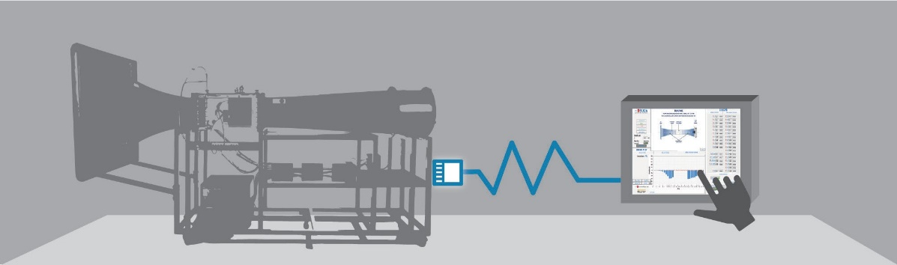
LABORATORY

The PLCHMI-TS range consists of some compact, powerful and robust touch screens that allow the user to interact with processes and variables locally through own PLCHMI SCADA application (SCADA-HMI).
* The SCADA software designed for the PLCHMI (SCADA-HMI) expansion includes indicators, actuators, waveform graphs, etc. to represent trends, display sensor values and manipulate hardware elements.
* The acquired data can be exported, plotted and post-processed for different software applications such as EXCEL, MATLAB, PYTHON, etc.

ADDITIONAL RECOMMENDED ELEMENTS (Not included)

PLCHMI-CLOUD. PLCHMI REMOTE CONTROL KIT:
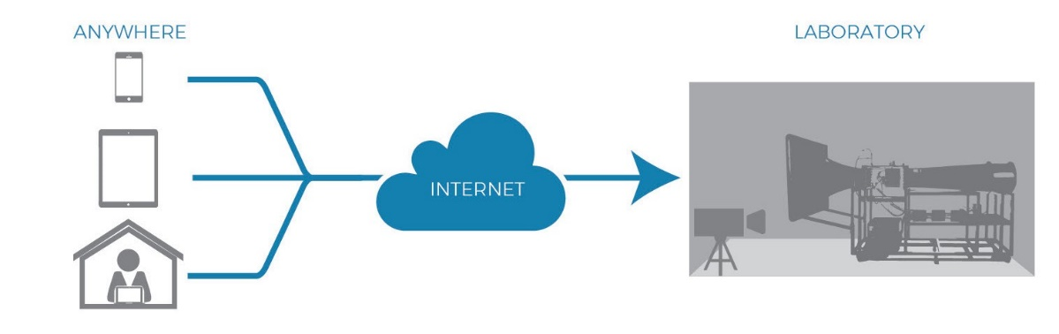

The PLCHMI-CLOUD is a COMPLETE cloud solution that allows to control and visualize EDIBON Units through the internet, allowing remote control through devices such as smartphones, tablets and PCs. (May require the intervention of laboratory technicians).
*The unit can be controlled and supervised in REAL TIME at any time and in any place using its internet connection using included HD cameras.
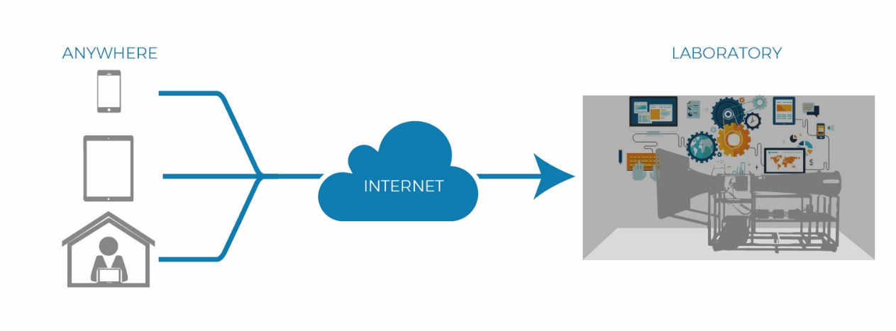
CLOUD-UNIT. AUTOMATION AND REMOTE CONTROL KIT FOR UNIT.

The CLOUD-UNIT kit includes automation of some or all hardware elements (see options) and its associated safety measures.
This kit additionally allows remote control with third-party applications.

IIoT local/remote Control and Monitoring with HMI software package, “PLCHMI” includes the following items:
SPECIFICATIONS
- PLCHMI expansion items: 1, 2 and 3.

1 PLCMI-UNIT. IIoT local/remote Control and Monitoring with HMI for each EDIBON unit.
IIoT local/remote Control and Monitoring with HMI, “PLCHMI”, is composed by the following included element:

HMI CONTROL BOX:
A high performance and reliability control box providing a controlled environment for all devices responsible of the electrical functionality of the unit (power supplying, data signal conditioning, control, electrical protection, etc.) and also for quick and easy connection between the unit and HMI.
• Electrical supply:
Single-phase 100 - 240 VAC, PH+N+G.
Magneto-thermal differential, 2 poles, 25 A, 30 mA AC 6 KA.
• PLC controller:
Panasonic FP7 CPS31E CPU.
• Digital I/O modules:
16 digital inputs; Input range 0 V to 24 V.
16 digital outputs; Relay output.
• Analogue I/O modules:
16 analog inputs; 16-bit resolution. Input range: -10 V – +10 V.
4 analog outputs; 16-bit resolution. Output range: -10 V – +10 V.
• Connectors and Communication Ports:
2-Port Ethernet switch. SCSI connector.
USB port, DB-9or DB-25 serial port (if required).

ROUTER WIFI GLOBAL 4G INDUSTRIAL ROUTER:
NAT, DHCP Server/Client.
Virtual Server.
DMZ Host.
Firewall with IP-, MAC and Domain-Filter.
RMS support.
OpenVPN, PPTP.
L2TP, QOS, IPsec.
Port Forwarding.
*This item could be replaced during and after the quotation if the device is not supported by the manufacture anymore.

2 Cables and Accessories, for normal operation.
3 Manuals: This unit is supplied with the following manuals: Required Services, Assembly and Installation, Starting-up, Safety, Maintenance
& Practices Manuals.

4 Required elements (Not included):
PLCHMI-TS. 10” Touch Screen Kit for PLCHMI:
• Electrical supply: Single-phase 100 - 240 VAC, PH+N+G.
• Touch screen: Analog resistive.
• Size: 10” 16:9 TFT.
• Resolution: 1024 x 600, WVGA.
• Colors: 64 K.
• Ethernet port.

PLCHMI-TS15. 15” Touch Screen Kit for PLCHMI:
• Electrical supply: Single-phase 100 - 240 VAC, PH+N+G.
• Touch screen: Analog resistive.
• Size: 15.6” TFT.
• Resolution: 1366 x 768, WVGA.
• Colors: 16 M.
• Ethernet port.

PLCHMI-TS21. 21” Touch Screen Kit for PLCHMI:
• Electrical supply: Single-phase 100 - 240 VAC, PH+N+G.
• Touch screen: Analog resistive.
• Size: 21.5” TFT.
• Resolution: 1920 x 1080, WVGA.
• Colors: 16 M.
• Ethernet port.

Additonal recommended elements (Not included):
5 PLCHMI-CLOUD. PLCHMI Remote Control Kit:
• IP Camera:
Hardware:
High quality CMOS sensor for crystal clear images. Pan and Tilt functions to cover a large area.
Built-in IR LEDs to capture video in low-light environments.
Wi-Fi Connectivity:
Wireless 802.11n that gives increased speed, range, and reliability.
Possibility to place anywhere without the need for additional network cabling. Sound and Video:
Real-time H.264 and MJPEG compression for reduced video file size. Sound and motion detection.
Remote and Mobile Access.
*This item could be replaced during and after the quotation if the device is not supported by the manufacture anymore.
SPECIFICATIONS
• Corvina Cloud License: Application to reach gateways such as human Interfaces and the endpoints like PLCs and IP cameras.

6 CLOUD-UNIT. Automation and Remote Control Kit for each EDIBON unit:
• Automation elements of some or all hardware elements (see options).
• Associated safety measures.

EDIBON SOFTWARE PLCHMI EXPANSION MAIN SCREENS

Example of an HMI SCADA interface

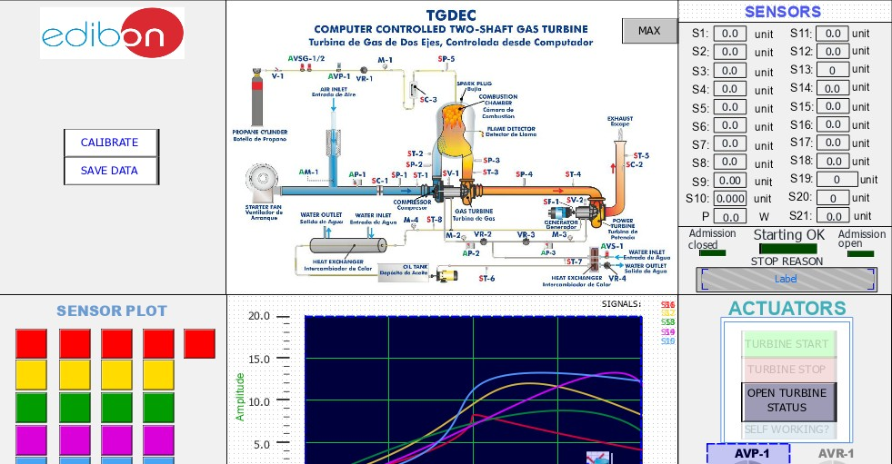

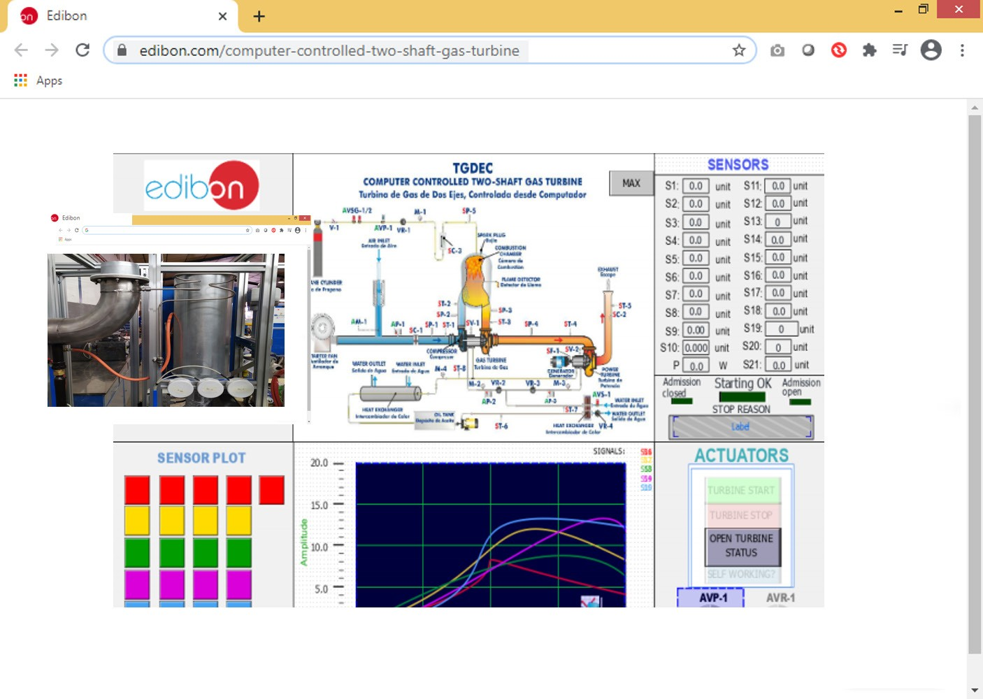
Example of an HMI SCADA interface

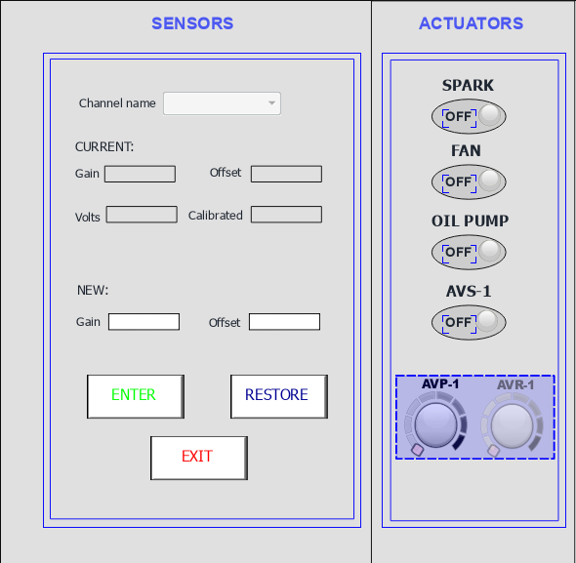

Example of an HMI SCADA interface
EDIBON SOFTWARE PLCHMI EXPANSION MAIN SCREENS

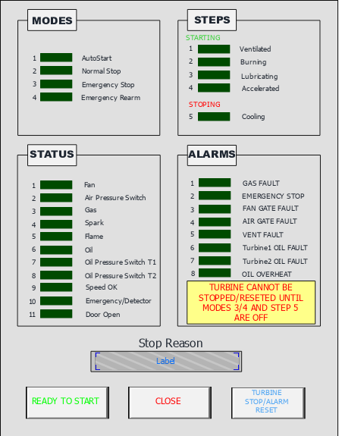
Example of an HMI SCADA interface

AVAILABLE WIDE RANGE OF PLCHMI APPLICATIONS (PID CONTROL)

Units which can use PLCHMI:

Examples:

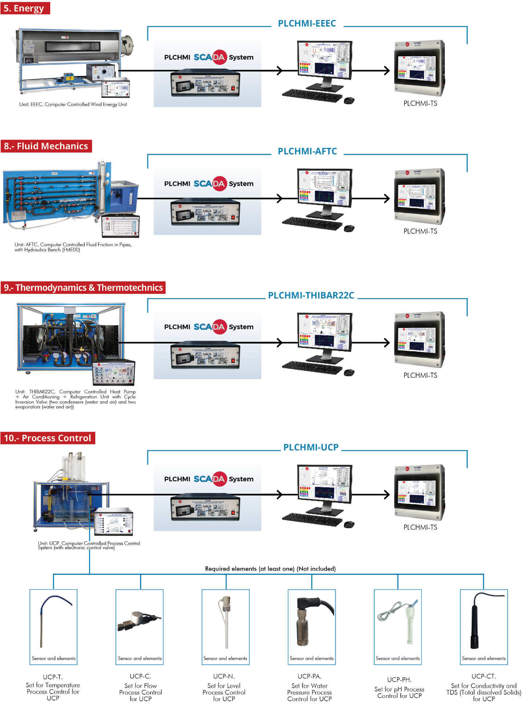

AVAILABLE WIDE RANGE OF PLCHMI APPLICATIONS (PID CONTROL)

Units which can use PLCHMI:
Example of an HMI SCADA interface

Examples:
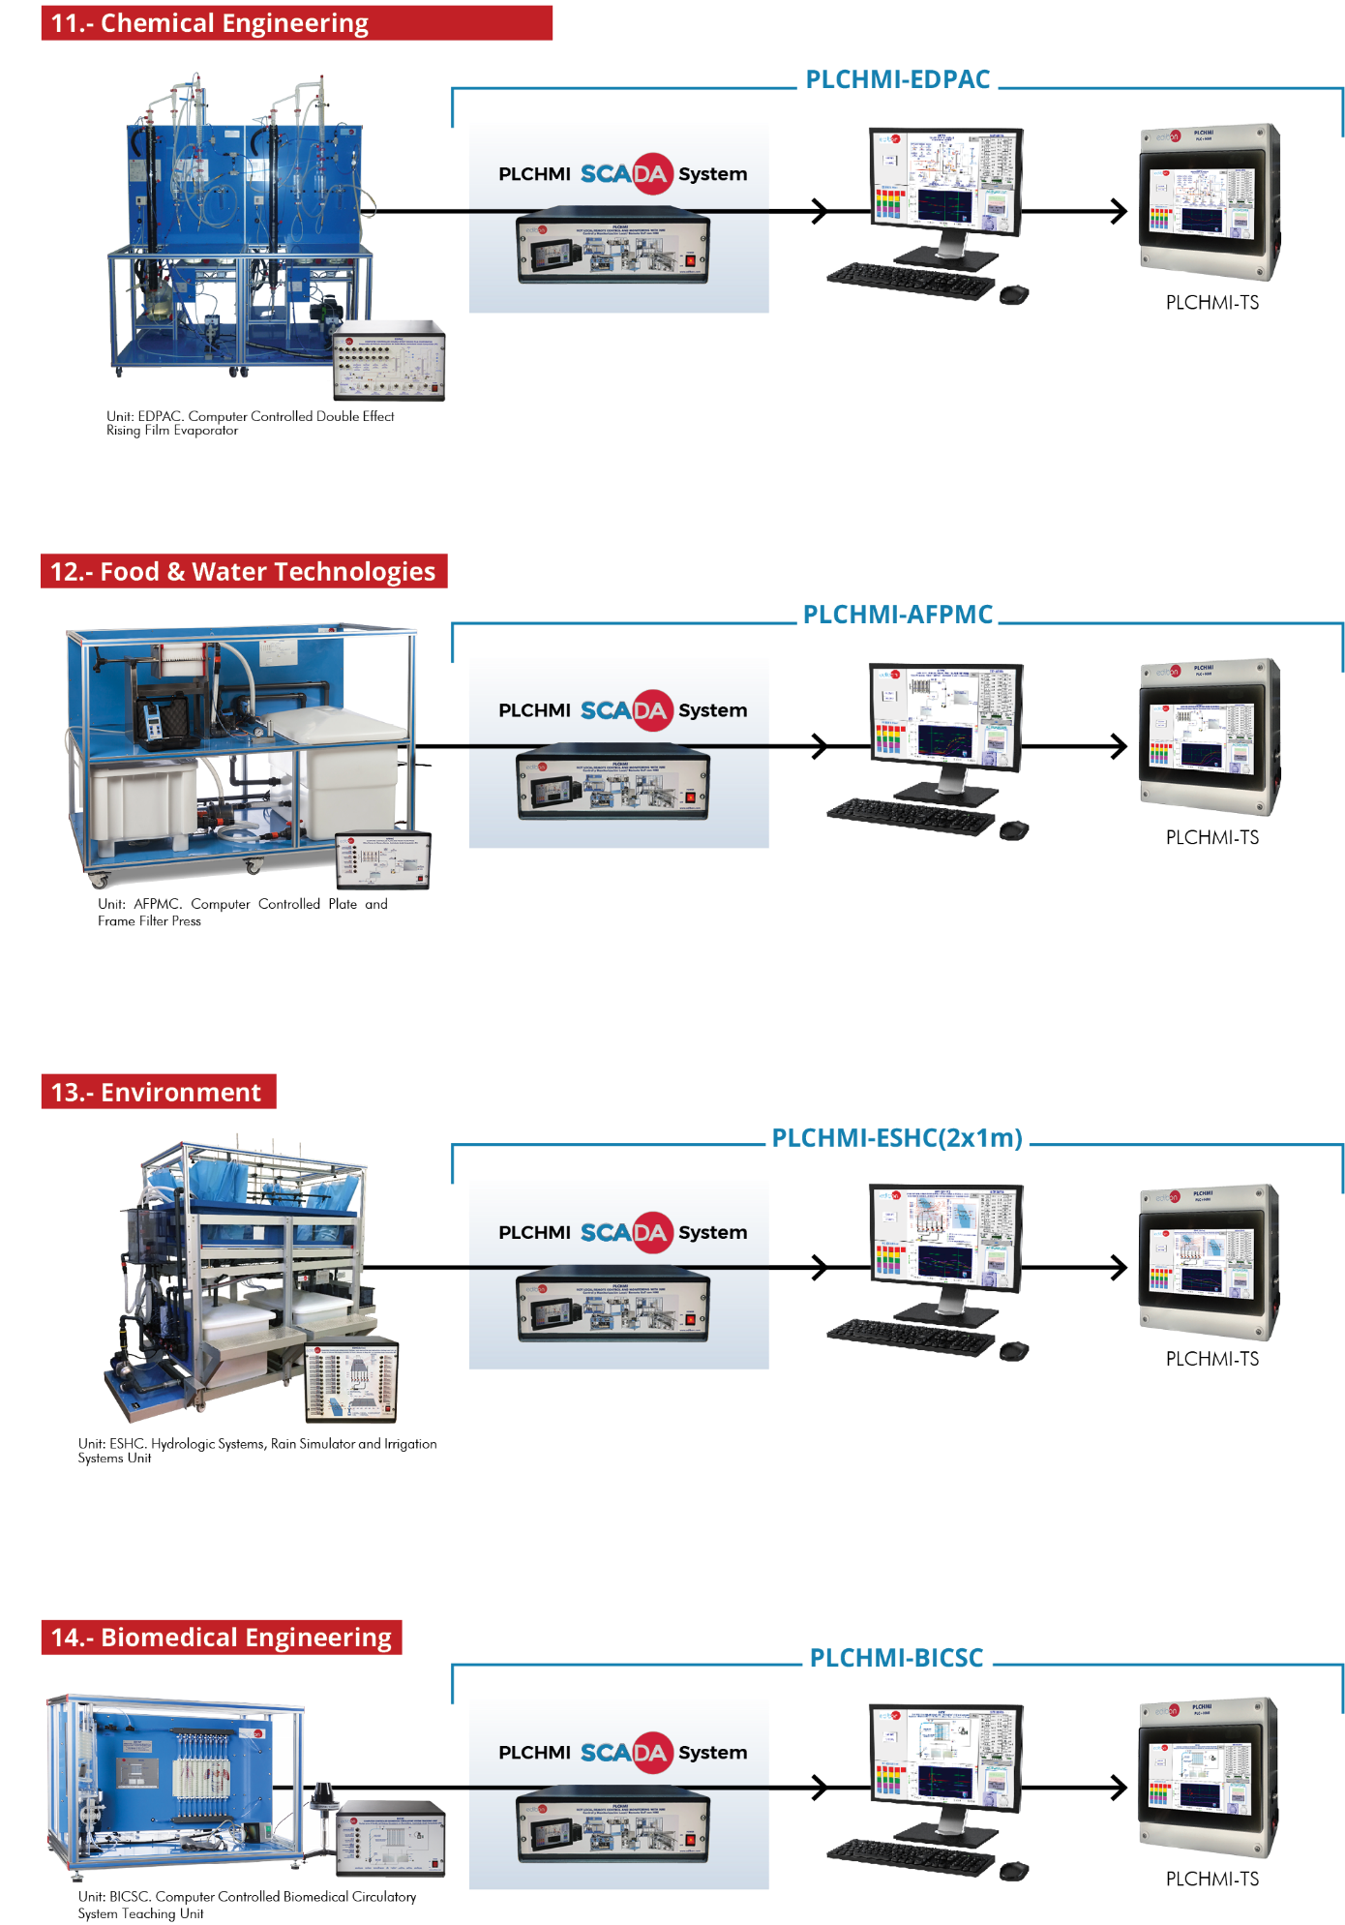

ORDER INFORMATION

Main items
Minimum supply always includes:
1 PLCHMI-UNIT: IIoT local/remote Control and Monitoring with HMI for each EDIBON unit.
2 Cables and Accessories, for normal operation.
3 Manuals.

4 Required elements (at least one) (Not included):
PLCHMI-TS. 10” Touch Screen Kit for PLCHMI.
PLCHMI-TS15. 15” Touch Screen Kit for PLCHMI.
PLCHMI-TS21. 21” Touch Screen Kit for PLCHMI.

Optional items (supplied under specific order)

5 PLCHMI-CLOUD. PLCHMI Remote Control Kit.
6 CLOUD-UNIT. Automation and Remote Control Kit for each EDIBON unit.

