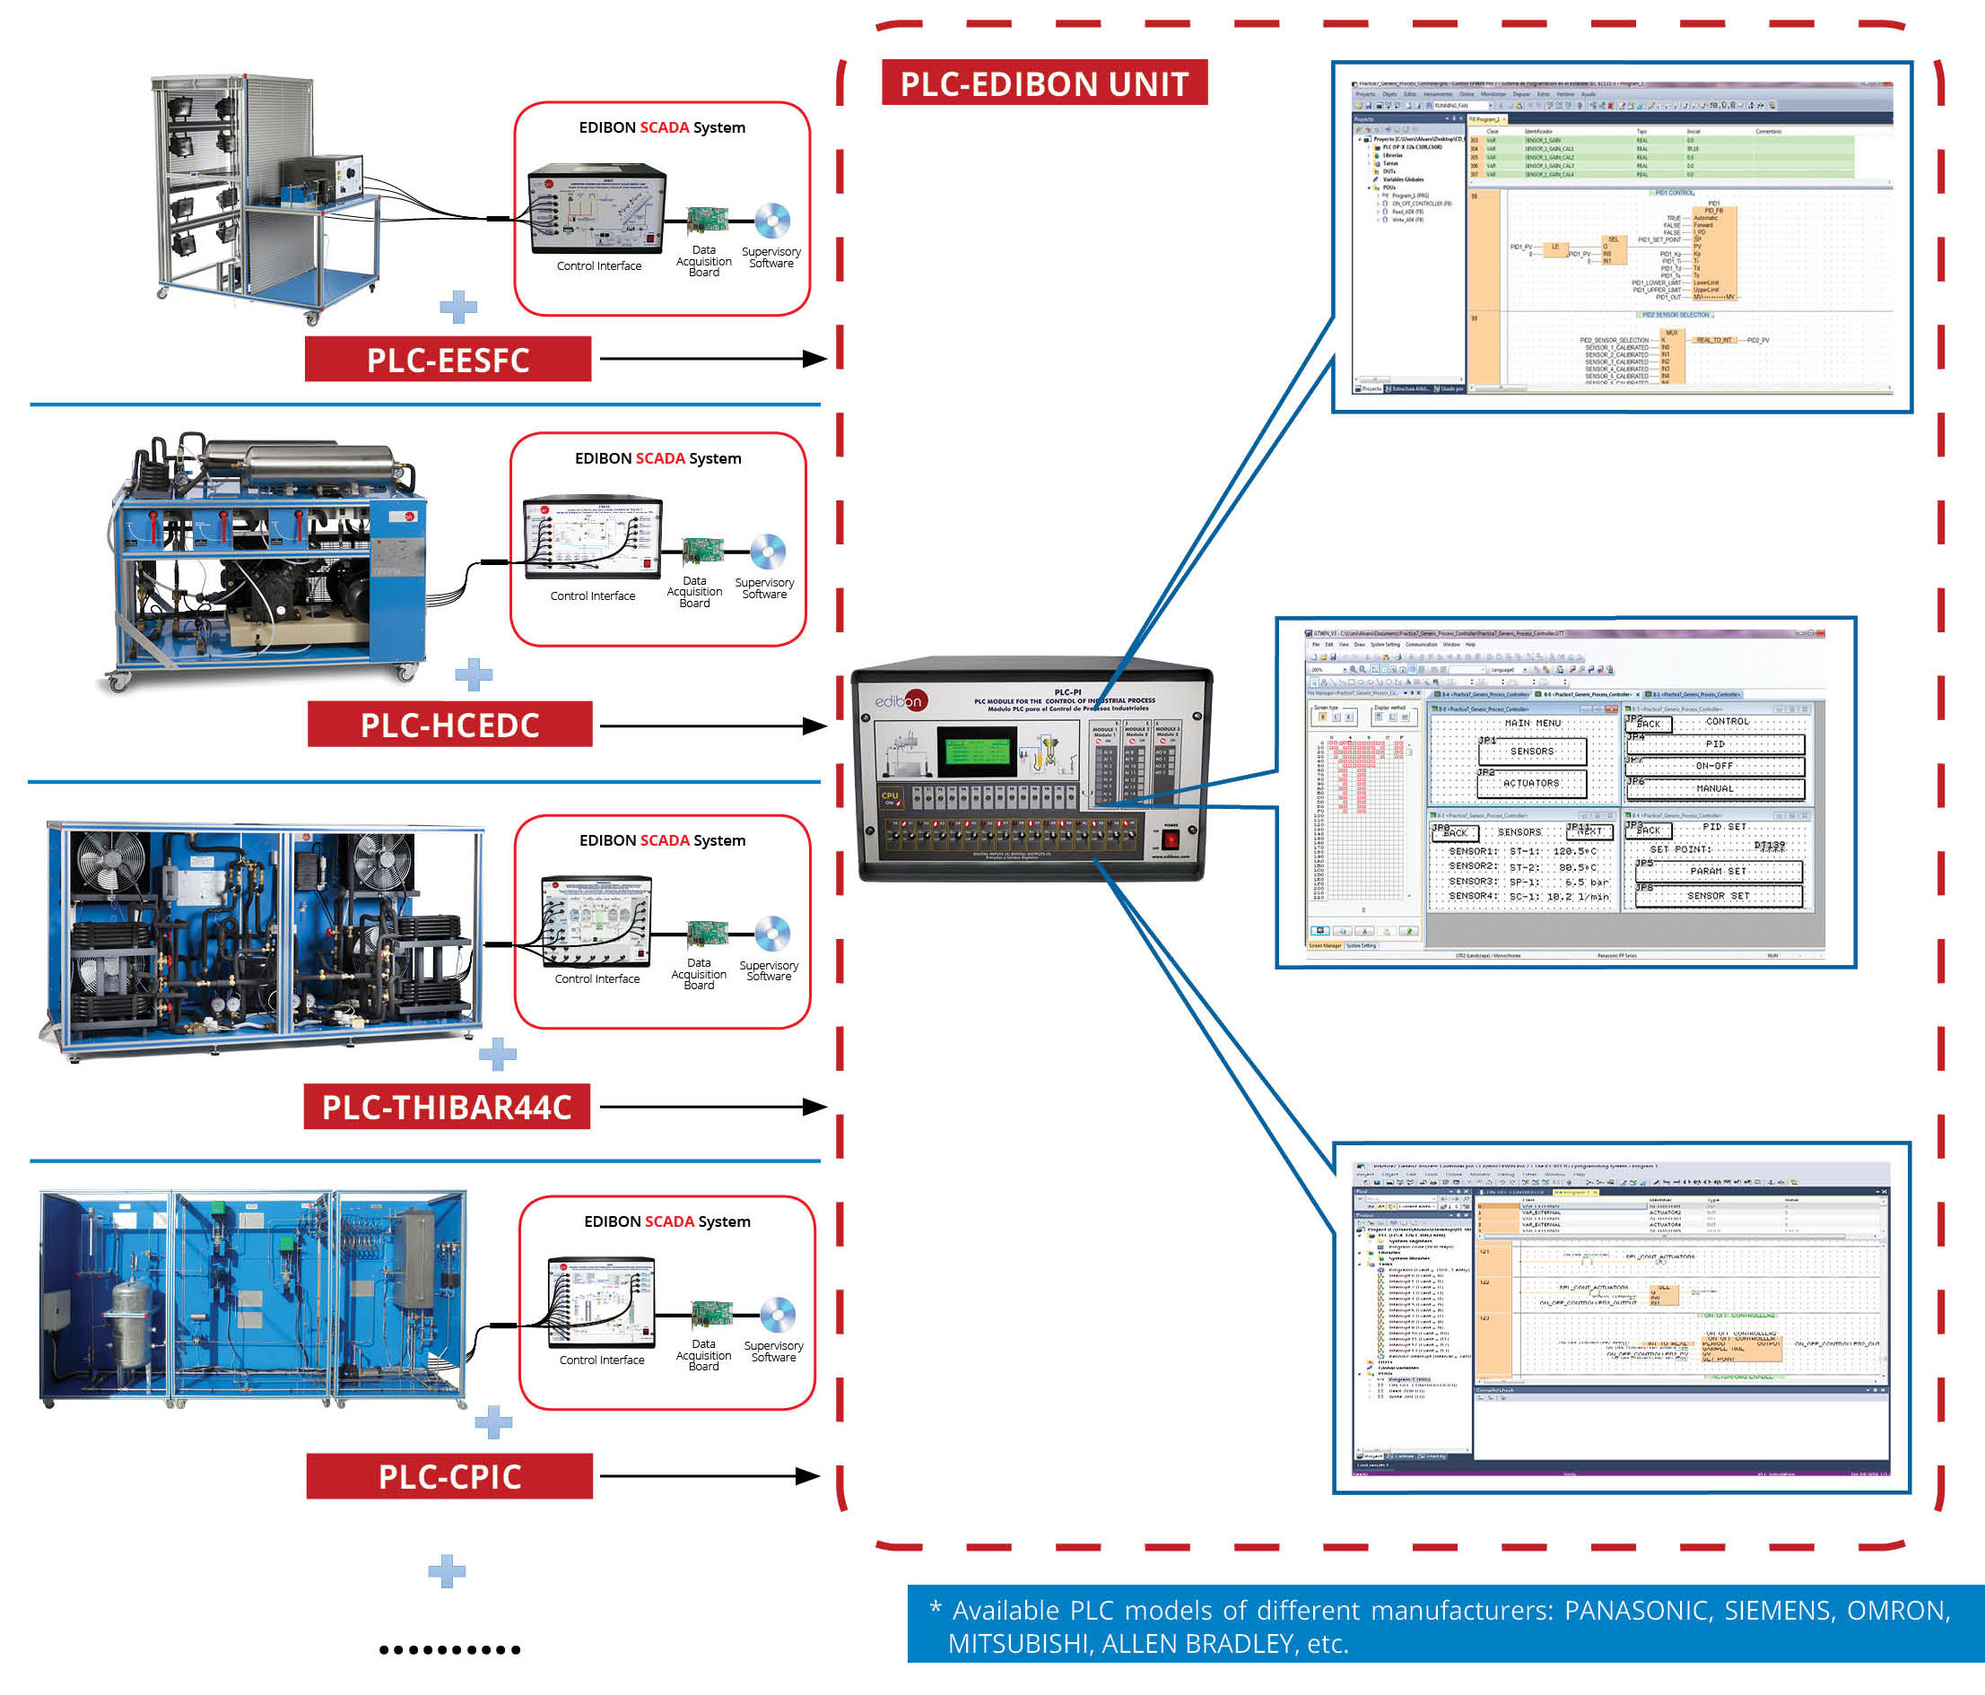

Key features:

• An industrial PLC with large capacity program, high speed and programming flexibility and touch screen to provide an HMI and expand the I/O functionality of the PLC system.

• Supports different programming languages such as Ladder Diagram (LD), Structured Text (ST), Function Block Diagram (FBD) Statement List (STL).

• Features different control algorithms such as PID control, proportional control, ON/OFF, etc. and possibility to develop custom algorithms.
• Programming software, sample programs and step-by-step practical exercises experiments are included.

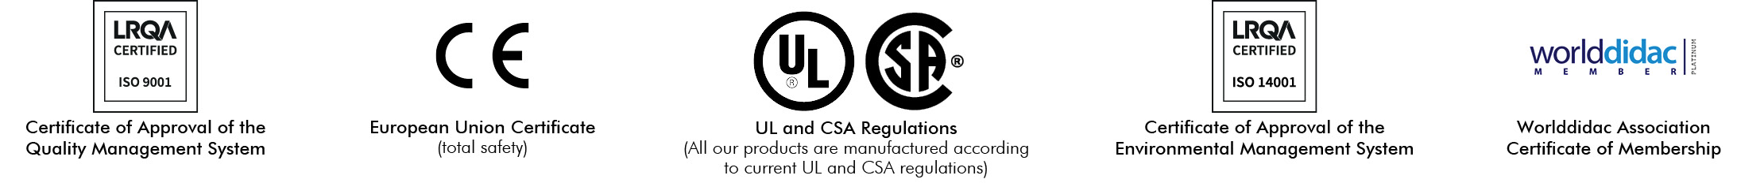

1

INTRODUCTION

A programmable logic controller (PLC) is a small industrial computer designed to work in industrial environments and automate electromechanical processes. PLCs are able to control processes based on real-time data, adjust parameters and act on production processes remotely.

Equipment or processes that require maintaining some fixed parameter can easily be found in industry. The speed of a motor, the flow, level and temperature of a hydraulic circuit or the pressure of a compressed air system are good examples. To control all these variables, different strategies are implemented using PLCs and control and acquisition applications that, in addition to controlling, allow the process visualization. PLCs use classical control algorithms such as PID control (proportional, integral and derivative) and other more complex strategies such as the cascade control, multivariable control, feed forward control and selective control.

The continuous improvement of the industrial processes and the search for new forms of production organization are laying the foundations of the Industry 4.0 or smart factories. This industry seeks complete digitalization and automation, generating a regular flow of information and interconnecting all the elements of a process through the so-called IoT (Internet of Things). The need for process flexibility and manufacturing efficiency involves the development of computer-controlled autonomous factories.

GENERAL DESCRIPTION

The PLC expansion is a PLC-based system designed to work in conjunction with other units from EDIBON. These units can be controlled by the PLC expansion to obtain a required function. The objective is to learn how PLCs are integrated in real industrial applications. The unit includes an industrial PLC, a HMI to expand the I/O functionality of the PLC system and different I/O modules such as a digital I/O module to acquire binary signals and control two-state actuators, an analog I/O to acquire analog signals (sensors, transducers and other analog signal sources) and control analog actuators (valves, pumps, etc.) and a communication module to communicate with a PC via USB.

The elements included are:

• PLC-PI. PLC Module for the Control of Industrial Processes (for working with EDIBON Computer Controlled Teaching Units).

Required elements:

• AEL-PC. Touch Screen and Computer.

SPECIFICATIONS

• Power Supply.
Supply voltage (Single-Phase): 230 VAC, PH+N+G. Differential magnetothermal, 2 poles, 25A, 30mA AC 6KA.

• Panasonic CPU.
Supply voltage (Single-Phase): 100-240 VAC PH+N+G. Overcurrent protection with fuse.
PLC device, Panasonic FP-X C3OR. Panasonic PLC:
High-speed scan of 0.32 sec. for a basic instruction.
Program capacity of 32 Ksteps, with a sufficient comment area. Free input AC voltage (100 to 240 VAC).
DC input: 16 (24 V DC).
Relay output: 14 (250 V A AC/2 A). Program capacity: 32 ksteps.
Equipped with a USB communication port. High-speed counter.

• Front Panel.
Digital inputs(X) and Digital outputs (Y) block:
16 Digital inputs, activated by switches and 16 LEDs for confirmation (red).
14 Digital outputs (through SCSI connector) with 14 LEDs for message (green).

• Back panel.
Power supply connector. Fuse 2A.
2 x USB connectors. SCSI connector.

SPECIFICATIONS

• Panasonic Analog I/O Module.
Expansion unit for analog inputs:
Input voltage range from -10V to +10V.
16 analog inputs. Resolution of 12 bits.
Expansion unit for analog outputs:
Output voltage range from -10V to +10V.
4 analog outputs. Resolution of 12 bits.
Connector for the analog input and output signals.

• Panasonic Small HMI Module.
HMI device: Touch screen.
STN Monochrome LCD.
Display size: 88.5 x 35.4 mm (3.8 inches). Screen resolution of 240 (W) x 96 (H) dots. Backlight: 3 color LED (White/pink/red).

• AEL-PC. Touch Screen and Computer.
Touch Screen:
Energy efficiency class: A.
Screen diagonal: 68.6 cm (27 inch (s)). Power consumption (operating): 26 watts. Annual energy consumption: 38 kWh.
Power consumption (standby / off) 0.49 watts. Screen resolution: 1920 x 1080 pixels.
Computer:
Processor Number: Intel Core i7-6600U Processor (4M Cache, up to 3,40 GHz). Cache: 4 MB Intel Smart Cache.
Clock speed: 2.6 GHz.
# Of Cores/# of Threads: 2/4. Max. TDP/Power: 15 W.
Memory Types: DDR4-2133, LPDDDR3-1866, DDR3L-1600. Graphics: Intel HD Graphics 530.
Slot for PCI Express.

• HMI Programming software:
To perform different actions such as design screens, download them, upload data and or print. Large parts library including switches, lamps, keyboards, charts, etc.
Easy operation with simply drag-and-drop functionality. Line graph function to represent sampling data.
Copy screens to a clipboard in bitmap format.
Fonts include: TrueType, Fixed and all the Windows fonts installed on the PC. Multiple languages available.
Operation security functions such as security levels and passwords.

• PLC Programming Software.
Programming software developed according to the norm IEC 61131-3. Compatible with Windows operating systems.
Five programming languages:
Ladder diagrams (LD). Structured text (ST). Instruction list (IL). Sequential function chart (SFC). Function block diagram (FBD). Remote programming, service and diagnosis.
Minimum size of program.
Powerful debugging and monitoring tools.
Supports functions created by the user and function blocks. Saves project files in the PLC.
Examples and quick tutorial included.

POSSIBLE PRACTICAL EXERCISES

The PLC expansion is a PLC-based system designed to work in conjunction with other units from EDIBON. These units can be controlled by the PLC expansion to obtain a required function. The objective is to learn how PLCs are integrated in real industrial applications. To that end, different practical exercises can be carried out, such as, data sensor acquisition and calibration, manual and automatic PID process control, development of custom controllers, etc.

1.- Sample program to use variables, timers and counters.

2.- Sample program to program in different languages: ST (Structured Text), LD (Ladder Diagram) and SFC (Sequential Function Chart).

3.- Sample program to use digital inputs/outputs.

4.- Sample program to use analog inputs/outputs.

5.- Sample program to program an HMI.

6.- Sample program for data sensor acquisition.

7.- Sample program for data sensor calibration.

8.- Sample program for manual control of a process (analog).

9.- Sample program for manual control of a process (digital).

10.- Sample program for PID control of a process.

11.- Sample program for ON-OFF control of a process.

12.- Sample program for a generic process controller.

EDIBON SOFTWARE PLC EXPANSION MAIN SCREENS

Example of a PLC program

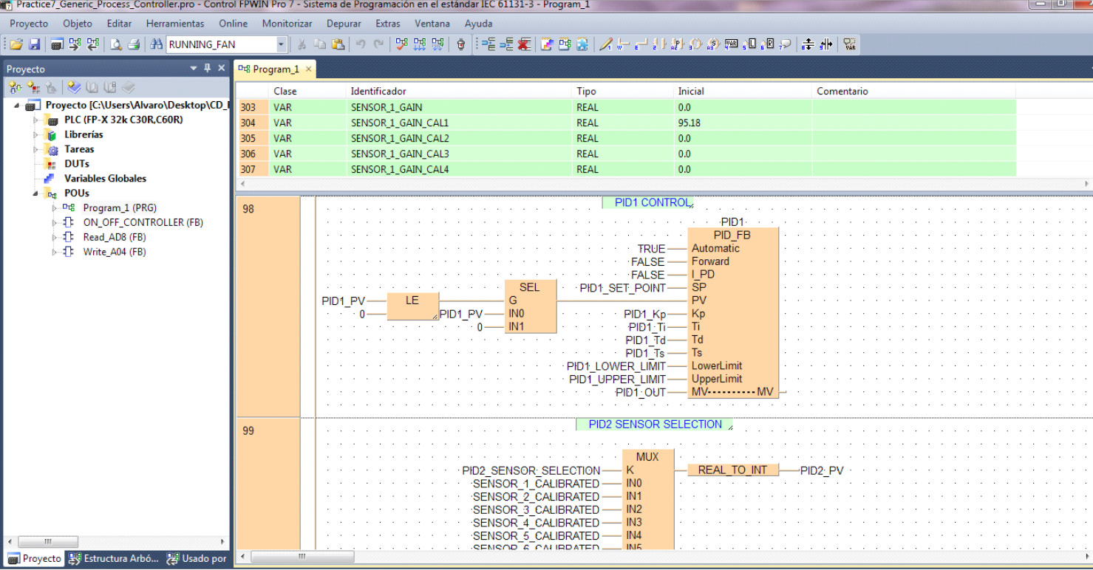

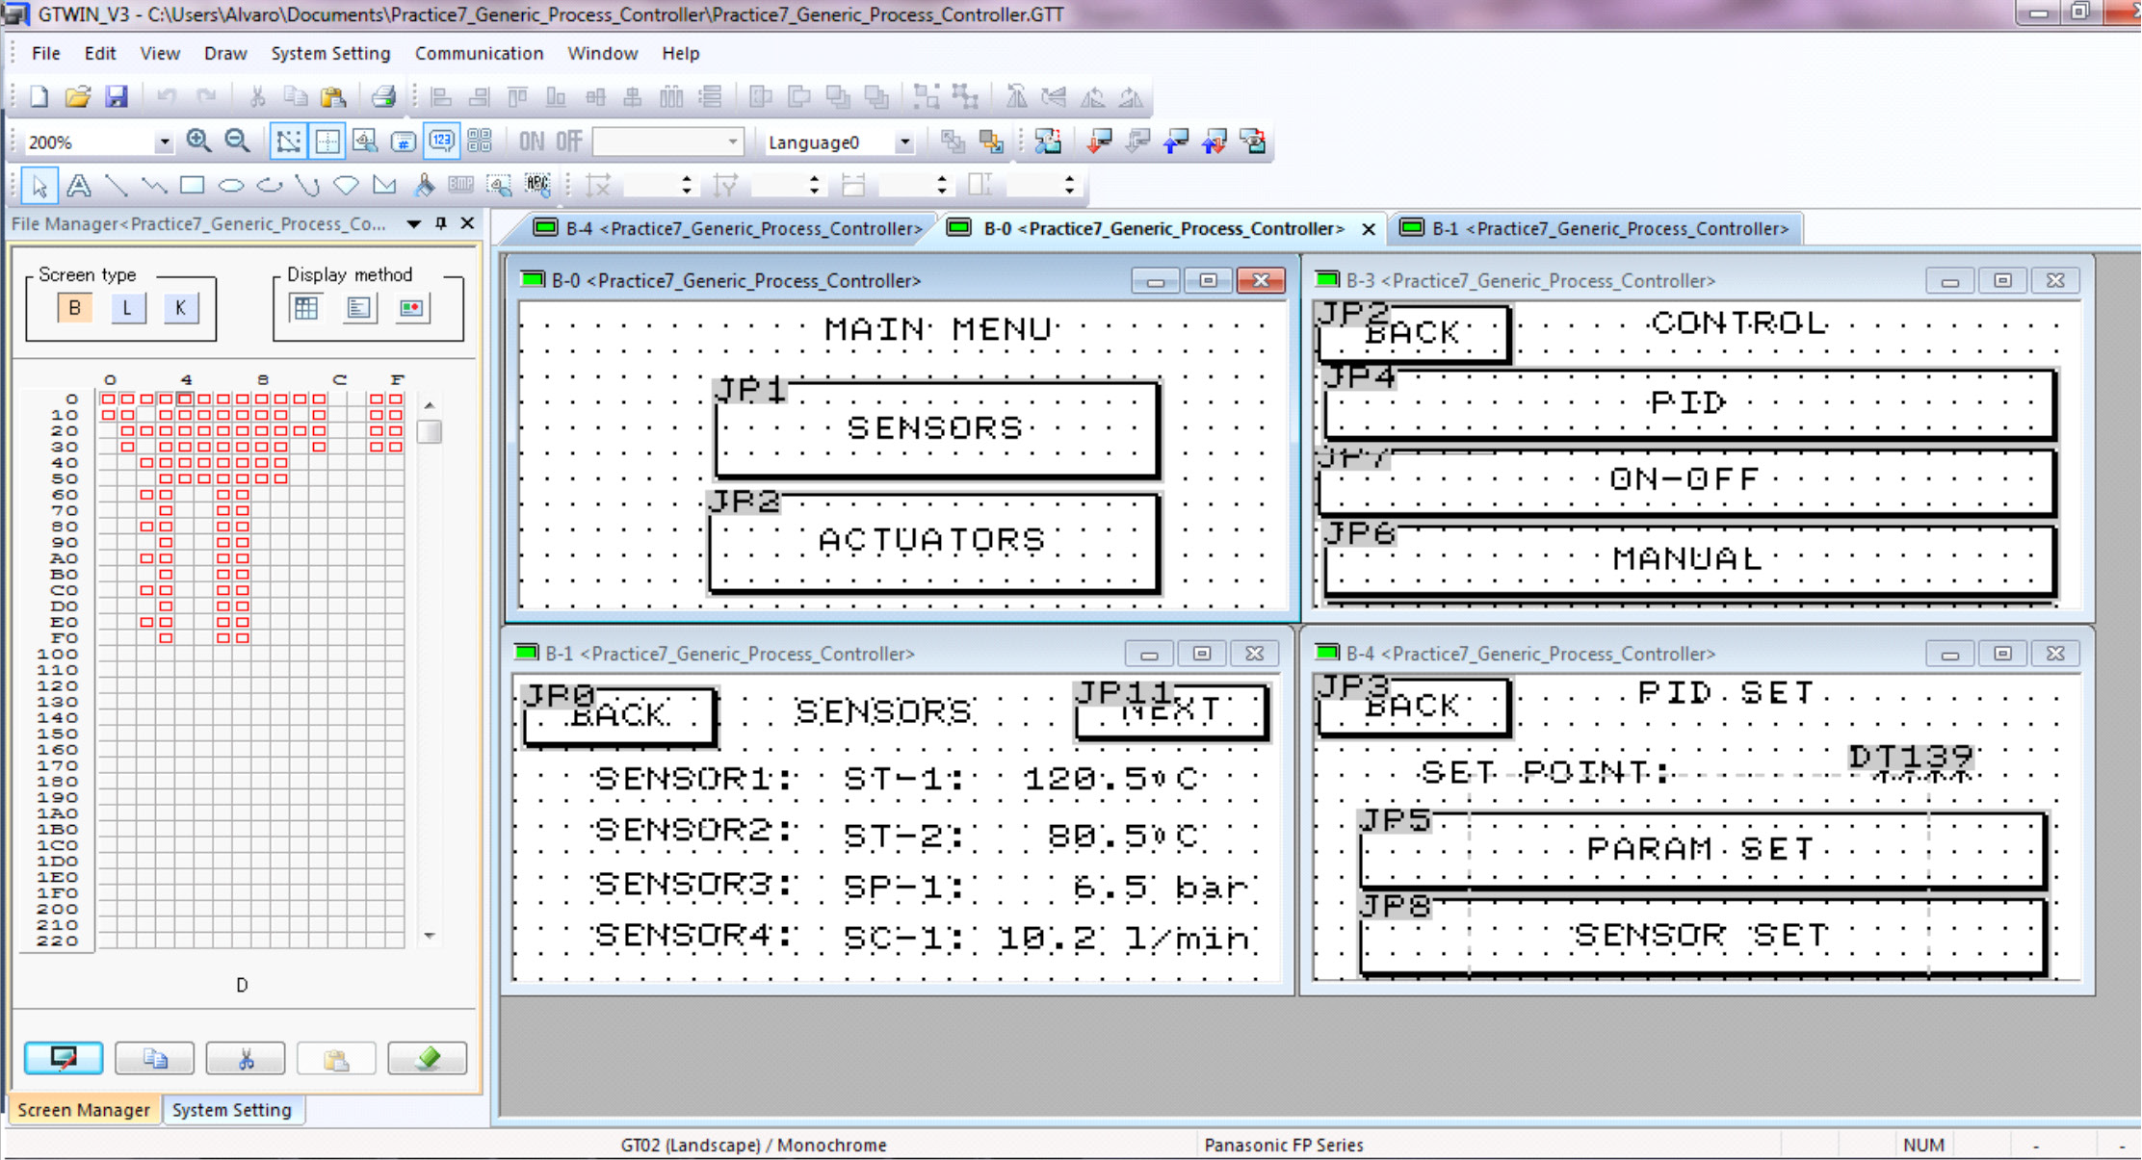

Example of an HMI program

EDIBON SOFTWARE PLC EXPANSION MAIN SCREENS
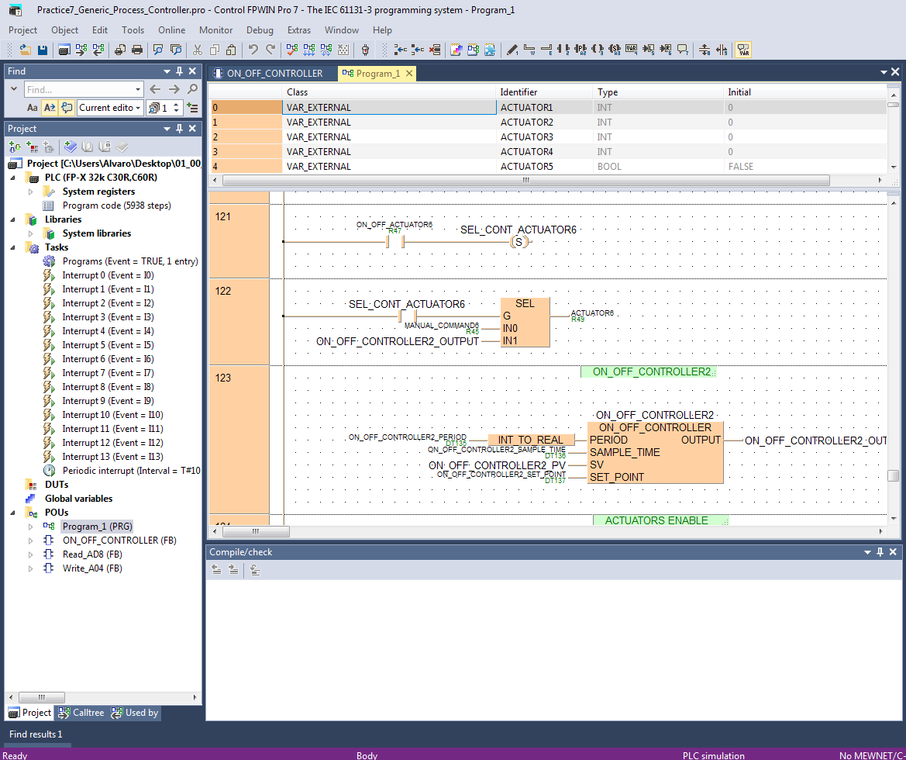
Example of a PLC program

PLC-THIBAR22C

AVAILABLE WIDE RANGE OF PLC APPLICATIONS (PID CONTROL)

Units which can use PLC-PI:
Examples:

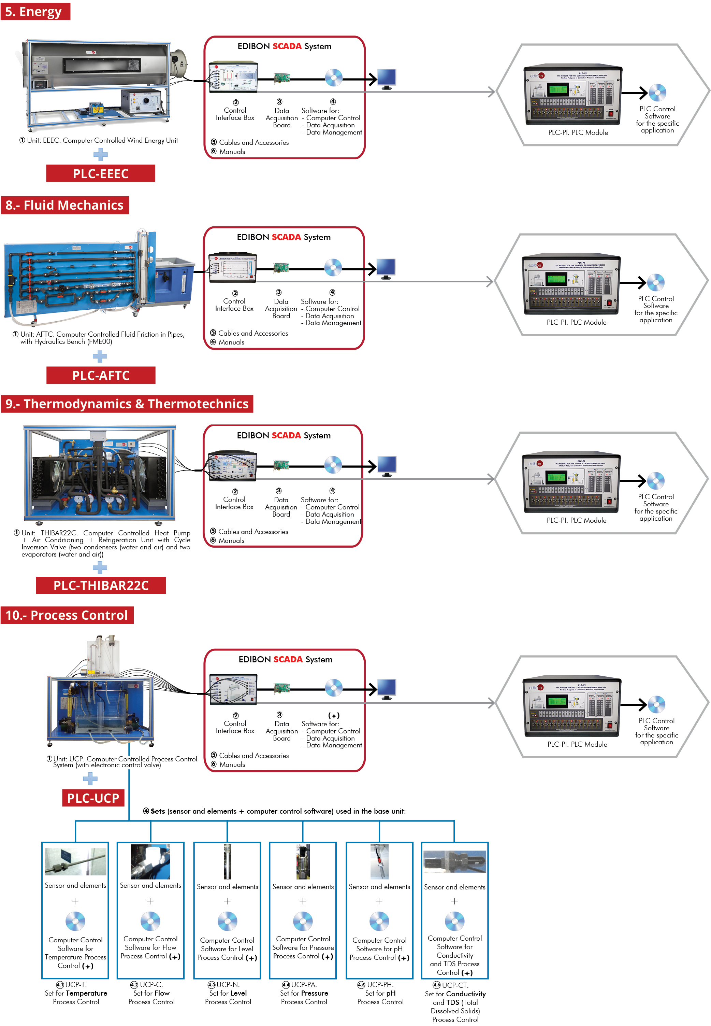

AVAILABLE WIDE RANGE OF PLC APPLICATIONS (PID CONTROL)

Units which can use PLC-PI:

Examples:

