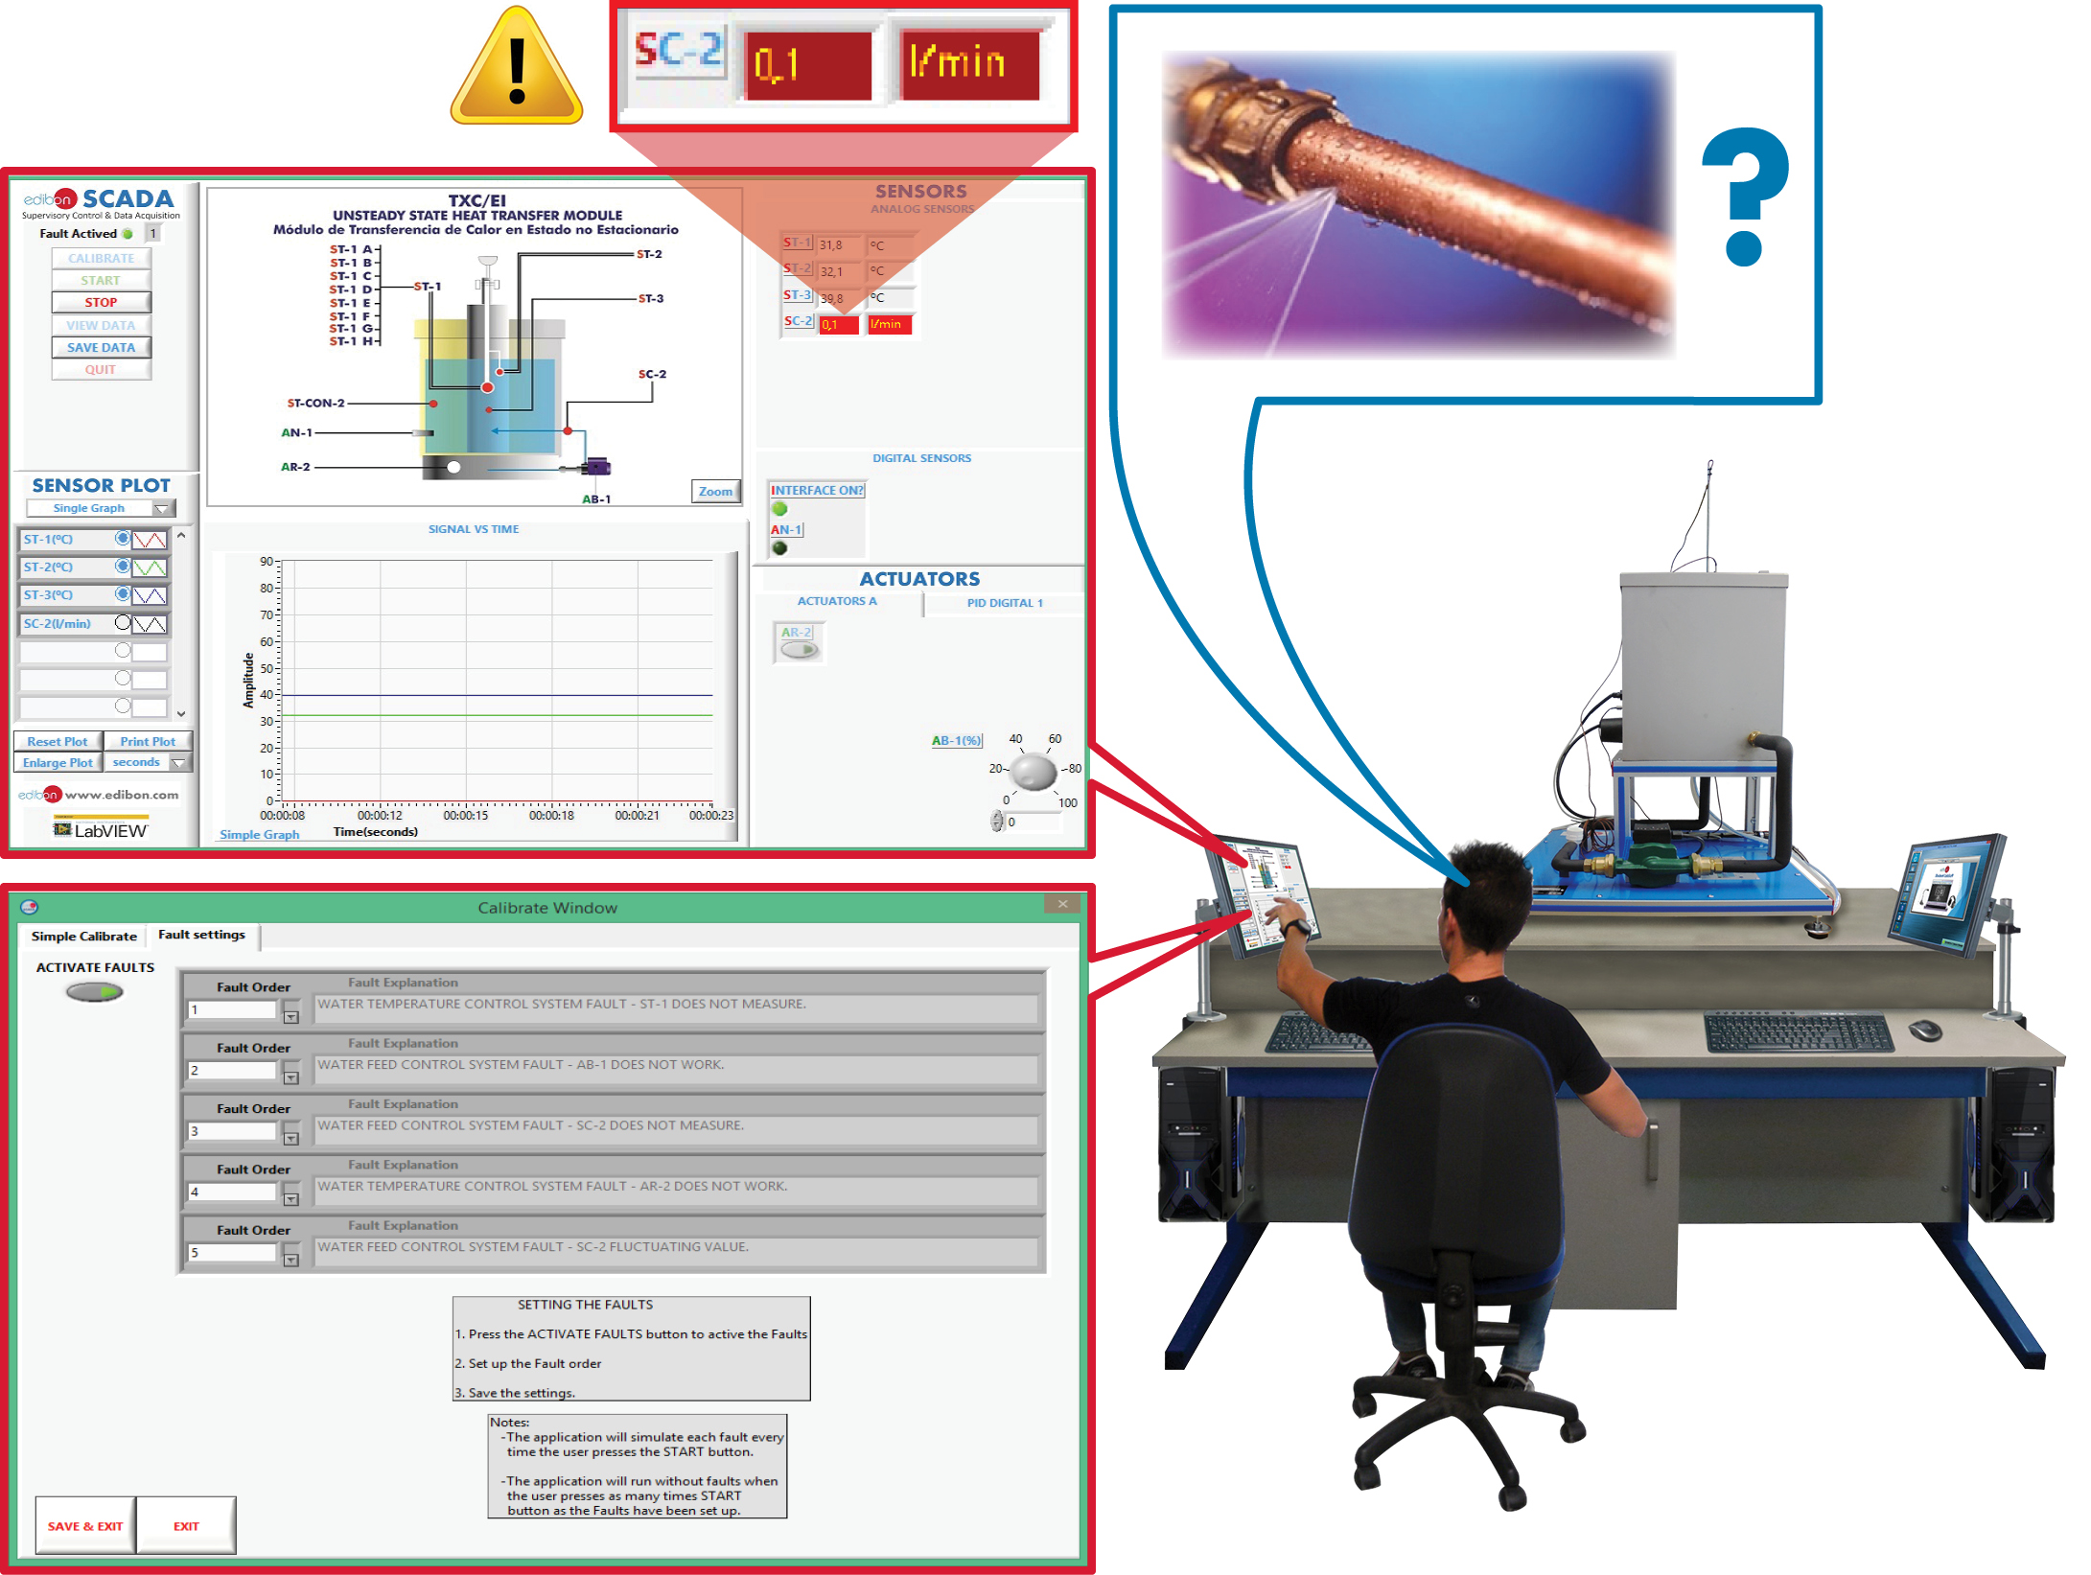
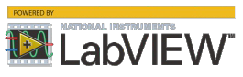

Key features:

- Wide range of faults, specific to each EDIBON teaching equipment.
- Configurable system: The faults are sequentially reproduced and can be reordered, as well as be activated/deactivated individually.
- Fully integrated with EDIBON SCADA control software.
- Supervising unexpected conditions.
- Alarms and warnings for extreme operating conditions.
- Includes specific EDIBON software, based on LabVIEW.
- Completely safe: Thanks to the simulation, the equipment is always protected from damage.
- Compatible with all EDIBON computer-controlled equipment, for each area.
- High teaching potential, particularly in the area of industrial maintenance.

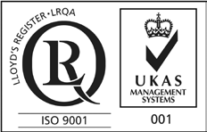

ISO 9001: Quality Management (for Design, Manufacturing, Commercialization and After-sales service)
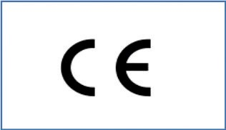

European Union Certificate
(total safety)

Certificates ISO 14001 and ECO-
Management and Audit Scheme
(environmental management)
1
Certificate and Worlddidac
Member

INTRODUCTION

The existing industrial processes have reached such an extent that it is essential to monitor any and all parameters and variables in order to ensure a proper functioning. This is possible through SCADA systems, although highly qualified personnel with the ability to interpret large volumes of information are required to act accordingly when needed. That is why the judgement of a good professional is crucial, particularly when anomalies indicating faults arise, which shall mean any change to a process or machine that prevents it from performing the function it was designed for. So, detecting these anomalies or signs and correctly identifying the faults that cause them make it possible to take the appropriate corrective actions, thus preventing, in many cases, serious damage to industrial equipment, which could otherwise lead to the ineffectiveness of entire plants.

GENERAL DESCRIPTION

Faults Simulation System (FSS) enables to safely reproduce signs of faults in the processes carried out by EDIBON teaching equipment. These faults are simulated, since the detected anomalies, indicating such faults, have been previously programmed and they only take place fictitiously. Therefore, real equipment is not damaged at any time.

The teaching objectives of this teaching technique are as follows:

1. The identification of anomalies or signs of the faults detected in software.

2. The diagnosis of potential faults that may be causing the aforementioned anomalies.

3. The development of the appropriate corrective actions for the potential faults that have been diagnosed.

Therefore, this tool has a high teaching potential to train highly qualified professionals, with the ability to monitor and to keep real industrial processes operating as efficiently as possible.

PRACTICAL POSSIBILITIES

Faults Simulation System has numerous potential applications, which represent a wide range of faults, including:

1) Potential faults affecting the Data Acquisition System:

- Incorrect application of calibration.

- Fluctuations in sensor measurements.

- Exchanged sensor measurements.

- Non-linearity in sensor response.

2) Potential faults affecting the Control System:

- Exchanged actuator response.

- Inverted actuator response.

- Reduced or cancelled actuator response.

- Reversing the response of automatic ON/OFF controls.

- Increasing or reducing the closed-loop system response with an automatic PID controller regarding the desired response.

- Cancelling the response of different types of automatic control.

SOFTWARE MAIN SCREENS

Fault settings access is restricted as it is required to previously introduce Instructor credentials
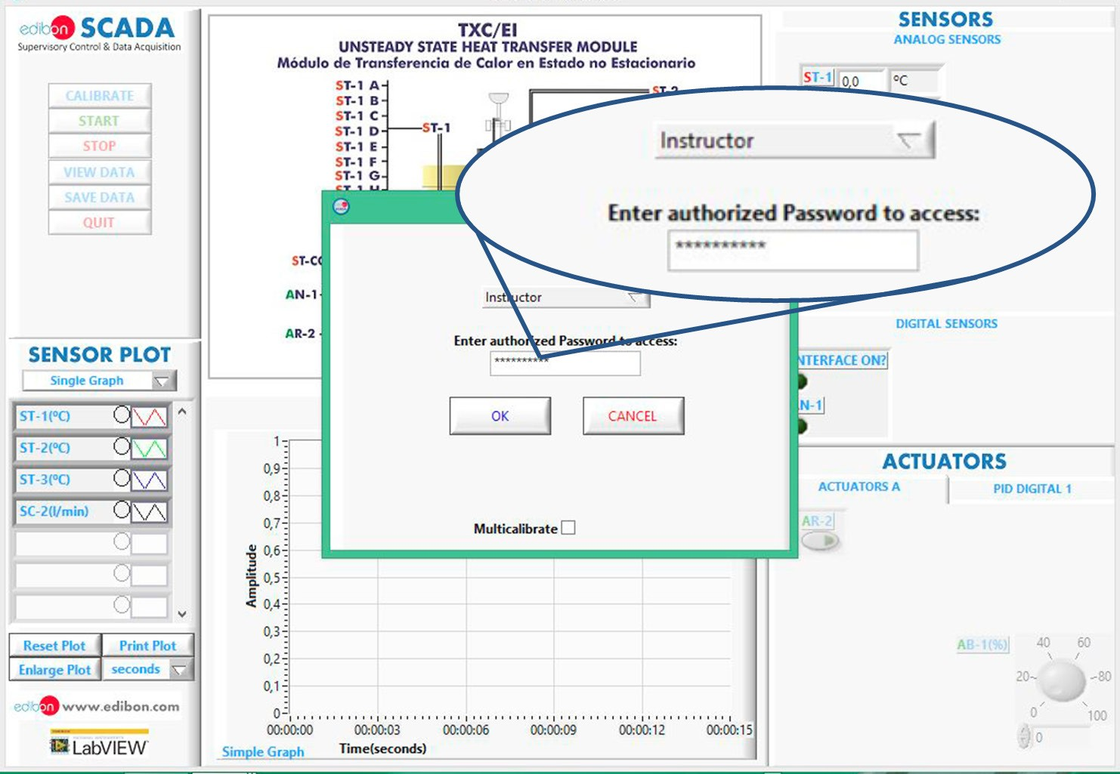

Fault settings menu. The Instructor can activate or deactivate the faults execution, observe the explanation of each individual fault and set the order in which those faults must be executed
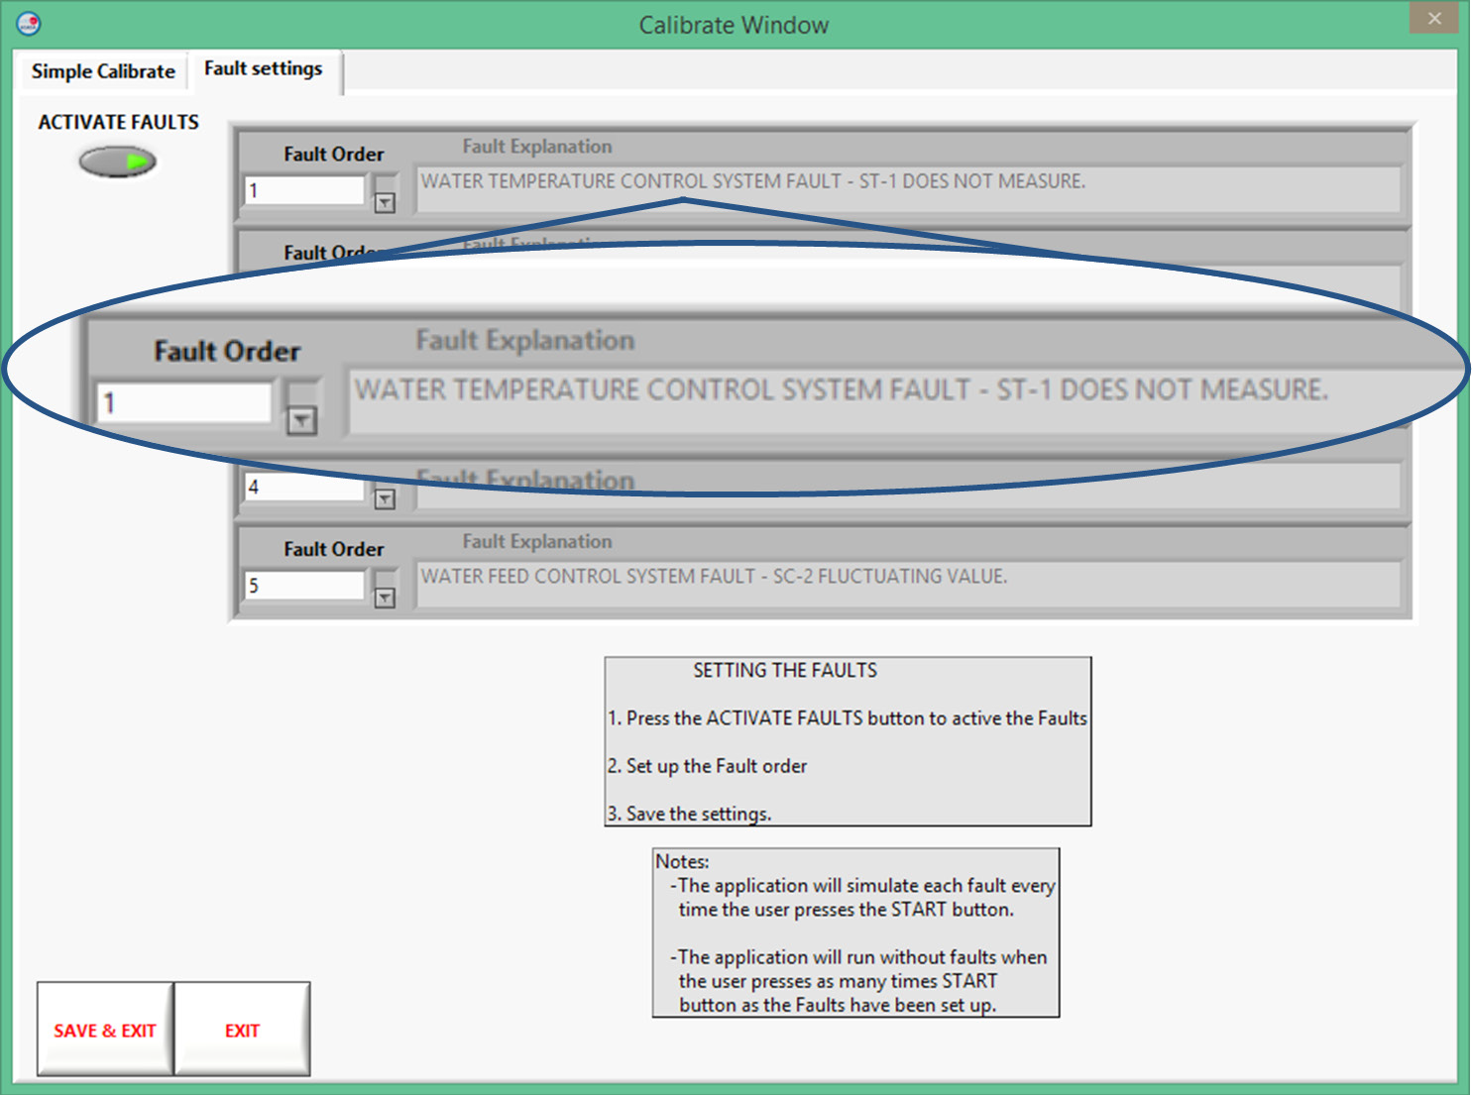

SOFTWARE MAIN SCREENS

Single fault execution example, consisting on an anomalous temperature measurement. The student must determine the causes of such anomaly as well as deciding the most appropiate corrective actions to fix that fault
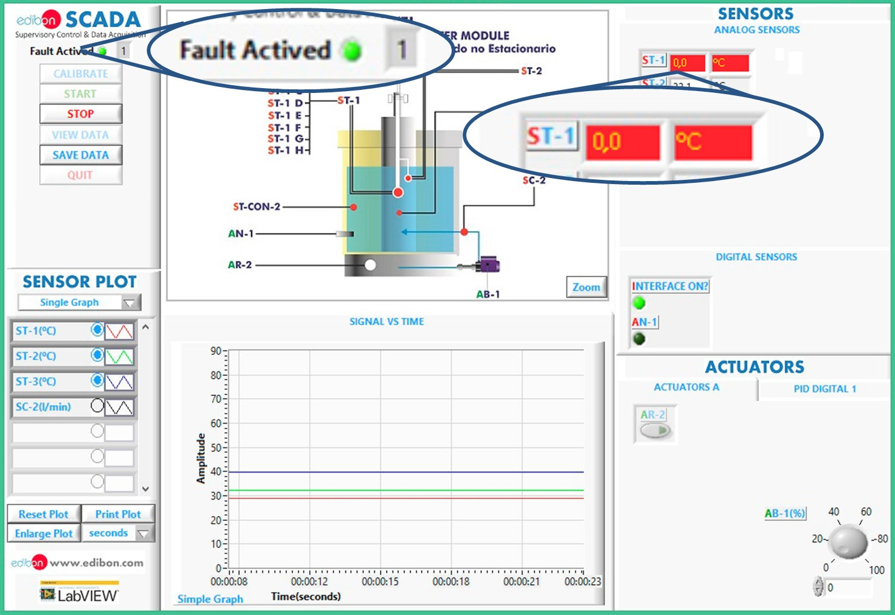

4

