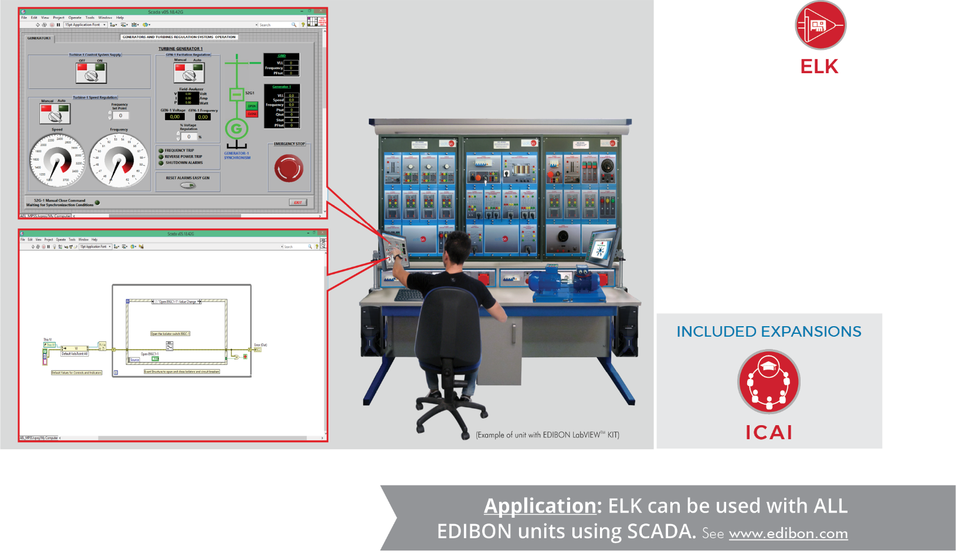

Application: ELK can be used with ALL

Key features:

- Initiation to the programing field in a practical way with EDIBON TECHNICAL TEACHING UNITS. Real Hardware development environment using NI LabVIEWTM at engineering R&D levels.
- Open Source Software packages (OSS) custom-developed for each individual unit.
- It will allow the researcher to work with any involved value and parameter without limits.
- It will allow the researcher to manipulate the data acquisition and its subsequent processing.
- It will allow the researcher to change the control algorithms (example: in a thermal process the researcher can change the heating system).
- Real-time display of sensor readings and calculated values.
- Digital variables readings to show process status indicators and alarms.
- Analog and digital control of hardware elements such as valves, pumps, turbines, etc.
- Software Development Kit (SDK): set of libraries and practical exercises based on several examples of incremental complexity.
- Edition of programs or Virtual Instruments (VI).
- Detailed help documentation introducing all the required concepts and supported on learning resources and guided practical exercises.

ISO 9001: Quality Management (for Design, Manufacturing, Commercialization and After-sales service)
European Union Certificate
(total safety)
Certificates ISO 14001 and ECO- Management and Audit Scheme (environmental management)
1
“Worlddidac Quality Charter” and Platinum Member of Worlddidac

INTRODUCTION

Nowadays, the complexity of real industrial systems and processes requires multidisciplinary engineers able to contribute not only with their specific knowledge but also with the ability of using advanced tools to solve problems efficiently.

One of the most used tools worldwide is National Instruments LabVIEWTM, which provides engineers with powerful tools to easily implement their own measurement, control and automation applications.
Consequently, combining expertise and the use of the best tools, engineers will be much better prepared to face industry challenges successfully and to create competitive advantages in an increasingly globalized world.

GENERAL DESCRIPTION

EDIBON Software Development KIT, Powered by NI LabVIEW™, “ELK”, is a software package, designed by EDIBON engineers, based on National Instruments LabVIEWTM environment, offered as an optional item for some EDIBON ENGINEERING TEACHING UNITS. It is a set of instructions and programs (VIs) addressed to users who need to get started in the fields of programming and instruments and hardware control.

LabVIEWTM is a development environment specifically designed by EDIBON, for engineers and scientists who want to visualize, create and code engineering systems. It is based on a graphical programming language that uses a dataflow model instead of sequential lines of text, allowing the user to write functional code using a visual layout that resembles the process to be developed.

EDIBON ENGINEERING TEACHING UNITS is a powerful learning tool that combined with LabVIEWTM development environment allows users to acquire and control processes, measure variables, display sensors and actuators graphically, etc. from currently used real and authentic hardware, apart from studying common processes and industrial systems.

Additionally, every ENGINEERING TEACHING UNITS is supplied by EDIBON with SCADA control application. Thus, the user can carry out practical exercises, check acquisitions and signals status, compare collected data, develop potential applications, etc. Also the ICAI expansion is included.

COMPLETE TECHNICAL SPECIFICATIONS

The EDIBON Software Development KIT, Powered by NI LabVIEW™, “ELK”, software package includes the following items:
- ELK expansion items: 1.1 and 1.2.
- ICAI expansion items included: 1.3, 1.4, 1.5 and 1.6.

1 ELK. EDIBON Software Development KIT, Powered by NI LabVIEW™.

1.1 ELK-VI-UNIT. EDIBON LabVIEW Kit Virtual Instrument files for each EDIBON UNIT.

LabVIEW programs are called virtual instruments, or VIs. They are similar to a functions or subroutines in other programming languages. Those files contain a comprehensive set of tools for acquiring, analyzing, displaying, and storing data, from the processes and experiments.
Note: EDIBON designs for each UNIT its own expansion.

1.2 ELK-UNIT. EDIBON LabVIEW Kit for each EDIBON UNIT.

It’s a Software Development Kit base on NI LabVIEW. Acquisitions and Control programs related to the purchased UNIT are provided to monitor processes. Also, a complete open source SCADA application is included to design new Control algorithm or design new user interfaces.

• EDIBON Software Development KIT requires: EDIBON TECHNICAL TEACHING UNIT. LabVIEWTM license 2019 or later, 32 bits.

• EDIBON Software Development KIT includes (*):
Practical exercises to get started with LabVIEWTM development environment. Practical exercises to get started with EDIBON TECHNICAL TEACHING UNITS.
A set of programs (VIs) to study the processes and fields of study applied to EDIBON TECHNICAL TEACHING UNITS. A set of programs (VIs) to edit or customize a SCADA application.
A set of programs (VIs) to create a SCADA application.
Note: EDIBON designs for each UNIT its own expansion. (*) The content may vary depending on the unit supplied.

COMPLETE TECHNICAL SPECIFICATIONS

Additionally to the ELK expansion items (1.1 and 1.2) described, we include in the software package a ICAI expansion: items from 1.3 to 1.6.

1.3 ECM-SOF. EDIBON Classroom Manager (Instructor Software).

EDIBON Classroom Manager (Instructor Software), “ECM-SOF”, is the application that allows the administrator/teacher to register students, manage and assign tasks for workgroups, create own content to carry out practical exercises, choose one of the evaluation methods to check the student knowledge and monitor the progression related to the planned tasks for individual students, workgroups, units, etc. so the administrator/teacher can know in real time the level of understanding of any student in the classroom.

1.4 ESL-SOF. EDIBON Student Labsoft (Student Software).

EDIBON Student Labsoft (Student Software), “ESL-SOF”, is the application addressed to the students that helps them to understand theoretical concepts by means of practical exercises and to prove their knowledge and progression by performing tests and calculations in addition to multimedia resources. Default planned tasks and an open workgroup are provided by EDIBON to allow the students start working from the first session. Reports and statistics are available to know their progression at any time, as well as explanations for every exercise to reinforce the theoretically acquired technical knowledge.

1.5 ESL-ELK-SOF. EDIBON E-Learning Content for ELK.

EDIBON E-Learning content, “ESL-ELK-SOF”, is a set of digital resources created by EDIBON that accompanies each Technical Didactic Team. The resources can be edited or enriched by the instructor adding others if deems it convenient. The content provided by EDIBON includes a practical manual, evaluation exercises, equations and multimedia support material to assimilate the concepts studied with the units.

1.6 ESL-UNIT-SOF. EDIBON E-Learning content for each unit (Unit Software).

EDIBON E-Learning content for each unit (Unit Software), “ESL-UNIT-SOF”, is a set of digital resources created by EDIBON that accompanies each Technical Teaching Unit. The resources can be edited or enriched by the administrator/teacher adding others if deems it convenient. The content provided by EDIBON includes a practical manual, evaluation exercises, equations and multimedia support material to assimilate the concepts studied with the units.

Note: EDIBON designs for each unit its own expansion.

PRACTICAL POSSIBILITIES TO BE DONE WITH THE “ELK”

1.- Basic practical exercises to get started with LabVIEWTM and build simple applications.

2.- Basic practical exercises to get started with EDIBON TECHNICAL TEACHING UNITS.

3.- Specific applications intended for the study of several engineering areas, such as Fluid Mechanics, Thermodynamics, Process
Control, Chemical Engineering, Power Systems, Renewable Energies, etc.

4.- Numerical and calculation practical exercises to perform complex mathematical operations, create and edit your own formulas and to obtain characteristic process parameters and variables.

5.- Data acquisition practical exercises to develop your custom supervision and control applications as well as to adjust its main parameters, such as sampling frequency, amount of data, number of signals to manage and more.

6.- Sensor calibration practical exercises to properly scale measurements using engineering units. Possibility of applying new calibration methods for any sensor.

7.- Signal processing practical exercises. Possibility of implementing your custom signal processing algorithms.

8.- Signal filtering practical exercises to study transients, refine data and remove unwanted components, such as noise.

9.- Signal plotting practical exercises to implement different graphical representations of the acquired signals, calculations and process variables in order to observe trends, patterns and variations in real time.

10.- Automatic control practical exercises to implement open/closed loop control algorithms reaching a higher level in the unit operation and automation. Examples: PID, ON/OFF Control, PWM, etc.

11.- DSC (Datalogging and Supervisory Control) practical exercises to log, view and manage historical data as well as to customize your own alarms & data reports.

12.- Fault simulation practical exercises to reproduce hardware breakdowns and their symptoms in a safe way, without any real damage. Additionally, possibility of incorporating your custom simulated faults.

13.- Hardware security elements management practical exercises to incorporate and supervise additional protections for EDIBON TECHNICAL TEACHING UNITS.

14.- User interface design practical exercises to customize the general appearance and layout of your own application.

EDIBON UNITS USING SCADA APPLICATIONS

About 1,000 EDIBON units using SCADA, can use the EDIBON Software Development KIT, Powered by NI LabVIEW™, “ELK”, in the following areas:

1. PHYSICS
2. ELECTRONICS
3. COMMUNICATIONS
4. ELECTRICITY
5. ENERGY
6. MECHATRONICS, AUTOMATION & COMPUMECHATRONICS
7. MECHANICS
8. FLUID MECHANICS
9. THERMODYNAMICS & THERMOTECHNICS
10. PROCESS CONTROL
11. CHEMICAL ENGINEERING
12. FOOD & WATER TECHNOLOGIES
13. ENVIRONMENT
14. BIOMEDICAL ENGINEERING

EDIBON LABVIEWTM KIT MAIN SCREENS

Parameter calculation - Customizable calculation application

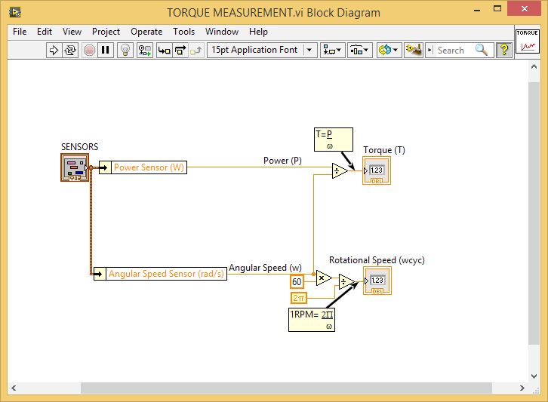
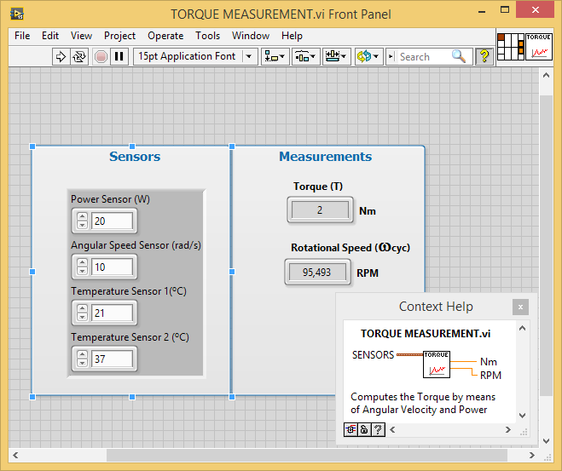

Representation of processes and variables of the system - Customizable acquisition application
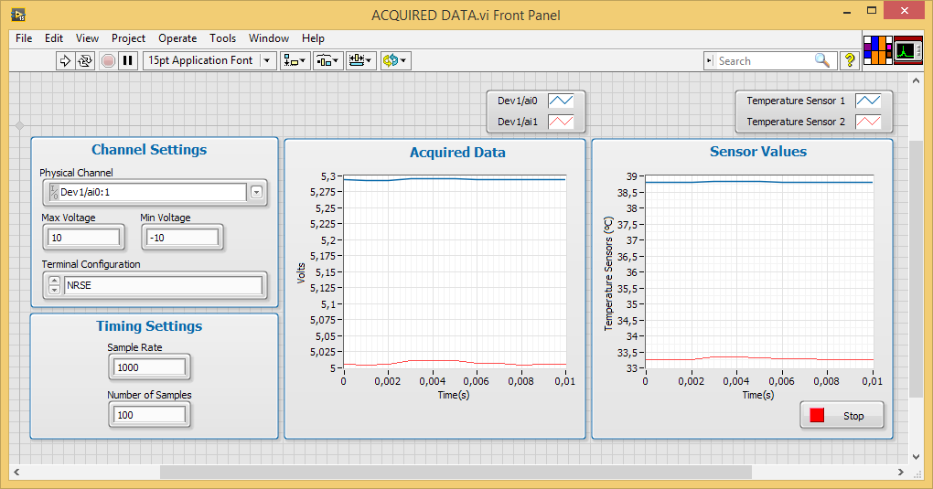

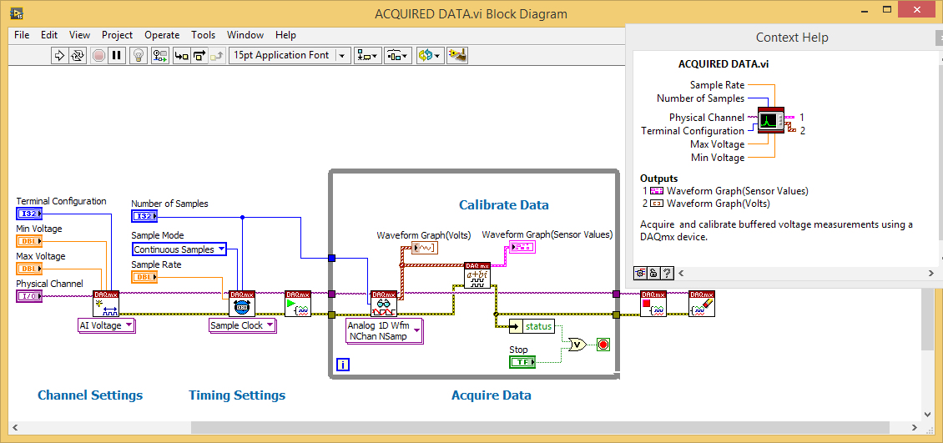

EDIBON LABVIEWTM KIT MAIN SCREENS

PID control algorithms to study open/closed control loops - Customizable control application

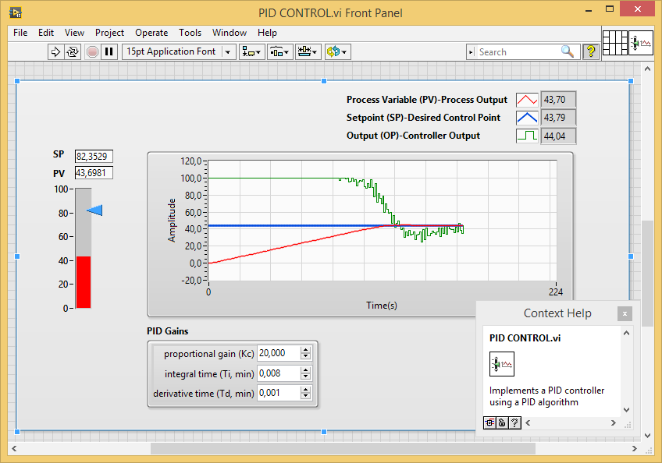

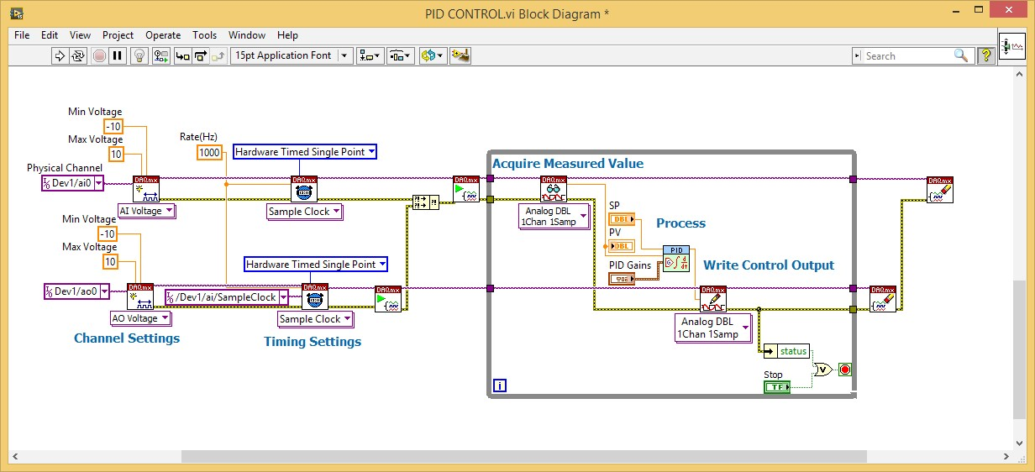

EDIBON LABVIEWTM KIT MAIN SCREENS
EDIBON LABVIEWTM KIT MAIN SCREENS
Process parameters calculation - Example of SCADA application developed by EDIBON (1)
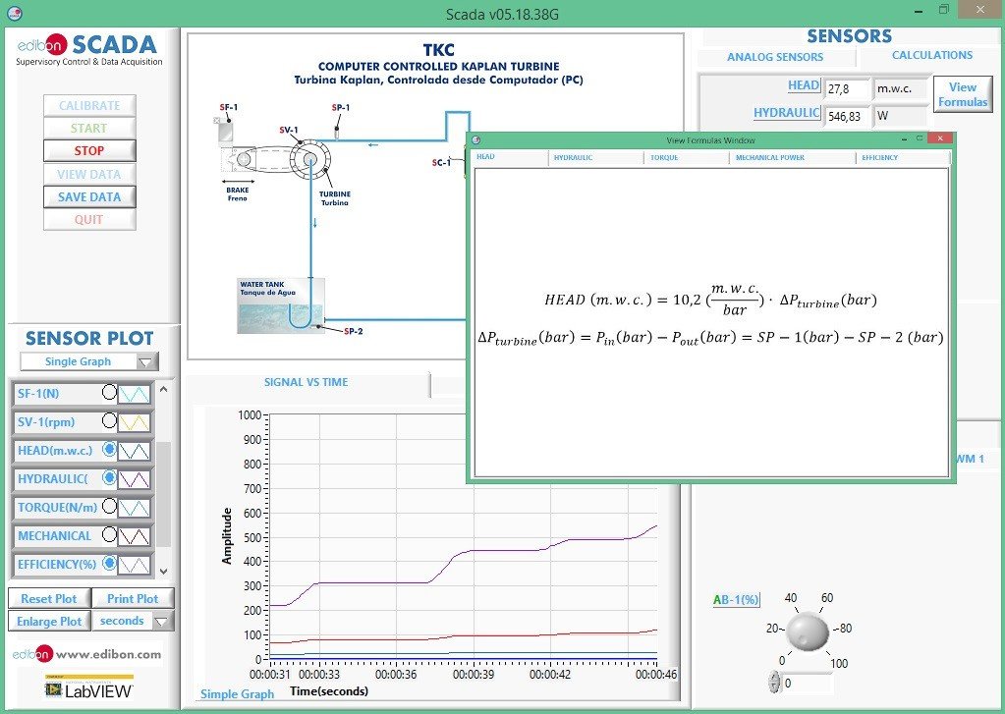

Representation of variables and processes of the system - Example of SCADA application developed by EDIBON(1)
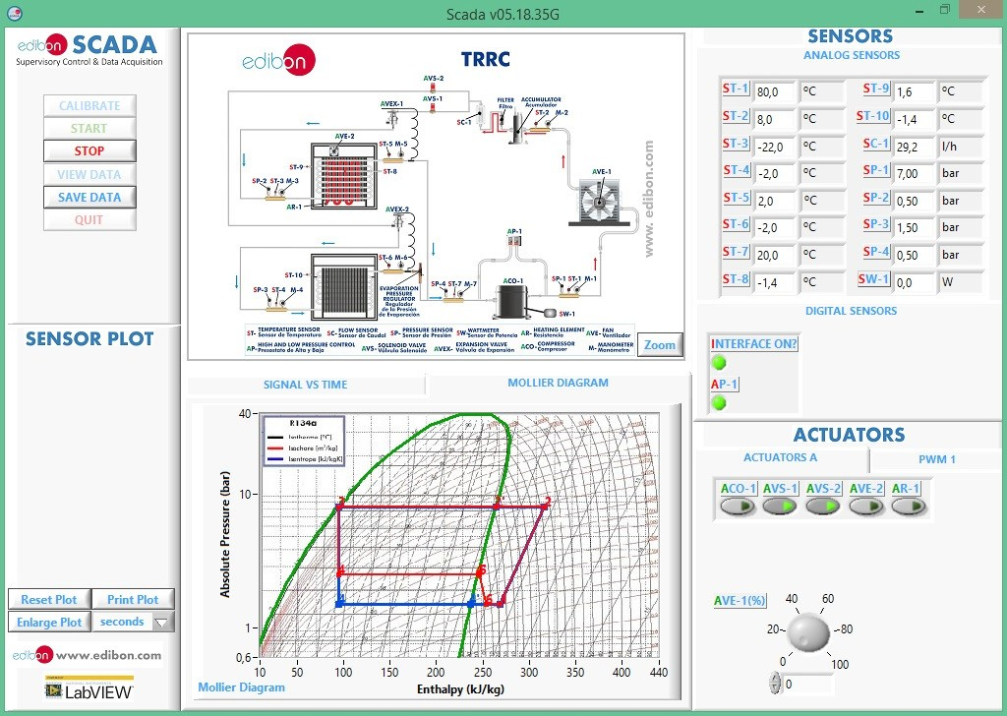

(1) EDIBON SCADA application is supplied with EDIBON Software Development KIT, Powered by NI LabVIEW™, “ELK”, but without its source code. It is displayed just as an example of a real SCADA application

LABORATORY CONFIGURATION EXAMPLE

Configuration example of a EDIBON Software Development KIT, Powered by NI LabVIEW™ Laboratory, “ELK”:

• 1 ELK-EG5C. • 5 students. (*) • 1 Virtual Instrument Files.
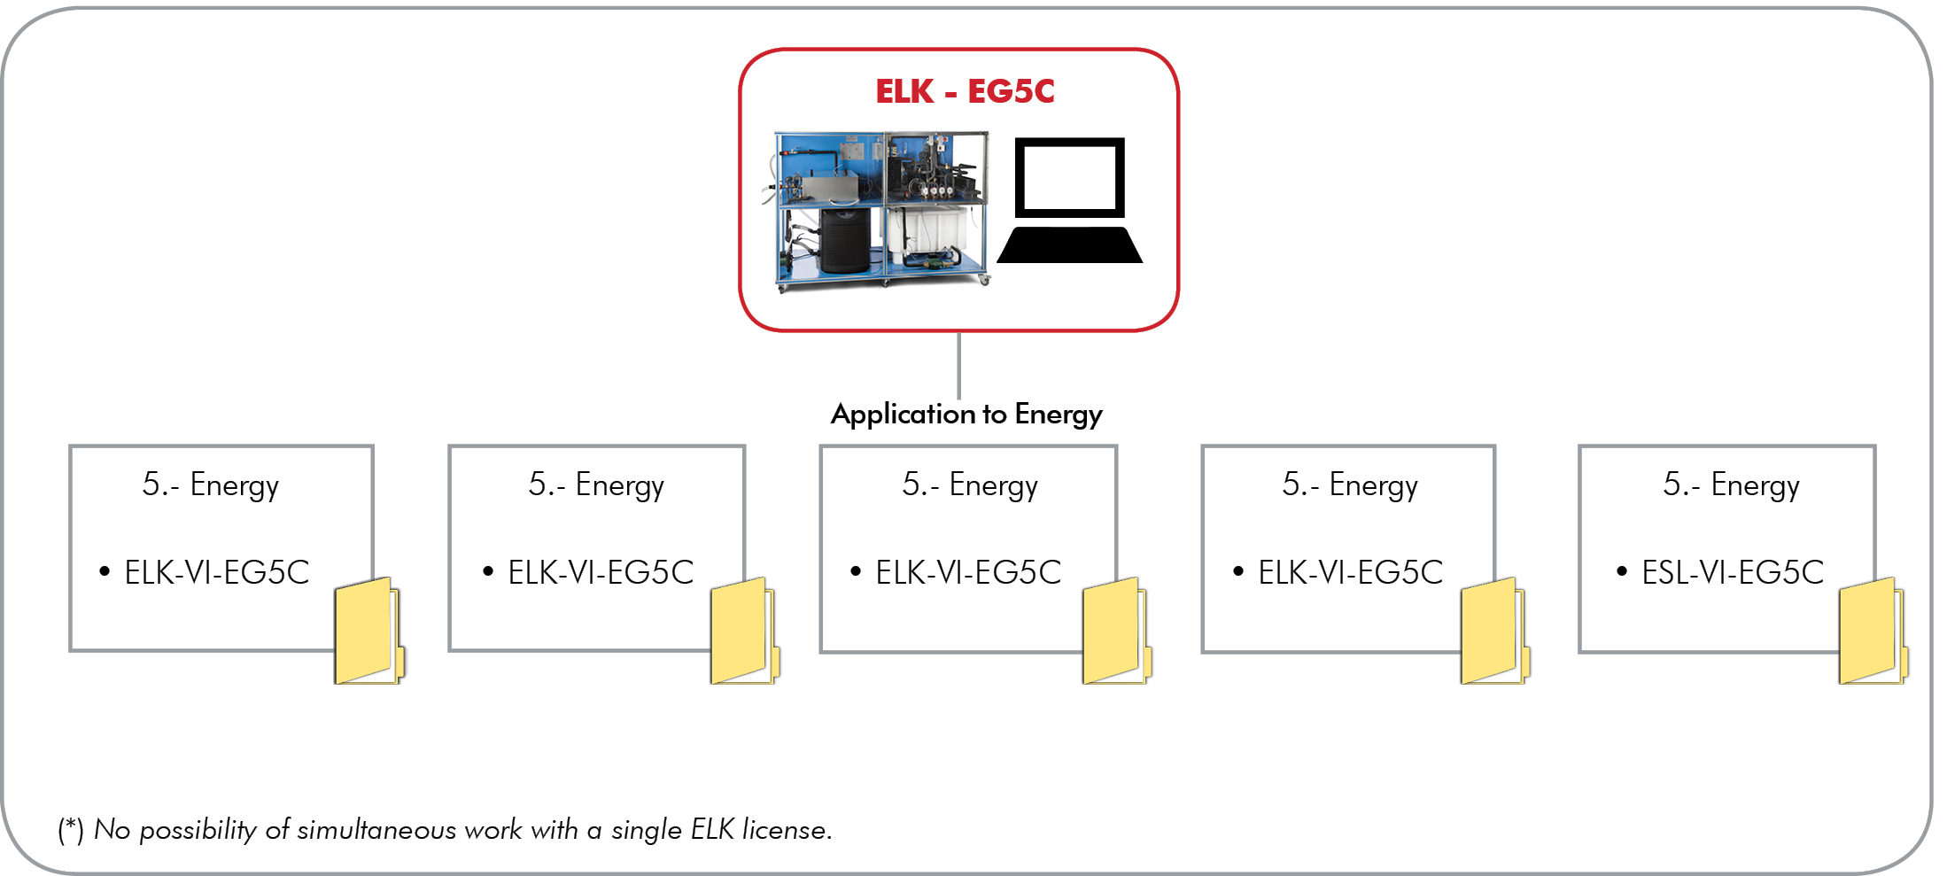

Configuration example of an Interactive Computer Aided Instruction Software Laboratory, “ICAI” included, with:

• 1 administrator/teacher. • 5 students. (**) • 1 E-Learning content + 1 E-Learning ELK content (***).

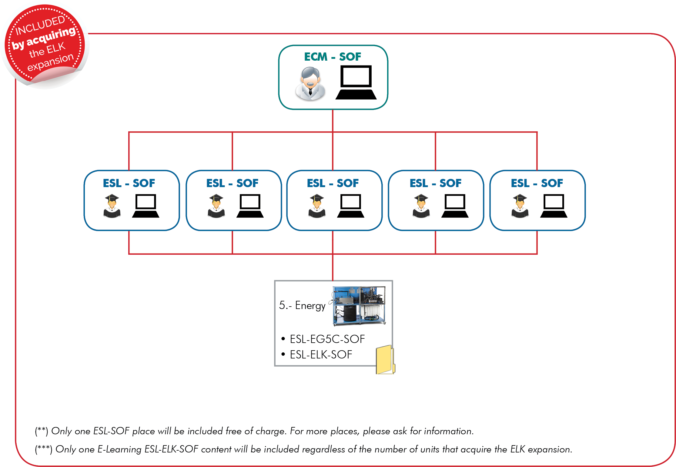

.

ORDER INFORMATION

• Contact EDIBON Sales Force to consult prices and availability of:

Practical exercises and set of programs (VIs).

ELK KIT EXPANSIONS

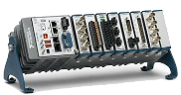
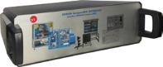
- ECR. EDIBON Industrial Modular System with NI CompactRIO.

EDIBON System
with NI CompactRIO

Advanced Monitor and Supervisor Platform

Programmable Real Time Control Architecture

Precisely and Truthfully Timed Data Acquisition

EDIBON CompactRIO Interface
NI CompactRIO

